EXNO:1 CREATING AND MANAGING TABLE DATE:

1.Create the DEPT table based on the DEPARTMENT following the table instance chart below. Confirm that the table is created.

|  |  |  |
| --- | --- | --- |
| **Column name** | ID | NAME |
| **Key Type** |  |  |
| **Nulls/Unique** |  |  |
| **FK table** |  |  |
| **FK column** |  |  |
| **Data Type** | Number | Varchar2 |
| **Length** | 7 | 25 |

QUERY: Create table DEPARTMENT(id number(7),name varchar2(25));

OUTPUT:

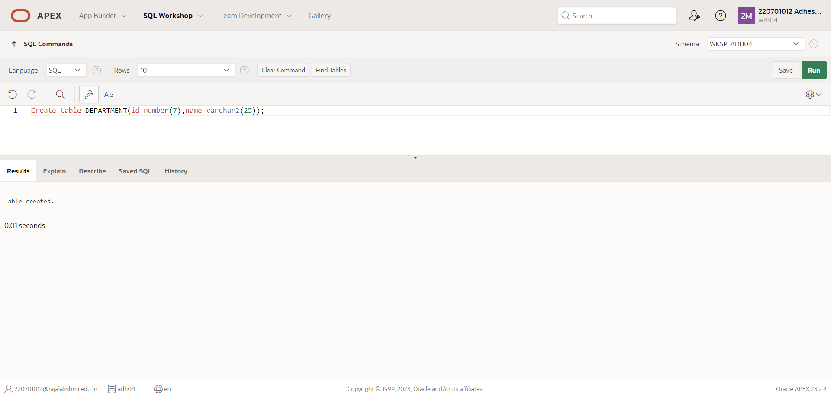

2.Create the EMP table based on the following instance chart. Confirm that the table is created.

|  |  |  |  |  |
| --- | --- | --- | --- | --- |
| **Column name** | ID | LAST_NA ME | FIRST_NA ME | DEPT_ID |
| **Key Type** |  |  |  |  |

|  |  |  |  |  |
| --- | --- | --- | --- | --- |
| **Nulls/Unique** |  |  |  |  |
| **FK table** |  |  |  |  |
| **FK column** |  |  |  |  |
| **Data Type** | Number | Varchar2 | Varchar2 | Number |
| **Length** | 7 | 25 | 25 | 7 |

QUERY: Create table emp(id number(7),Last_Name varchar(25),First_Name varchar(25),Dept_id number(7));

OUTPUT:

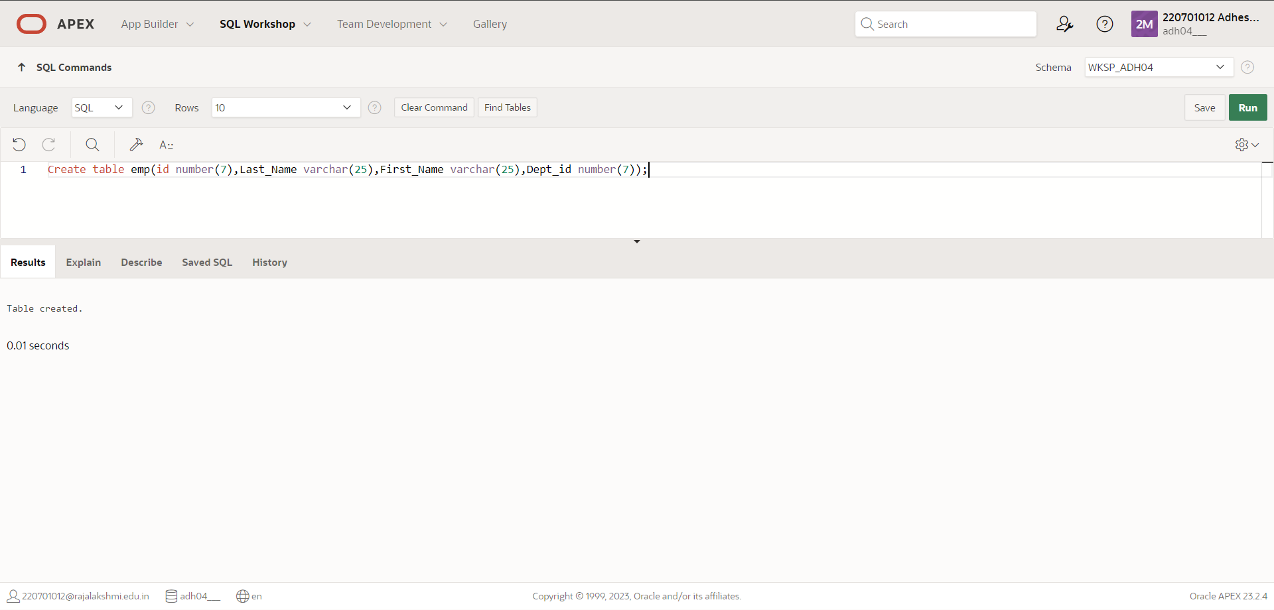

3.Modify the EMP table to allow for longer employee last names. Confirm the modification.(Hint: Increase the size to 50)

QUERY: Alter table emp modify(Last_Name varchar2(50));

OUTPUT:

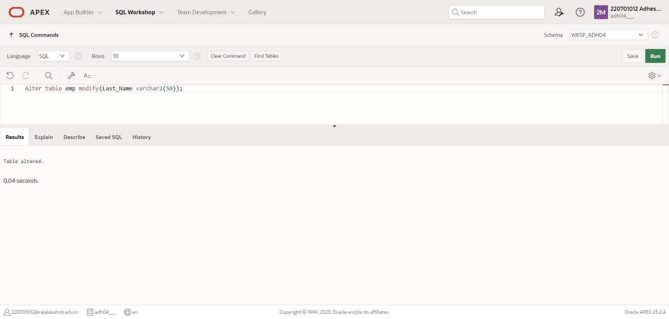

4.Create the EMPLOYEES2 table based on the structure of EMPLOYEES table. Include Only the Employee_id, First_name, Last_name, Salary and Dept_id coloumns. Name the columns Id, First_name, Last_name, salary and Dept_id respectively.

QUERY: Create table employees2(id number(7),first_name varchar2(25),Last_name varchar2(25),Salary int,Dept_id number(7));

**OUTPUT**:

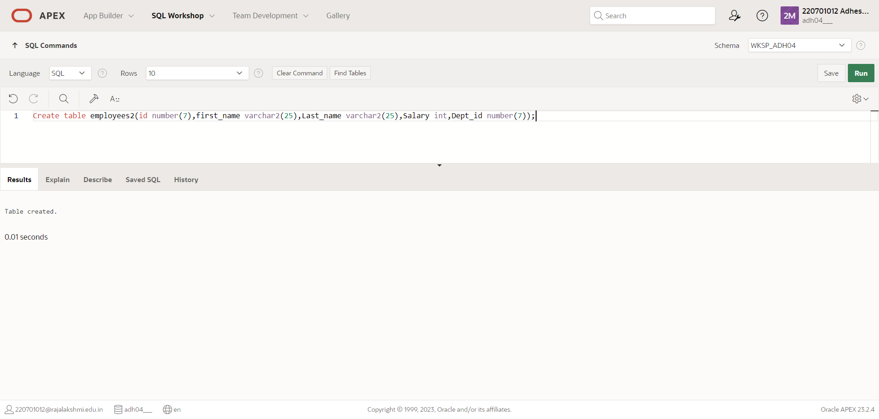

5. Drop table emp.

QUERY: Drop table emp;

OUTPUT:

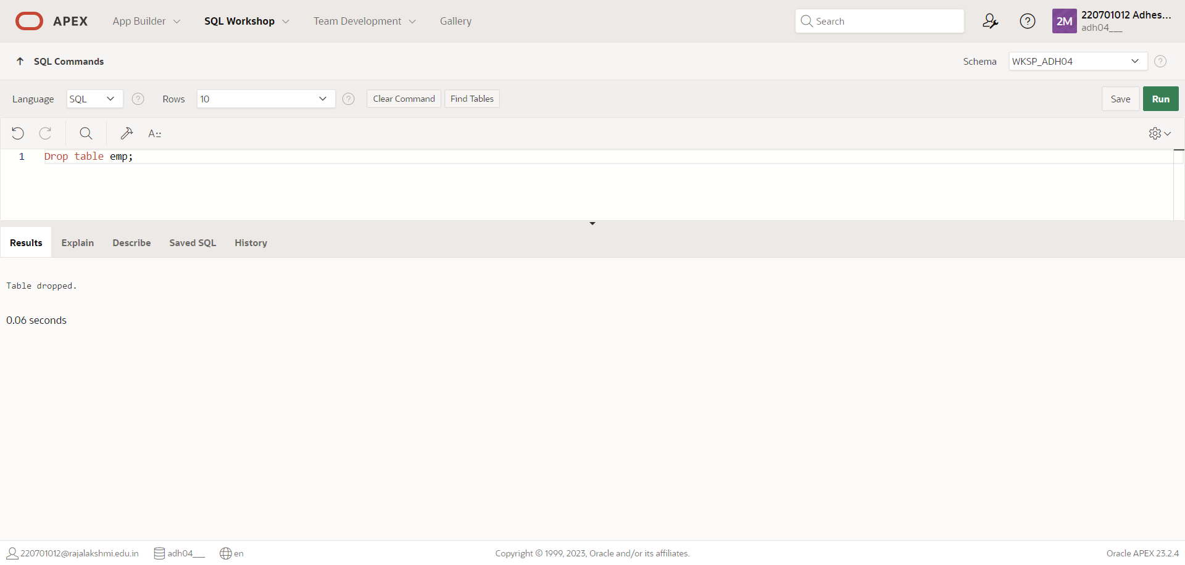

6.Rename the EMPLOYEES2 table as EMP.

QUERY: alter table employees2 rename to emp;

OUTPUT:

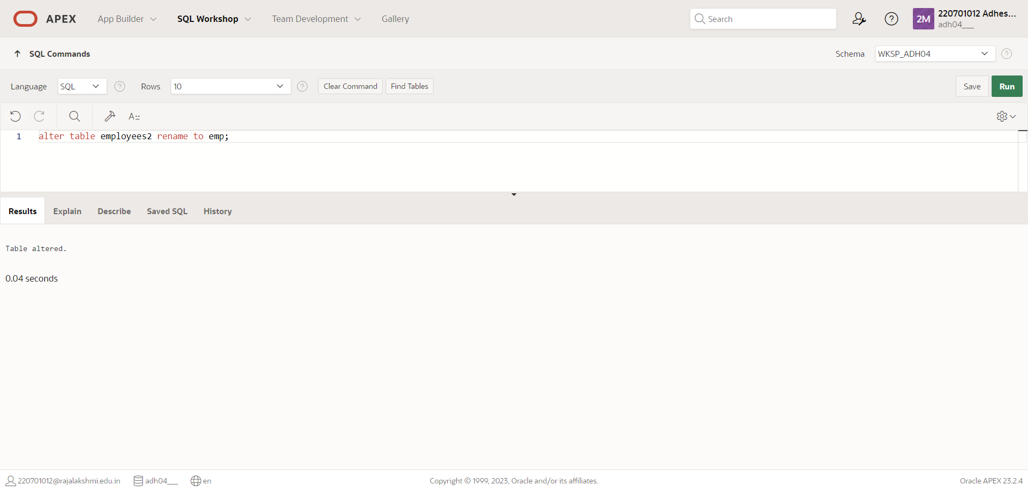

7.Add a comment on DEPT and EMP tables. Confirm the modification by describing the table.

QUERY: comment on table dept is 'Employee info';

OUTPUT:

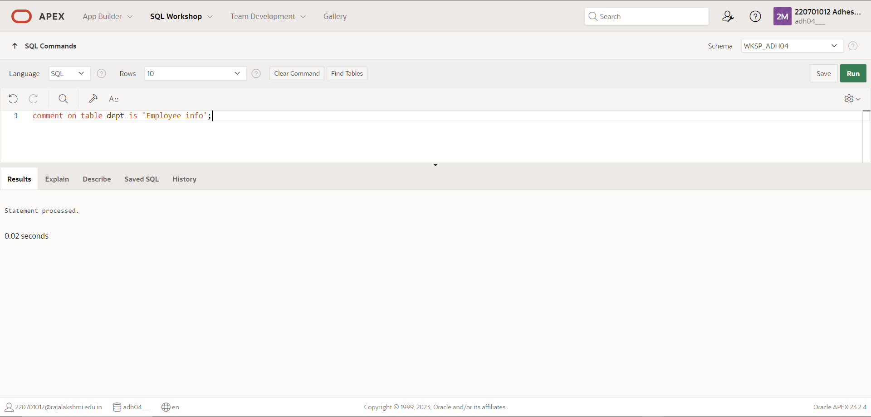

8.Drop the First_name column from the EMP table and confirm it.

QUERY: Alter table emp drop column first_name;

OUTPUT:

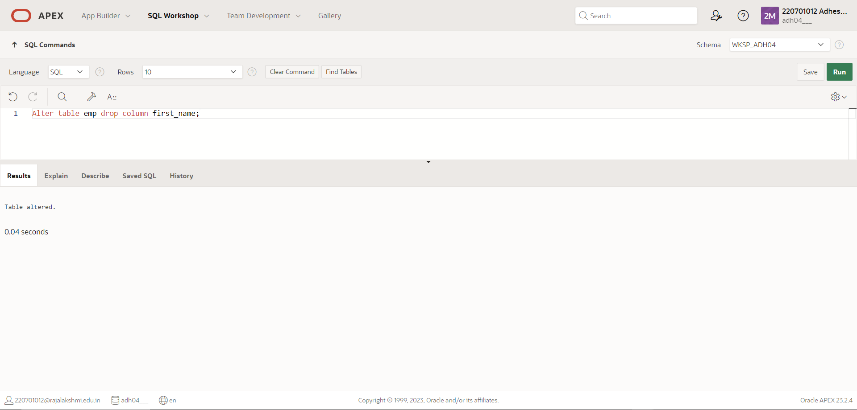

|  |  |
| --- | --- |
| Evaluation Procedure | Marks awarded |
| Query(5) |  |
| Execution (5) |  |
| Viva(5) |  |
| Total (15) |  |
| Faculty Signature |  |

RESULT:

**EXNO:2 MANIPULATING DATA DATE:**

1. **Create MY_EMPLOYEE table with the following structure**

|  |  |  |
| --- | --- | --- |
| NAME | NULL? | TYPE |
| ID | Not null | Number(4) |
| Last_name |  | Varchar(25) |
| First_name |  | Varchar(25) |
| Userid |  | Varchar(25) |
| Salary |  | Number(9,2) |

**QUERY**:

Create table My_emp(ID number(4), last_name varchar(25), first_name varchar(25), user_id varchar(25), salary number(9,2));

**OUTPUT**:

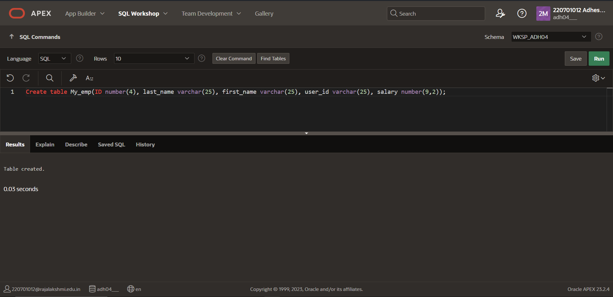

1. Add the first and second rows data to MY_EMPLOYEE table from the following sample data.

|  |  |  |  |  |
| --- | --- | --- | --- | --- |
| **ID** | **Last_name** | **First_name** | **Userid** | **salary** |
| 1 | Patel | Ralph | rpatel | 895 |
| 2 | Dancs | Betty | bdancs | 860 |
| 3 | Biri | Ben | bbiri | 1100 |
| 4 | Newman | Chad | Cnewman | 750 |
| 5 | Ropebur | Audrey | aropebur | 1550 |

**QUERY**:

INSERT INTO My_emp values(1,’patel’,’ralph’,’rpatel’,895);

INSERT INTO My_emp values(2,’dancs’,’betty’,’bdancs’,860);

**OUTPUT:**

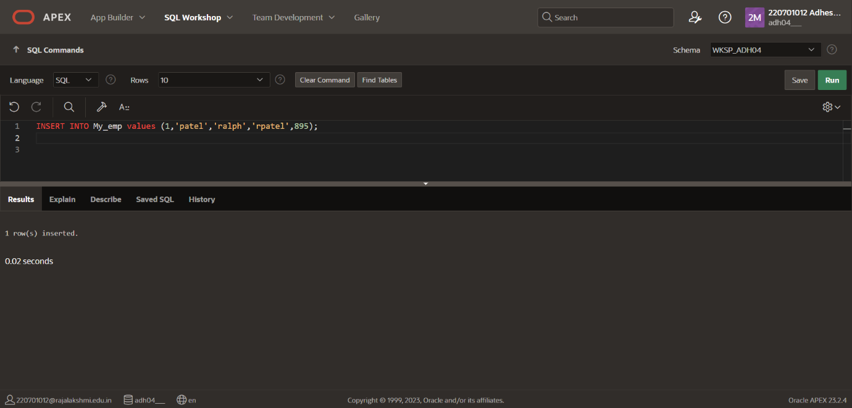

**3.Display the table with values.**

**QUERY:** select * from My_emp;

**OUTPUT:**

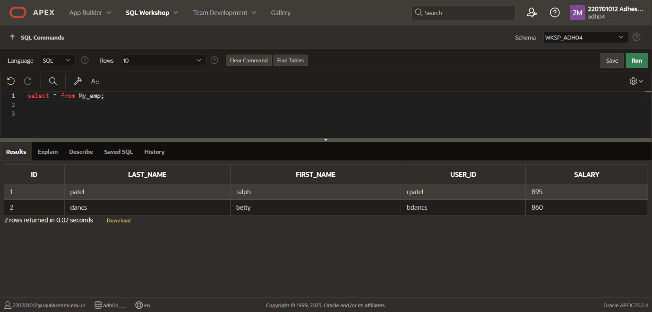

**4.Change the last name of employee 3 to Drexler.**

**QUERY:** update My_emp set LAST_NAME=’dexler’ where ID=3;

**OUTPUT:**

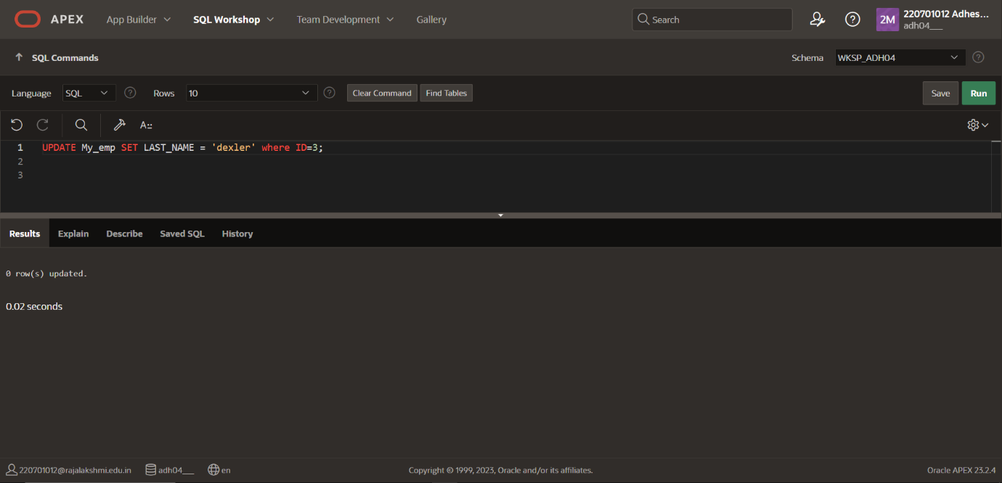

**5.Change the salary to 1000 for all the employees with a salary less than 900.**

**QUERY**: update My_emp set salary =1000 where salary<900;

**OUTPUT**:

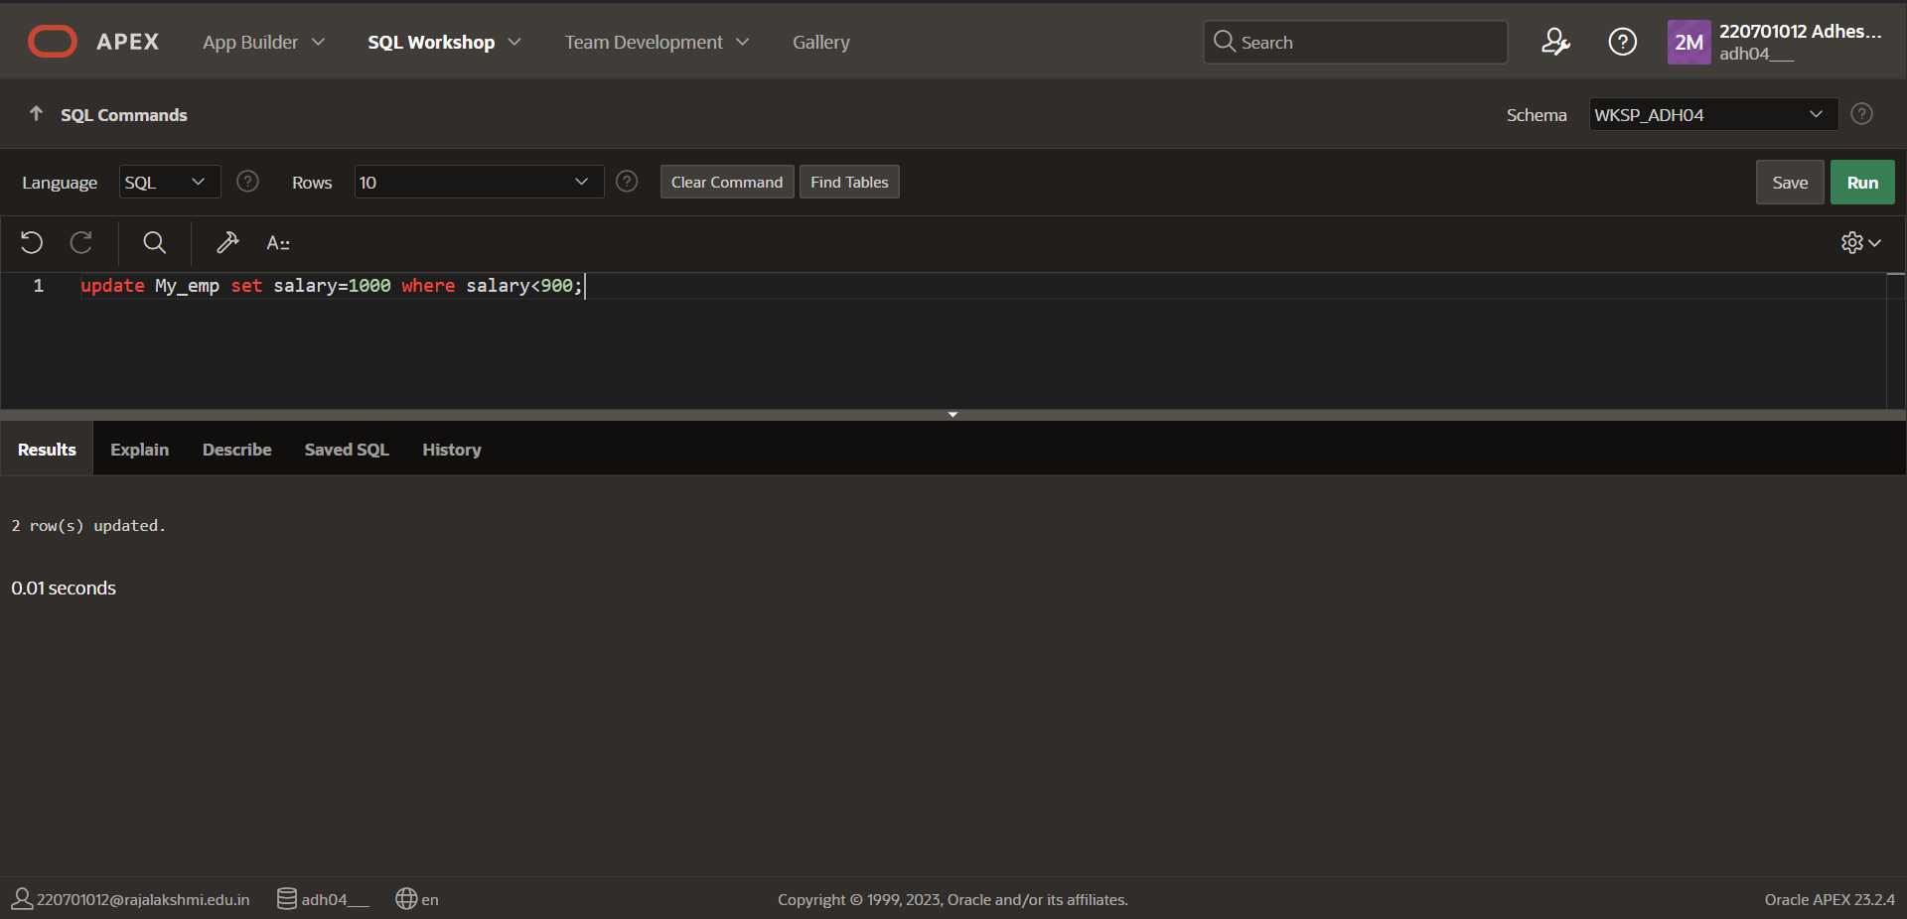

**6.Delete Betty dancs from MY _EMPLOYEE table.**

**QUERY:** delete from My_emp where last_name='dancs';

**OUTPUT**:

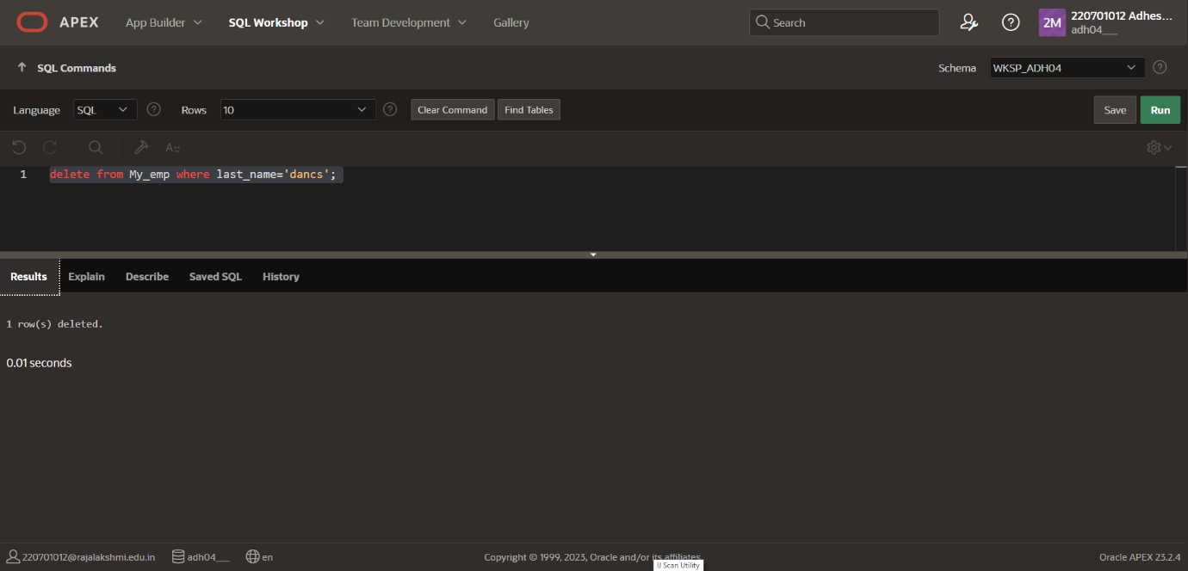

**7.Empty the fourth row of the emp table.**

**QUERY:** delete from My_emp where id=4;

**OUTPUT**:

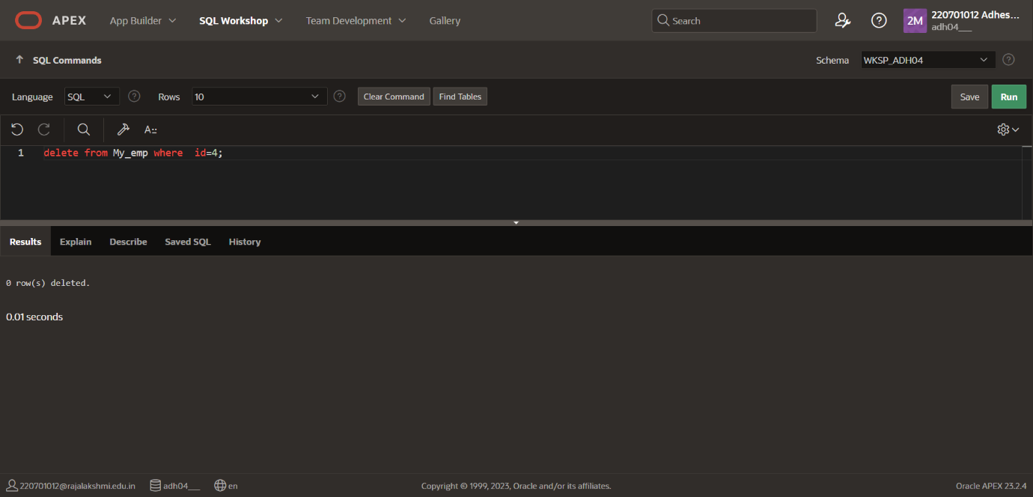

|  |  |
| --- | --- |
| Evaluation Procedure | Marks awarded |
| Query(5) |  |
| Execution (5) |  |
| Viva(5) |  |
| Total (15) |  |
| Faculty Signature |  |

**RESULT**:

**EXNO:3 INCLUDING CONSTRAINTS DATE:**

1. **Add a table-level PRIMARY KEY constraint to the EMP table on the ID column.The constraint should be named at creation. Name the constraint my_emp_id_pk.**

**QUERY:** ALTER TABLE My_emp ADD CONSTRAINT my_emp_id_pk PRIMARY KEY(ID);

**OUTPUT:**

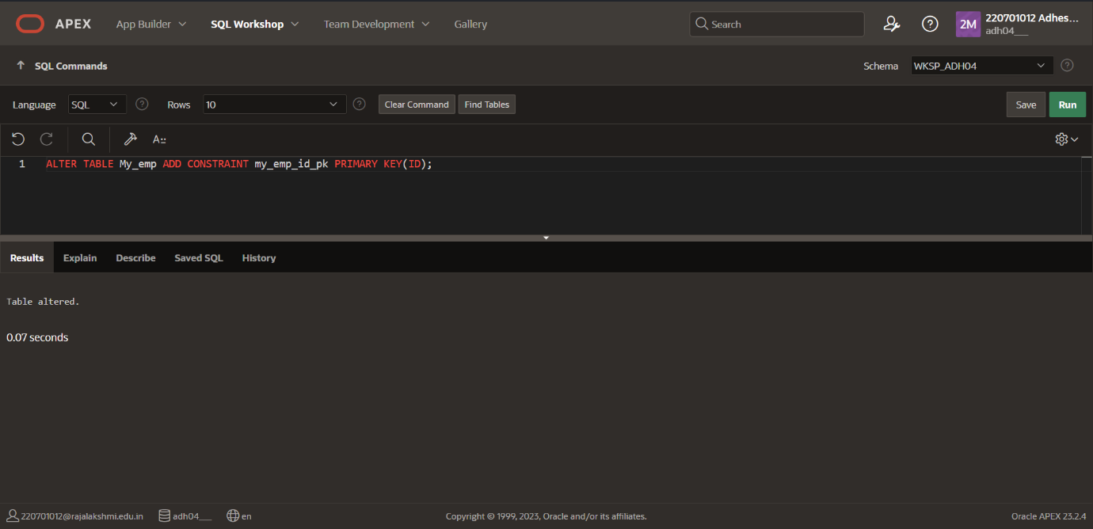

**2.Create a PRIMAY** KEY **constraint to the DEPT table using the ID column. The constraint should be named at creation. Name the constraint my_dept_id_pk.**

**QUERY:** CREATE TABLE DEPT(DEPT_ID number(4),deptname varchar(25),CONSTRAINT my_dept_id_pk PRIMARY KEY(DEPT_ID));

**OUTPUT**: 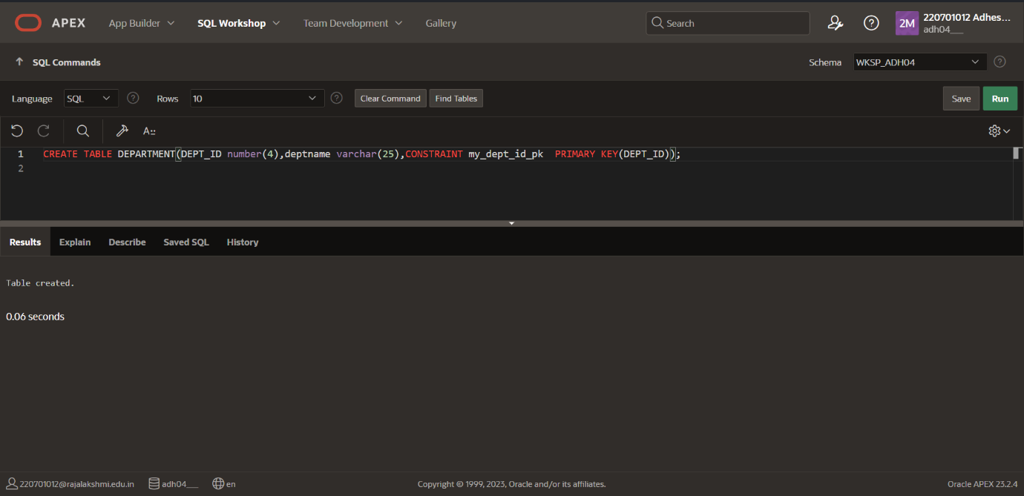

**3.Add a column DEPT_ID to the EMP table. Add a foreign key reference on the EMP table that ensures that the employee is not assigned to nonexistent deparment. Name the constraint my_emp_dept_id_fk.**

**QUERY:** ALTERTABLE My_emp ADD CONSTRAINT my_emp_dept_id_fk FOREIGN KEY(DEPT_ID) REFERENCES DEPT(DEPT_ID);

**OUTPUT**:

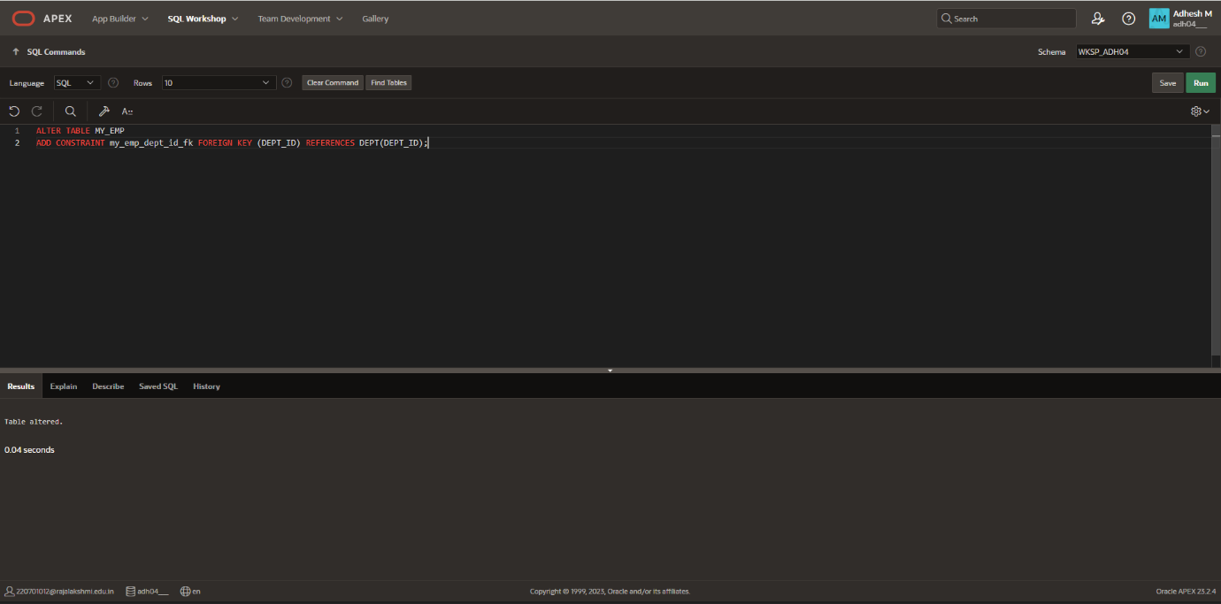

4.Modify the EMP table. Add a COMMISSION column of NUMBER data type, precision 2, scale 2. Add a constraint to the commission column that ensures that a commission value is greater than zero.

QUERY: ALTER TABLE My_emp ADD COMMISION number(2,2);

ALTER TABLE My_emp ADD CONSTRAINT CK1 CHECK(COMMISSION>0);

OUTPUT:

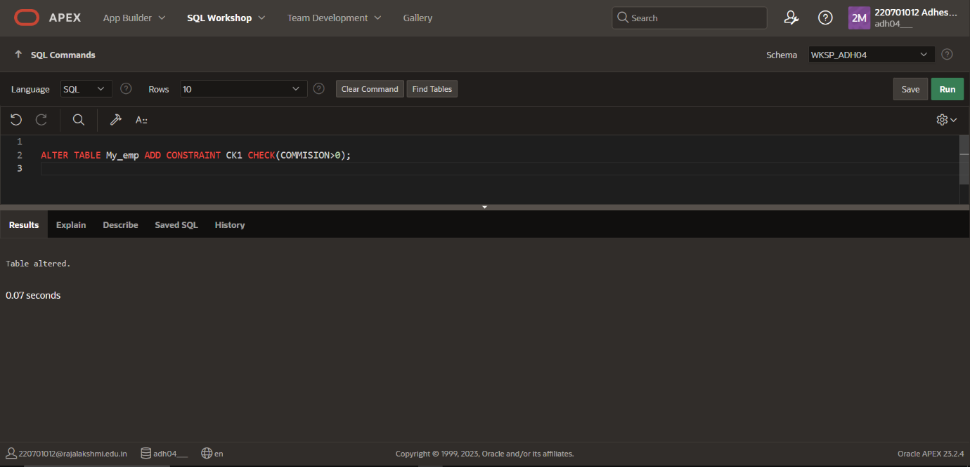

|  |  |
| --- | --- |
| Evaluation Procedure | Marks awarded |
| Query(5) |  |
| Execution (5) |  |
| Viva(5) |  |
| Total (15) |  |
| Faculty Signature |  |

**RESULT:**

**EXNO:4 WRITING BASIC SQL SELECT STATEMENTS DATE:**

**1.Identify the Errors**

**SELECT employee_id, last_name ,sal*12 ANNUAL SALARY FROM employees;**

**QUERY:**

SELECT id, last_name ,sal,sal*12 as “ANNUAL SALARY” FROM My_emp;

**OUTPUT:**

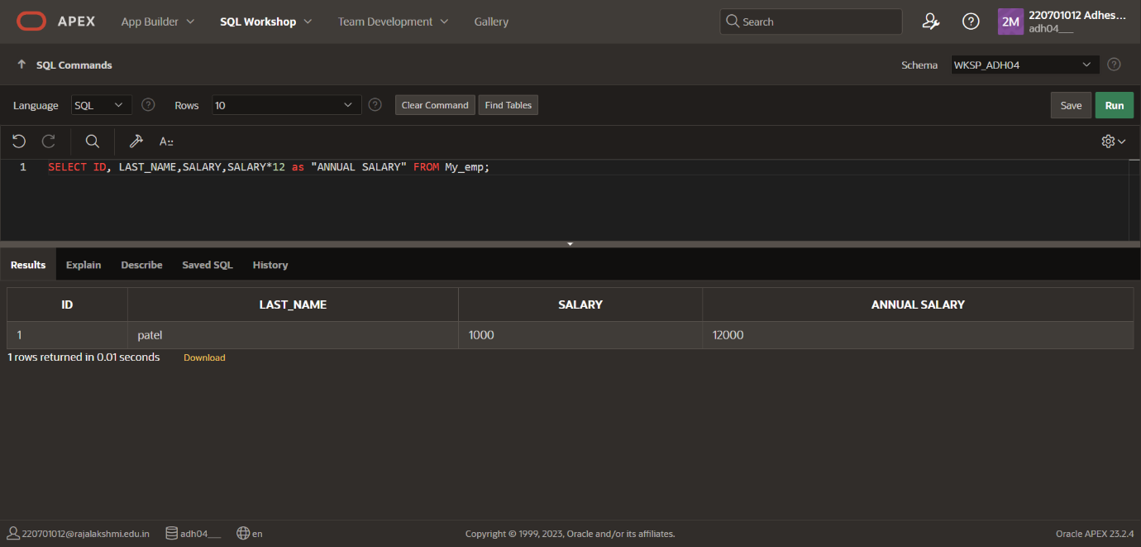

**2. Show the structure of departments the table. Select all the data from it.**

**QUERY:** SELECT * FROM DEPARTMENT;

**OUTPUT**:

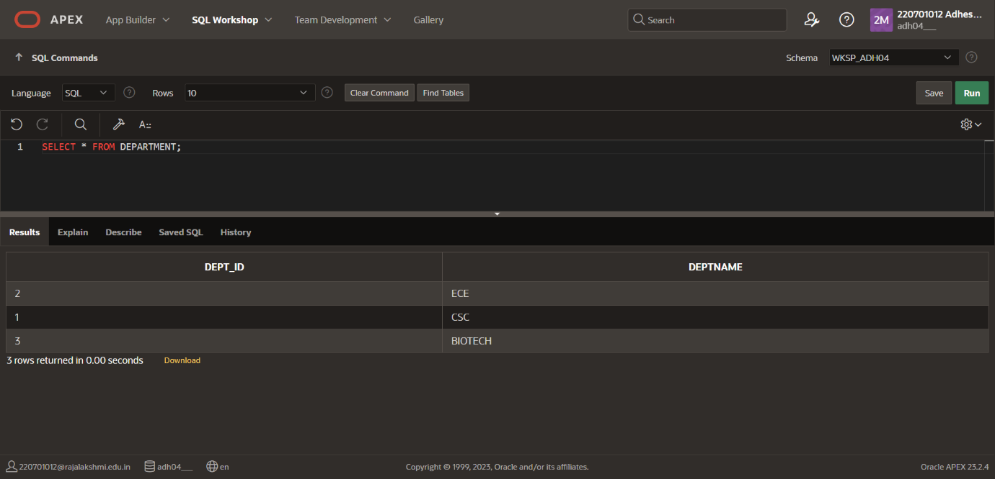

3.Create a query to display the last name, job code, hire date, and employee number for each employee, with employee number appearing first.

QUERY: SELECT ID, LAST_NAME, JOB_CODE, HIRE_DATE FROM MY_EMP;

**OUTPUT**:

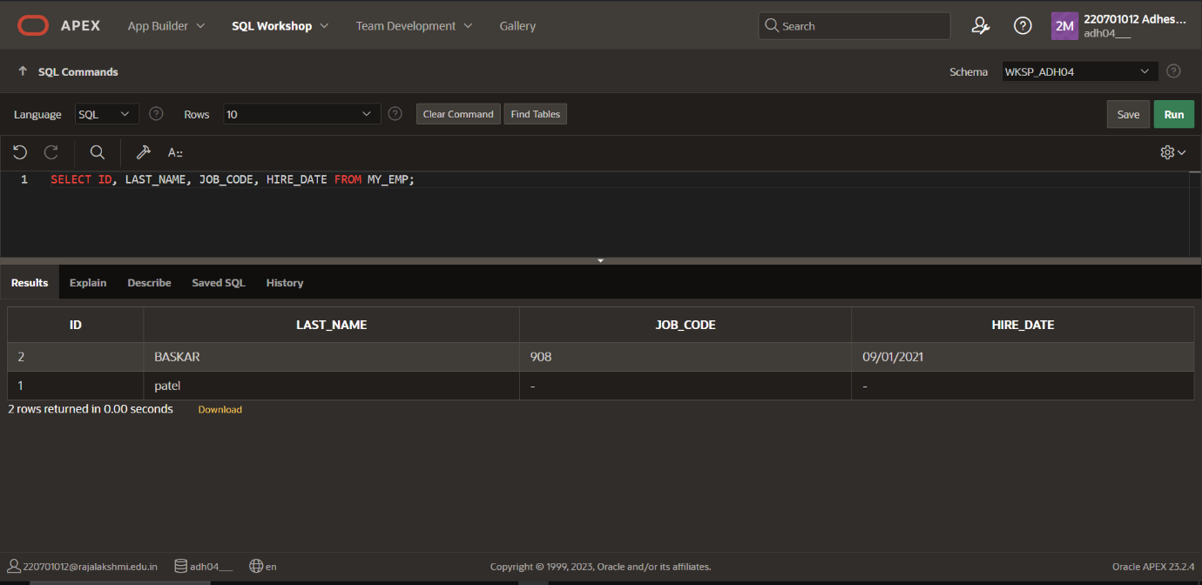

**4. Provide an alias STARTDATE for the hire date.**

**QUERY:** SELECT HIRE_DATE as "START_DATE" FROM MY_EMP;

**OUTPUT**:

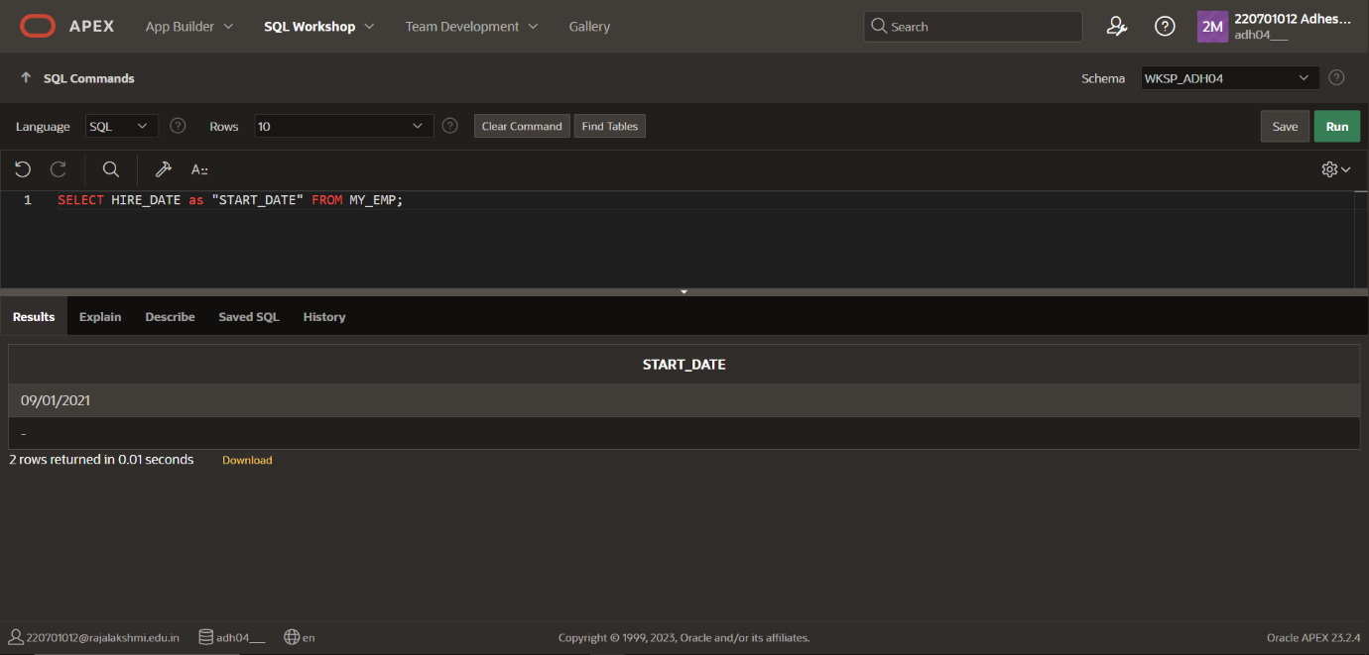

**5. Create a query to display unique job codes from the employee table.**

**QUERY:** SELECT UNIQUE JOB_CODE FROM MY_EMP;

**OUTPUT:**

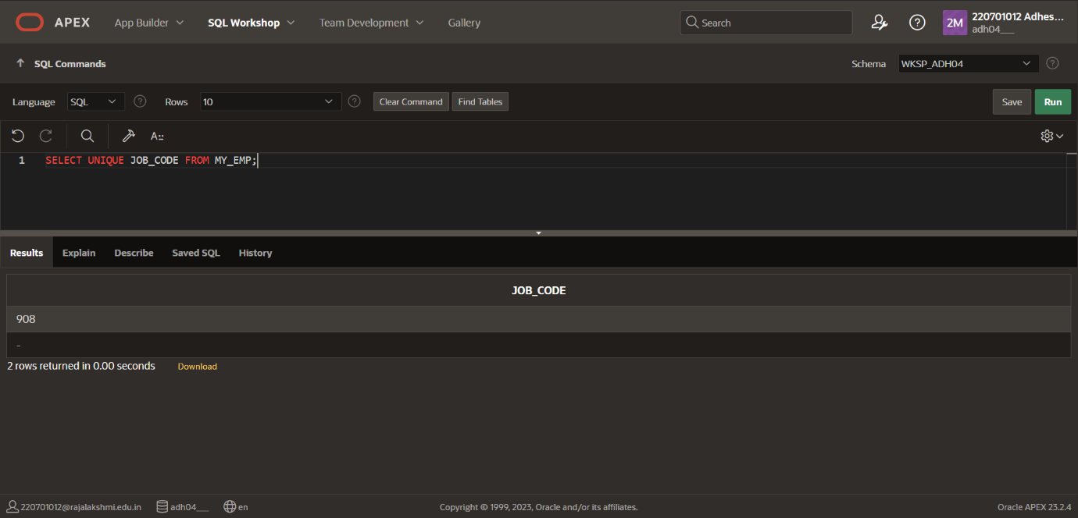

**6. Display the last name concatenated with the job ID , separated by a comma and space, and name the column EMPLOYEE and TITLE.**

**QUERY:** SELECT LAST_NAME||', '|| JOB_CODE as "EMPLOYEE TITLE" FROM MY_EMP;

**OUTPUT**:

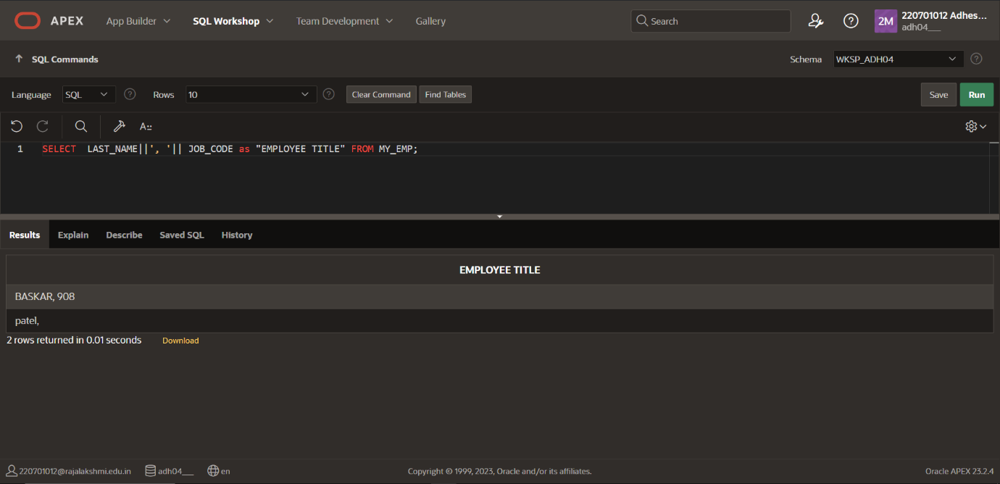

**7.Create a query to display all the data from the employees table. Separate each column by a comma. Name the column THE_OUTPUT.**

**QUERY:** SELECT LAST_NAME||’,’||FIRST_NAME||’,’||JOB_CODE||’,’||ID||’,’||hire_date||’,’||dept_id as “THE_OUTPUT”;

**OUTPUT**:

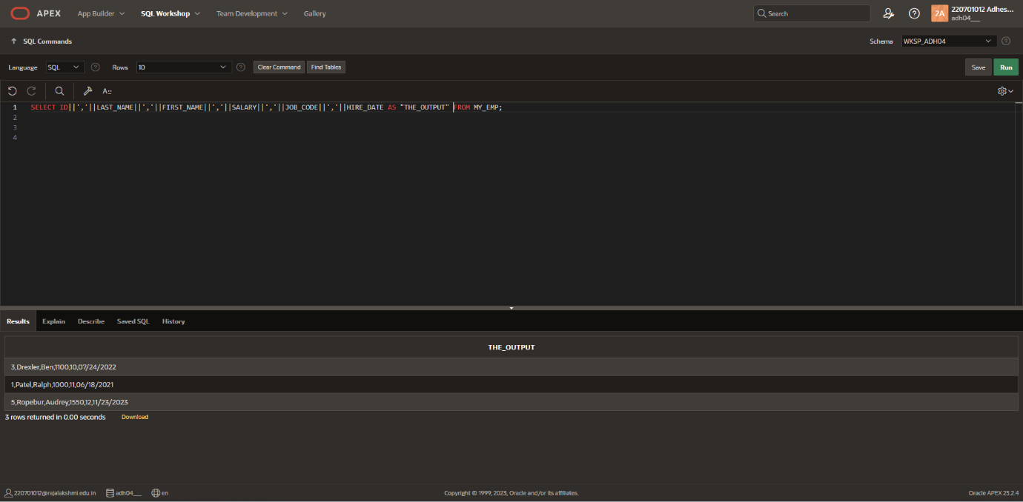

|  |  |
| --- | --- |
| Evaluation Procedure | Marks awarded |
| Query(5) |  |
| Execution (5) |  |
| Viva(5) |  |
| Total (15) |  |
| Faculty Signature |  |

**RESULT**:

**EXNO:5 RESTRICTING AND SORTING DATA DATE:**

1. **Create a query to display the last name and salary of employees earning more than 12000.**

**QUERY**:SELECT LAST_NAME, SALARY from MY_EMP where SALARY>12000;

**OUTPUT**:

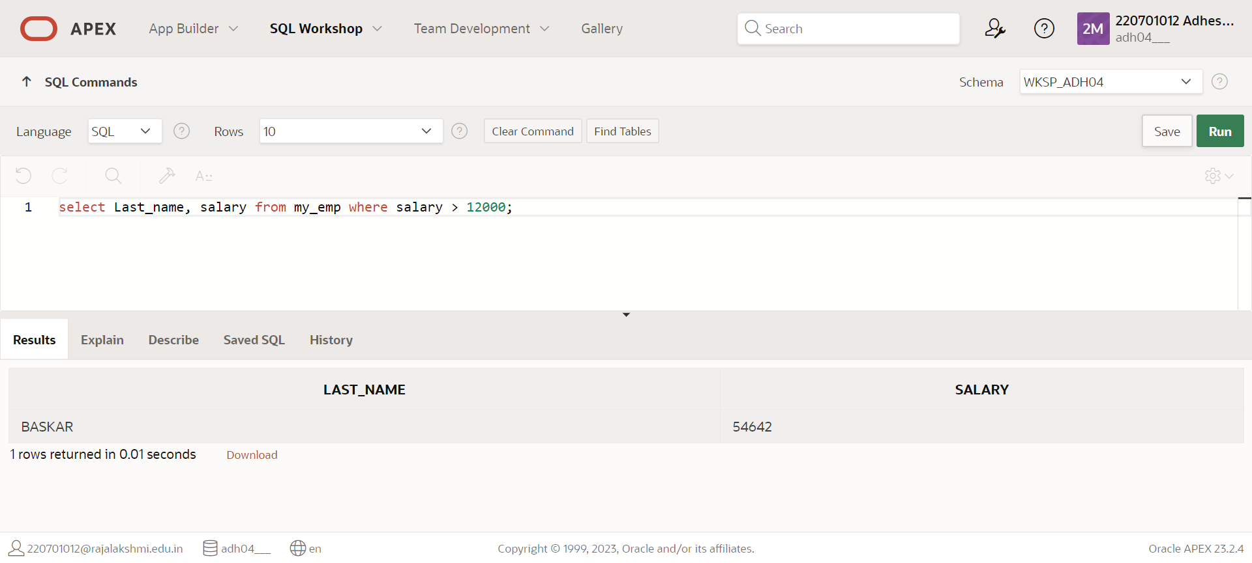

1. Create a query to display the employee last name and department number for employee number 176.

**QUERY**:Select last_name, dept_id from MY_EMP where emp_id=176;

**OUTPUT:**

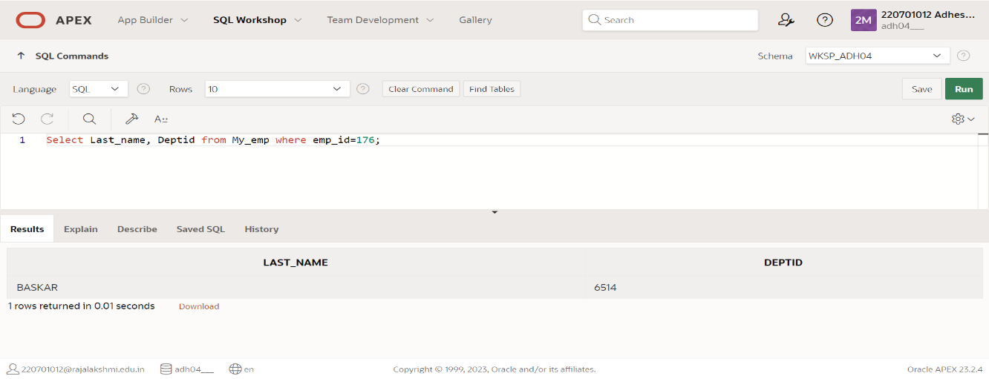

**3. Create a query to display the last_name and salary of employees whose salary is not in the range of 5000 and 12000.**

**QUERY:** Select last_name, salary from MY_EMP where salary BETWEEN 5000 and 12000;

**OUTPUT:**

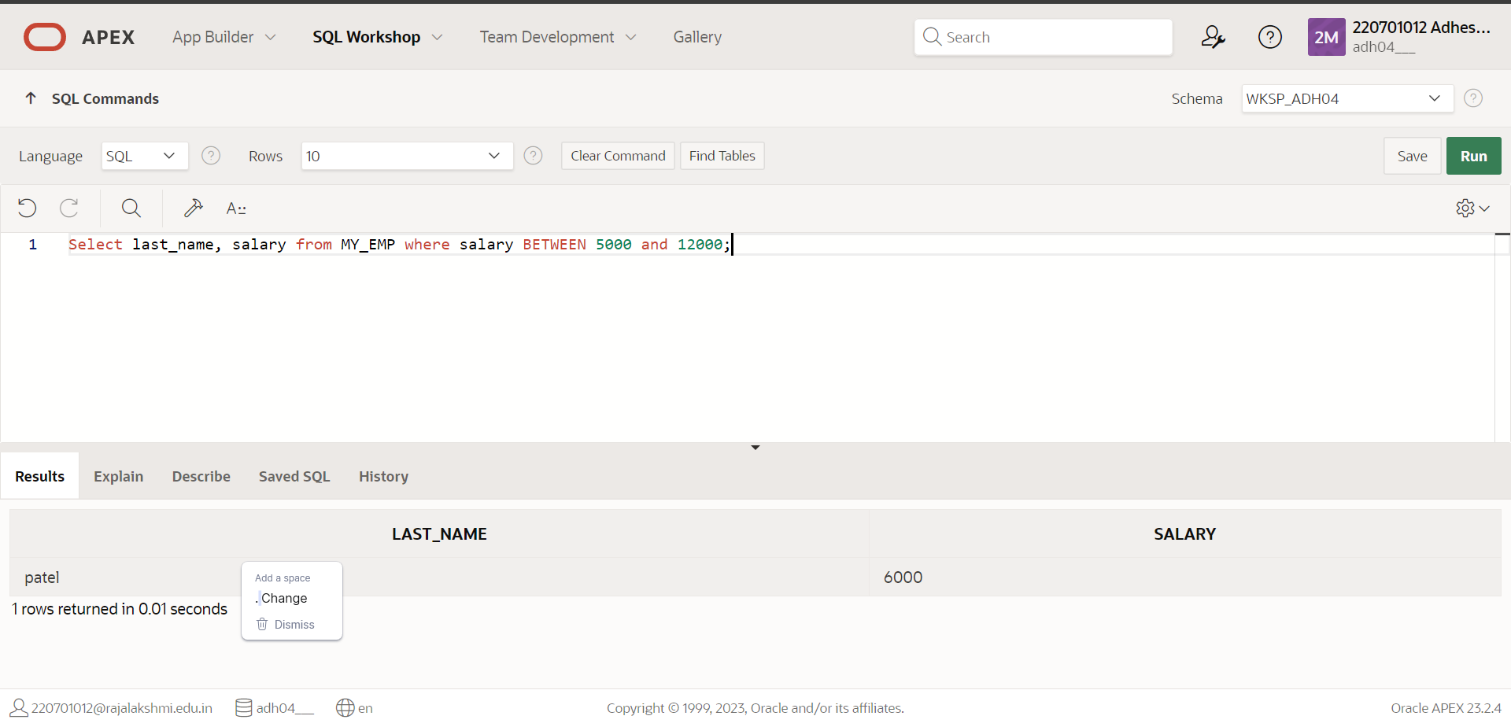

**4.Display the employee last name, job id, and start date of employees hired between February 20,1998 and May 1,1998. Order the query in ascending order by start date.**

**QUERY:** Select last_name, job_code, start_date from MY_EMP where hire_date between 02/20/1998 and 05/01/1998;

**OUTPUT:**

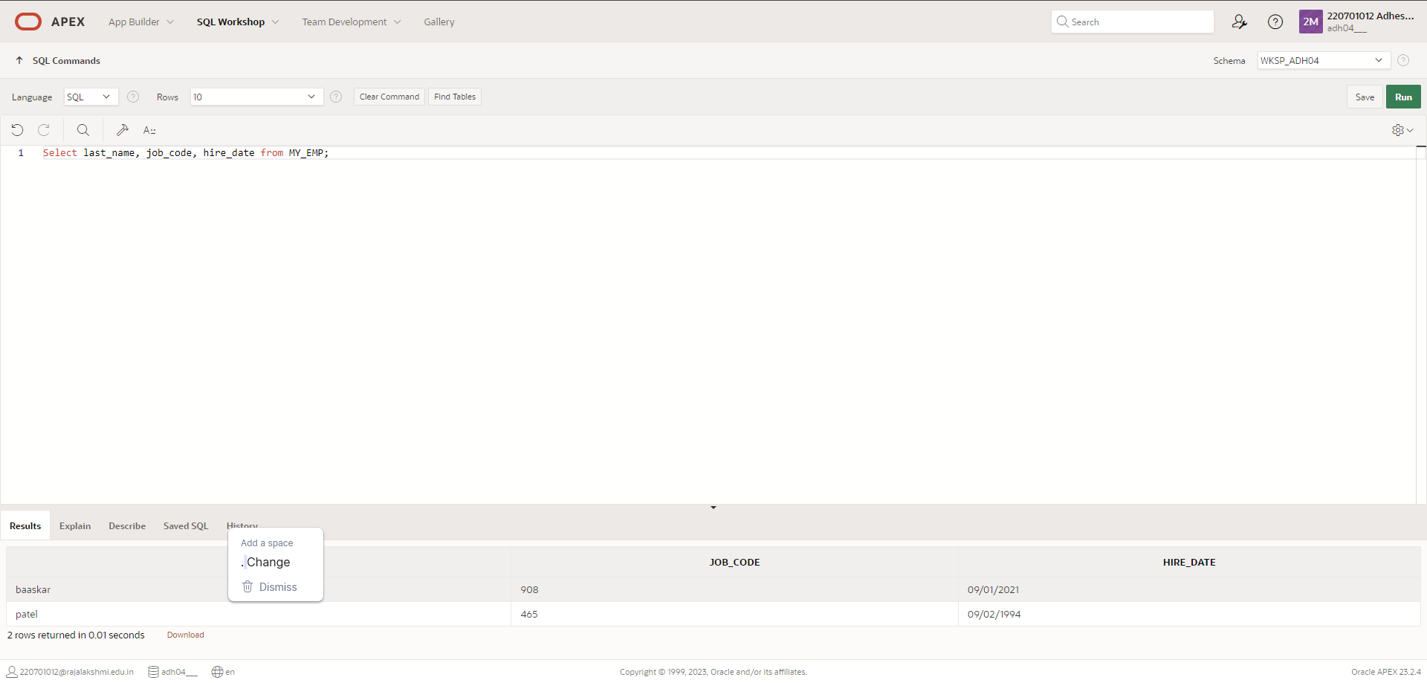

**5.Display the last_name and department number of all employees in departments 20 and 50 in alphabetical order by name.**

**QUERY**: Select last_name, dept_id, from MY_EMP where dept_id IN (20,50) order by last_name;

**OUTPUT**:

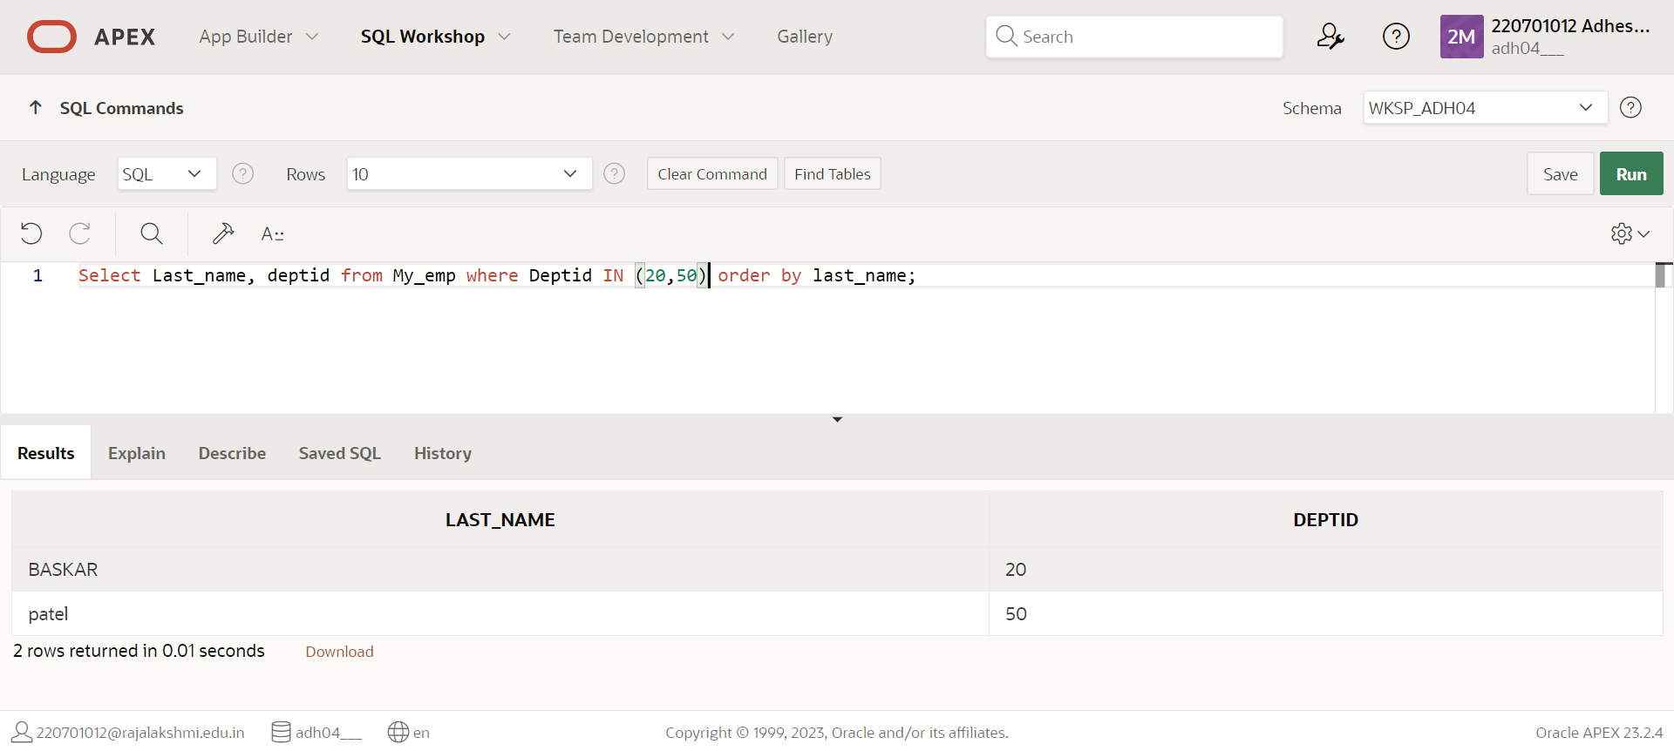

**6.Display the last name and salary of all employees who earn between 5000 and 12000 and are in departments 20 and 50 in alphabetical order by name. Label the columns EMPLOYEE, MONTHLY SALARY respectively.(hints: between, in)**

**QUERY:** elect last_name as “EMPLOYEE”, Salary as “MONTHLY SALARY” from MY_EMP where Salary between 5000 and 12000 and deptid in (20,50) order by last_name;

**OUTPUT**:

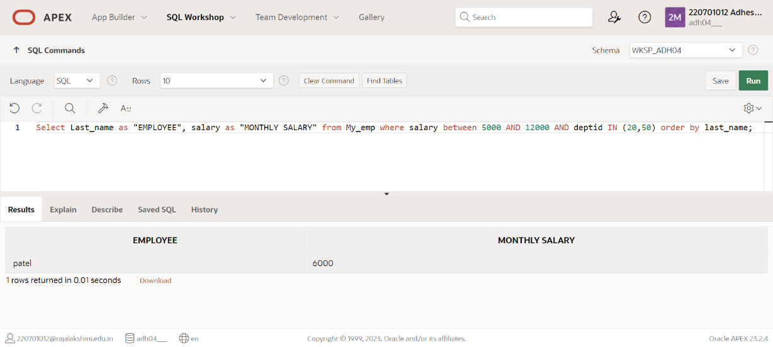

**7.** **Display the last name and hire date of every employee who was hired in 1994.(hints: like)**

**QUERY:** select last_name, hire_date from my_emp where hire_date like ‘%1994’;

**OUTPUT**:

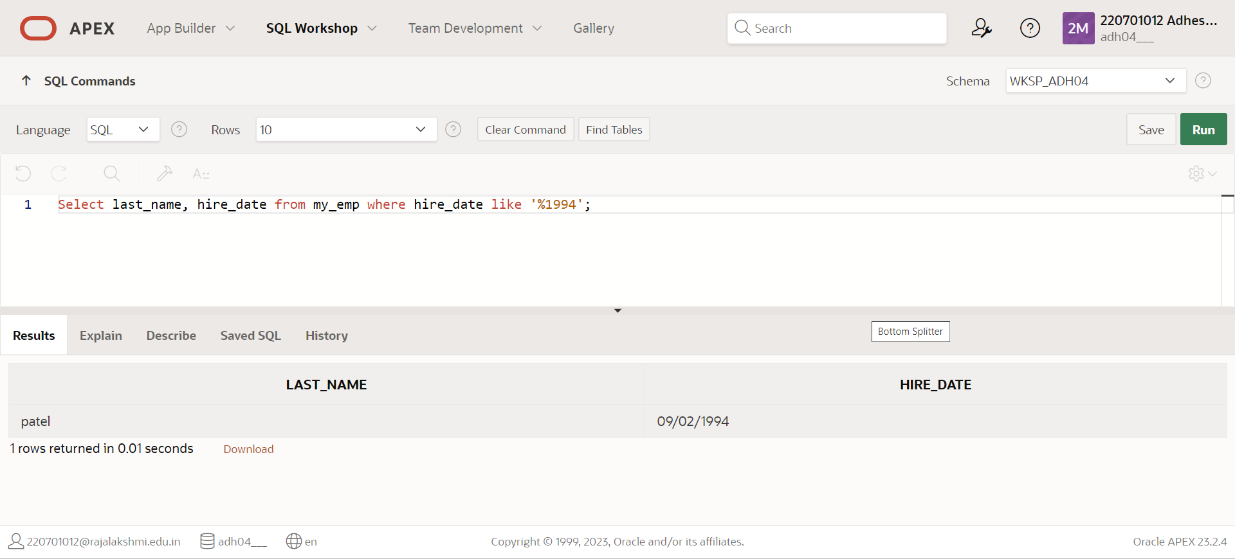

**8.** **Display the last name and job title of all employees who do not have a manager.(hints: is null)**

**QUERY:** Select last_name, job_name from MY_EMP where manager is NULL;

**OUTPUT**:

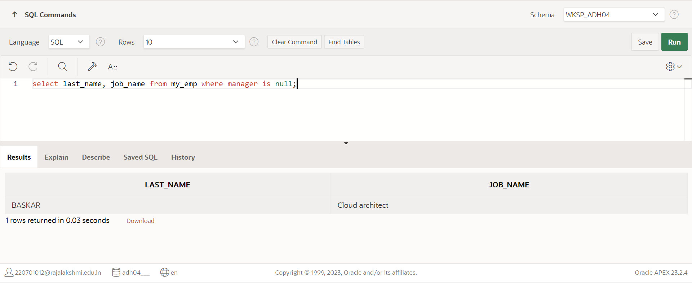

**9. Display the last name, salary, and commission for all employees who earn commissions. Sort data in descending order of salary and commissions.(hints: is not nul,orderby)**

**QUERY:** Select last_name, salary, commission from MY_EMP where commission IS NOT NULL order by Salary, commission desc;

**OUTPUT**:

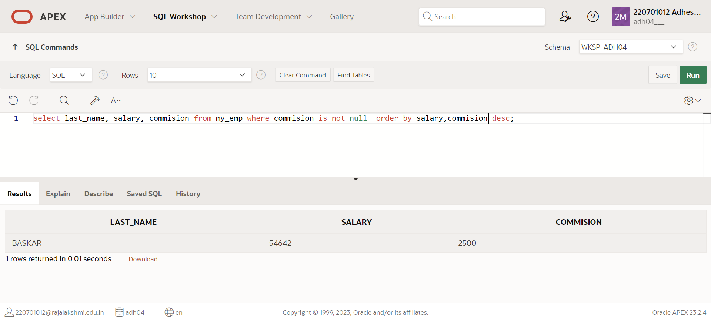

**10. Display the last name of all employees where the third letter of the name is a.(hints:like)**

**QUERY:** Select last_name from my_emp where last_name like ‘%__a%’;

**OUTPUT**:

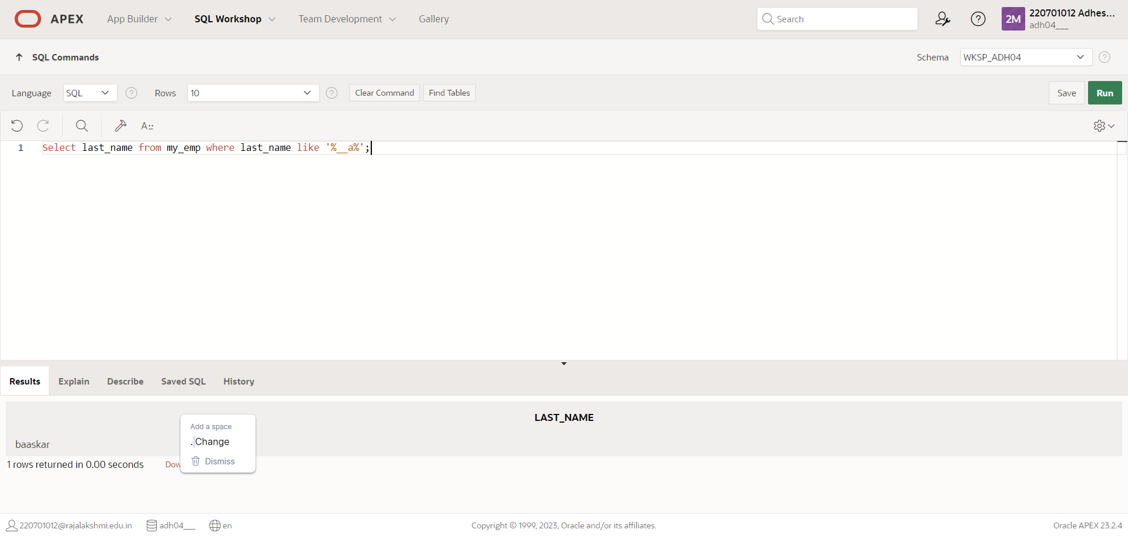

**11. Display the last name of all employees who have an a and an e in their last name.(hints: like)**

**QUERY:** Select last_name from employee where last_name like ‘%a%’ OR last_name like ‘%e%’;

**OUTPUT**:

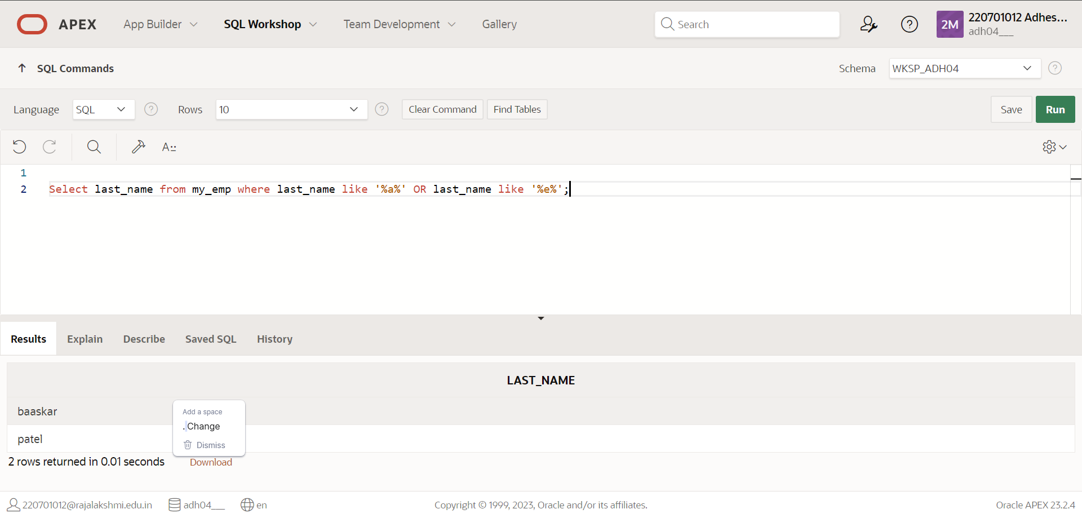

**12. Display the last name and job and salary for all employees whose job is sales representative or stock clerk and whose salary is not equal to 2500 ,3500 or 7000.(hints:in,not in)**

**QUERY:** select last_name, job, salary from my_emp where job in sales OR job IN stock_clerk and salary not in 2500 and salary not in 3500 or salary not in 7000;

**OUTPUT**:

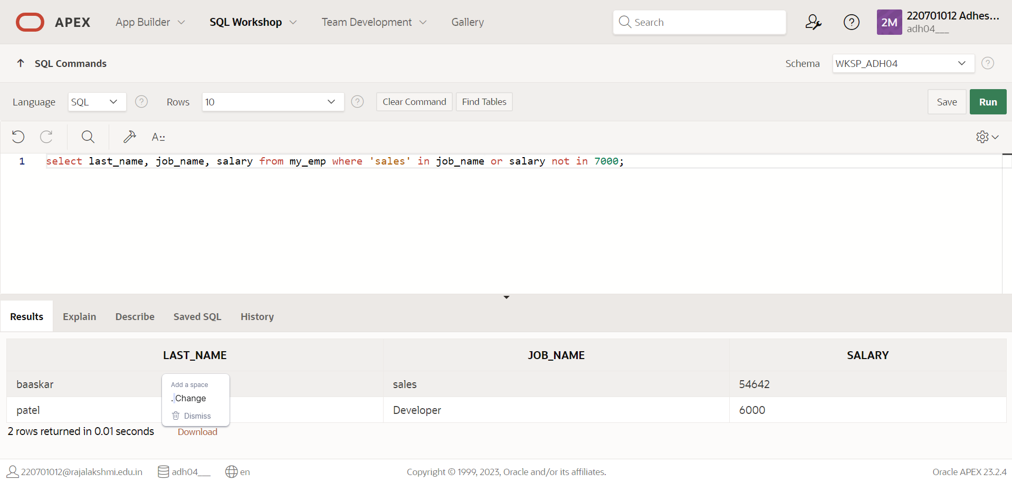

**13. Display the last name, salary, and commission for all employees whose commission amount is 20%.(hints:use predicate logic)**

**QUERY:** select last_name, salary, commission from my_emp;

**OUTPUT**:

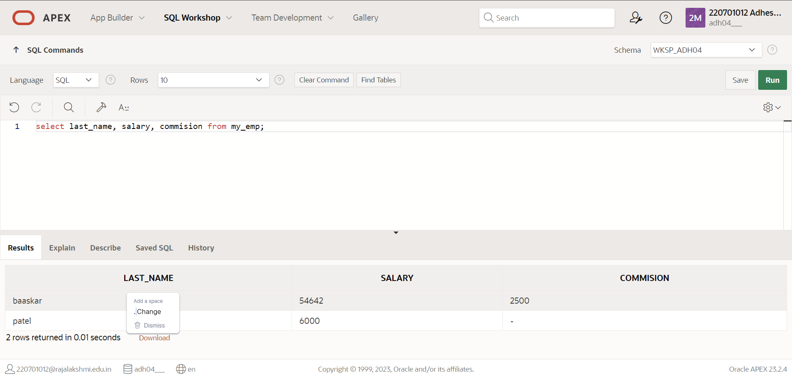

|  |  |
| --- | --- |
| Evaluation Procedure | Marks awarded |
| Query(5) |  |
| Execution (5) |  |
| Viva(5) |  |
| Total (15) |  |
| Faculty Signature |  |

**RESULT**:

**EXNO:6 ISINGLE ROW FUNDT DATE:**

1. **Add a table-level PRIMARY KEY constraint to the EMP table on the ID column.The constraint should be named at creation. Name the constraint my_emp_id_pk.**

**QUERY:** ALTER TABLE My_emp ADD CONSTRAINT my_emp_id_pk PRIMARY KEY(ID);

**OUTPUT:**



**2.Create a PRIMAY** KEY **constraint to the DEPT table using the ID column. The constraint should be named at creation. Name the constraint my_dept_id_pk.**

**QUERY:** CREATE TABLE DEPT(DEPT_ID number(4),deptname varchar(25),CONSTRAINT my_dept_id_pk PRIMARY KEY(DEPT_ID));

**OUTPUT**: 

**3.Add a column DEPT_ID to the EMP table. Add a foreign key reference on the EMP table that ensures that the employee is not assigned to nonexistent deparment. Name the constraint my_emp_dept_id_fk.**

**QUERY:** ALTERTABLE My_emp ADD CONSTRAINT my_emp_dept_id_fk FOREIGN KEY(DEPT_ID) REFERENCES DEPT(DEPT_ID);

**OUTPUT**:



4.Modify the EMP table. Add a COMMISSION column of NUMBER data type, precision 2, scale 2. Add a constraint to the commission column that ensures that a commission value is greater than zero.

QUERY: ALTER TABLE My_emp ADD COMMISION number(2,2);

ALTER TABLE My_emp ADD CONSTRAINT CK1 CHECK(COMMISSION>0);

OUTPUT:



|  |  |
| --- | --- |
| Evaluation Procedure | Marks awarded |
| Query(5) |  |
| Execution (5) |  |
| Viva(5) |  |
| Total (15) |  |
| Faculty Signature |  |

**RESULT:**

**EXNO:7** DISPLAYING DATA FROM MULTIPLE TABLES **DATE**:

**1.Write a query to display the last name, department number, and department name for all employees.**

**QUERY:** Select e.last_name, e.dept_name from my_emp e, department d where e.dept_id=d.dept_id;

**OUTPUT:**

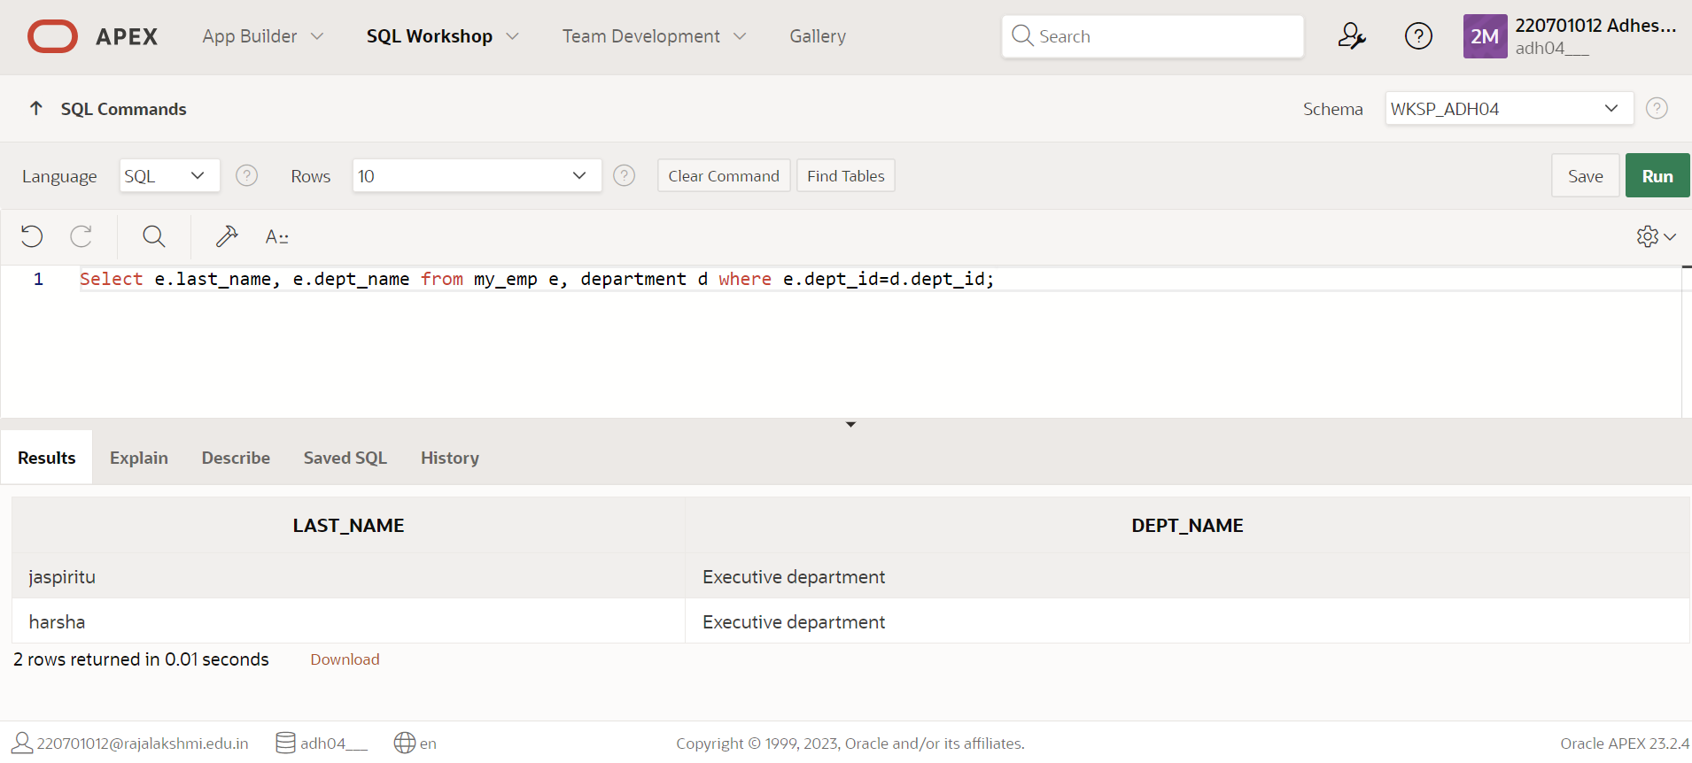

**2.Create a unique listing of all jobs that are in department 80. Include the location of the department in the output**.

**QUERY**: SELECT DISTINCT job_code, location_id FROM My_emp, department WHERE My_emp.dept_id = department.dept_id and My_emp.dept_id=80;

**OUTPUT:**

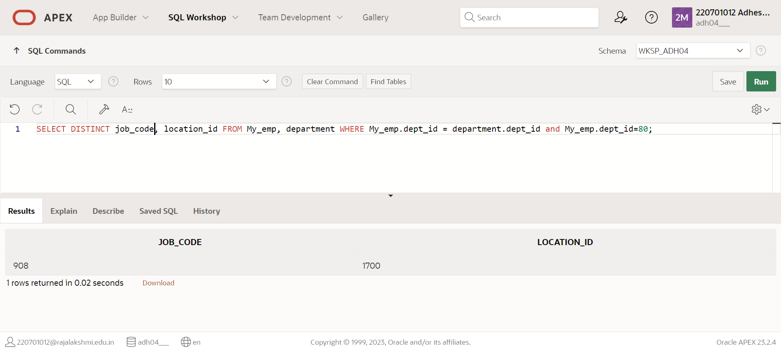

**3. Write a query to display the employee last name, department name, location ID, and city of all employees who earn a commission**

**QUERY:** SELECT My_emp.last_name,My_emp.job_name, My_emp.location_id, My_emp.location FROM My_emp, dept WHERE My_emp.dept_id = dept.dept_id;

**OUTPUT**:

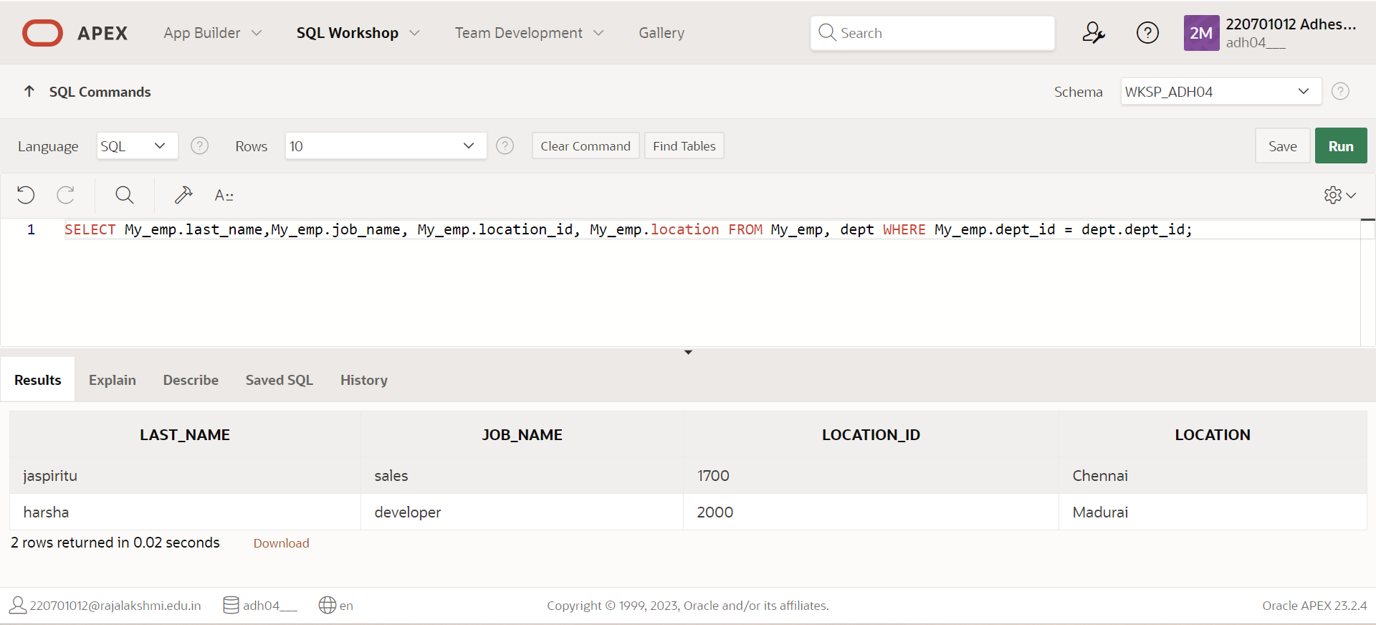

**4. Display the employee last name and department name for all employees who have an**

**a(lowercase) in their last names.**

**QUERY:** SELECT employees.last_name, departments.dept_name FROM employees, departments WHERE employees.dept_id = departments.dept_id AND last_name LIKE '%a%';

**OUTPUT**:

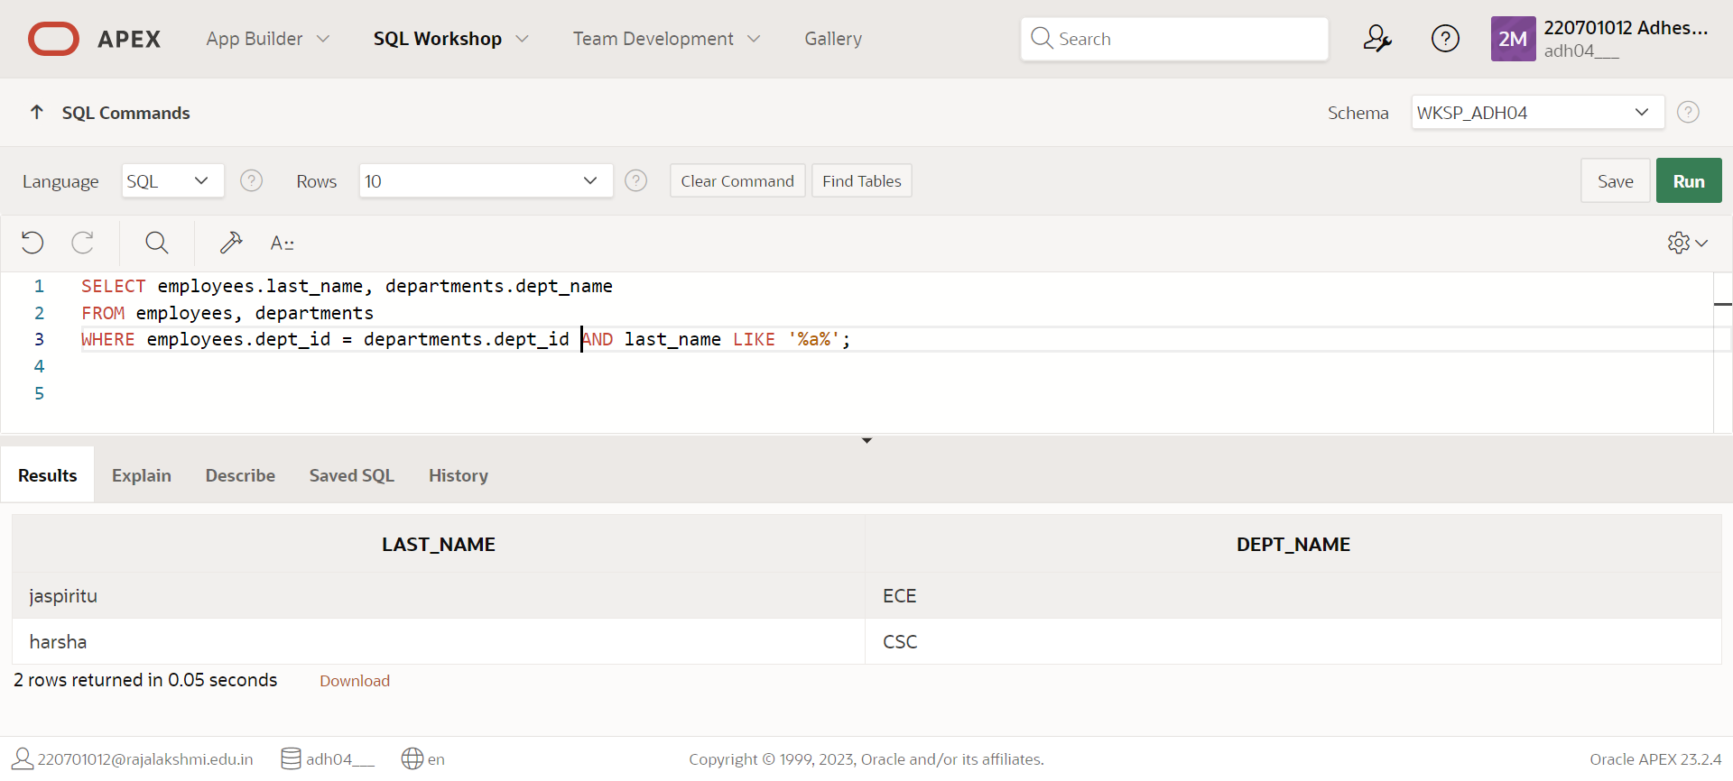

**7. Modify lab4_6.sql to display all employees including King, who has no manager. Order the**

**results by the employee number.**

**QUERY: SELECT e.last_name "Employee", e.emp_id "EMP#", m.last_name "Manager", m.emp_id "Mgr#" FROM employees e LEFT OUTER JOIN employees m ON (e.manager_id = m.emp_id);**

**OUTPUT**:

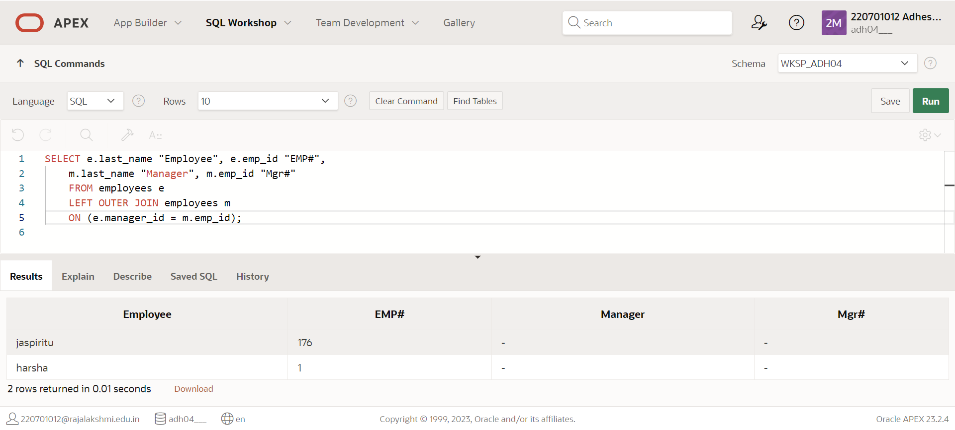

**10. Create a query to display the name and hire date of any employee hired after employee Davies.**

**QUERY:** SELECT e.last_name, e.hire_date FROM employees e, employees davies WHERE davies.last_name = 'Davies' AND davies.hire_date < e.hire_date;

**OUTPUT**:

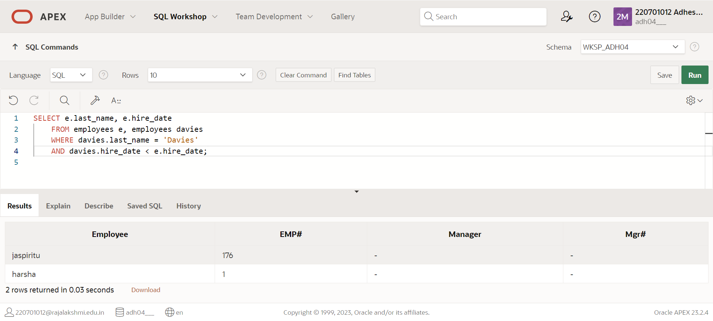

**11. Display the names and hire dates for all employees who were hired before their managers,**

**along with their manager‘s names and hire dates. Label the columns Employee, Emp Hired,**

**Manager, and Mgr Hired, respectively.**

**QUERY: SELECT e.last_name, e.hire_date, m.last_name, m.hire_date FROM employees e, employees m WHERE e.manager_id = m.employee_id AND e.hire_date < m.hire_date;**

**OUTPUT**:

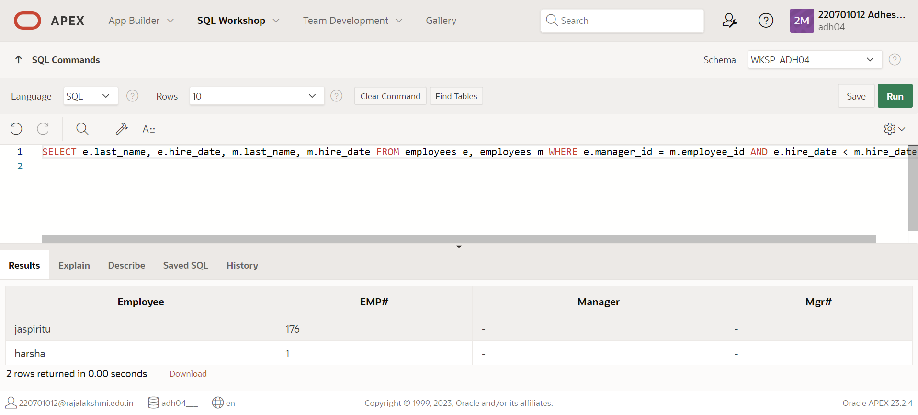

|  |  |
| --- | --- |
| Evaluation Procedure | Marks awarded |
| Query(5) |  |
| Execution (5) |  |
| Viva(5) |  |
| Total (15) |  |
| Faculty Signature |  |

**RESULT**:

# EXNO:8 AGGREGATING DATA USING GROUP FUNCTIONS DATE:

1.Find the highest, lowest, sum, and average salary of all employees. Label the columns Maximum, Minimum, Sum, and Average, respectively. Round your results to the nearest whole number.

QUERY: select max(salary) as "MAXIMUM", min(salary) as"MINIIMUM",sum(salary) as"SUM",round(avg(salary),2) as "average" from My_emp;

OUTPUT:

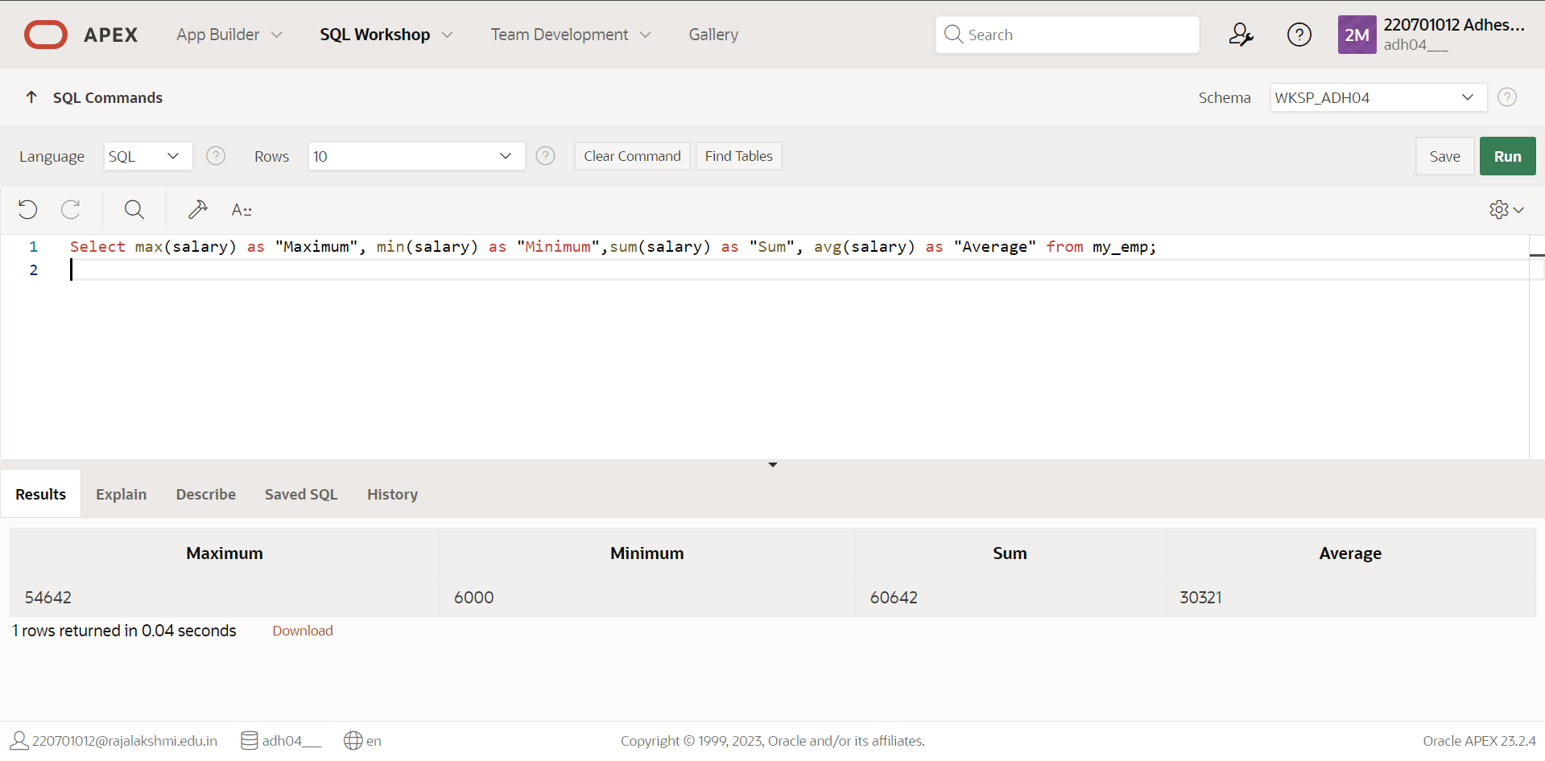

2. Modify the above query to display the minimum, maximum, sum, and

average salary for each job type.

QUERY: select job_title,max(salary) as "MAXIMUM", min(salary) as"MINIIMUM",sum(salary) as"SSUM",round(avg(salary),2) as "average" from My_emp group by job_title;

OUTPUT:

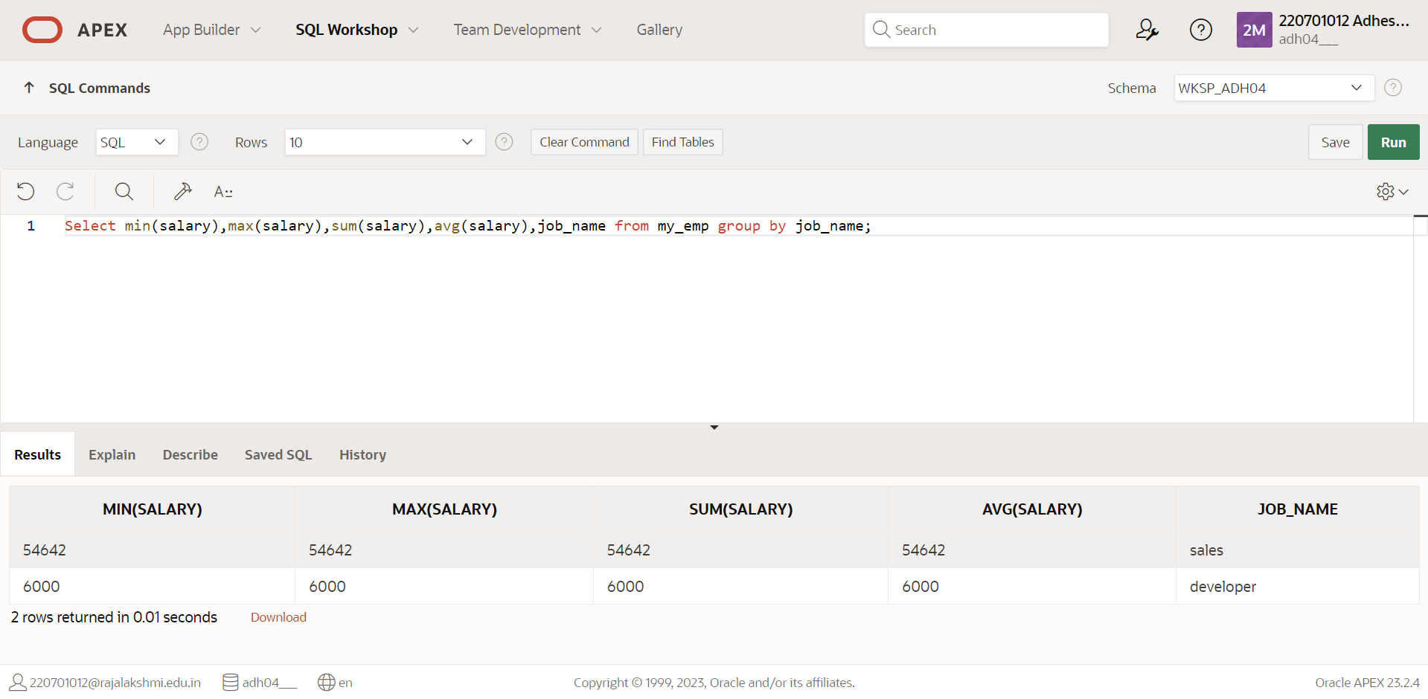

3.  Determine the number of managers without listing them. Label the column Number

of Managers. Hint: Use the MANAGER_ID column to determine the number of

managers.

QUERY: select count(manager) as "Manager" from My_emp;

OUTPUT:

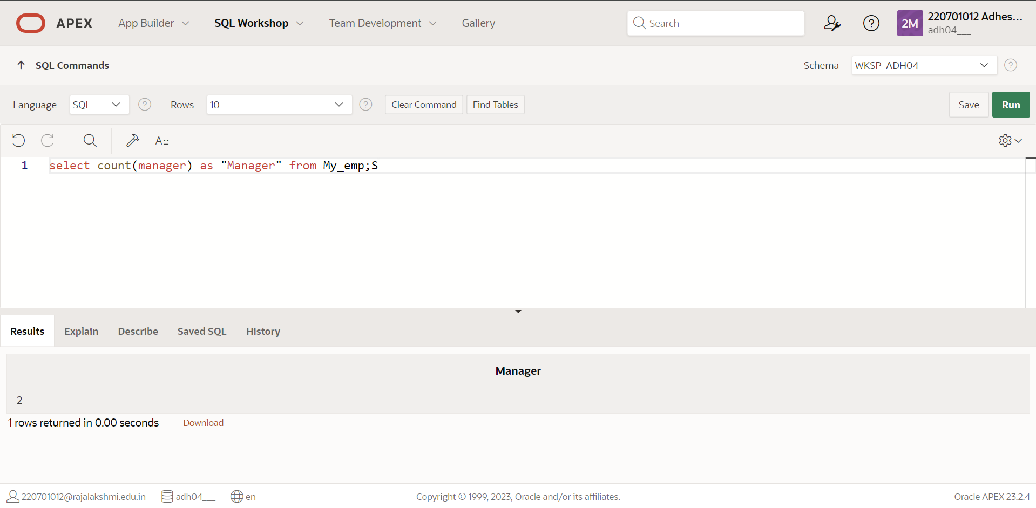

4. Find the difference between the highest and lowest salaries. Label the column

DIFFERENCE

QUERY: select max(salary)-min(salary) as "DIFFERENCE"from My_emp;

OUTPUT:

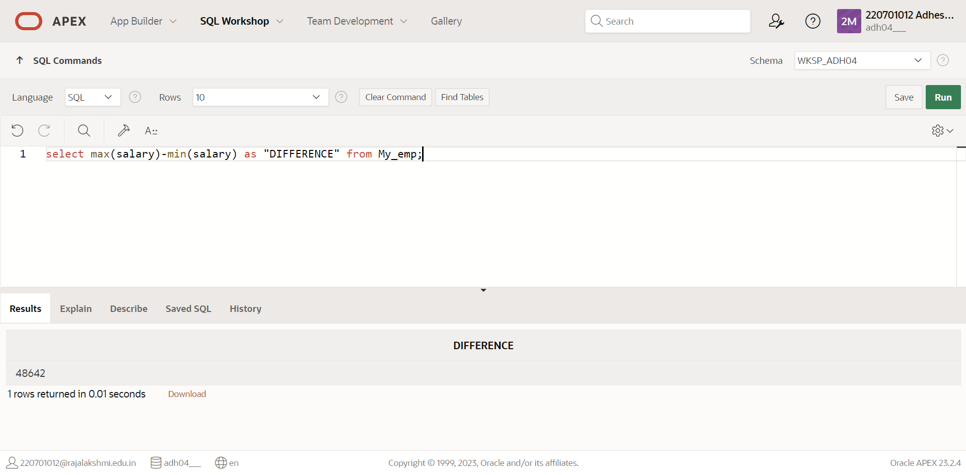

5.Create a report to display the manager number and the salary of the lowest paid employee for that manager. Exclude anyone whose manager is not known. Exclude any groups where the minimum salary is $6000 or less. Sort the output in descending order of salary

QUERY: select working_under, min(salary) from my_emp where working_under is not null;

OUTPUT:

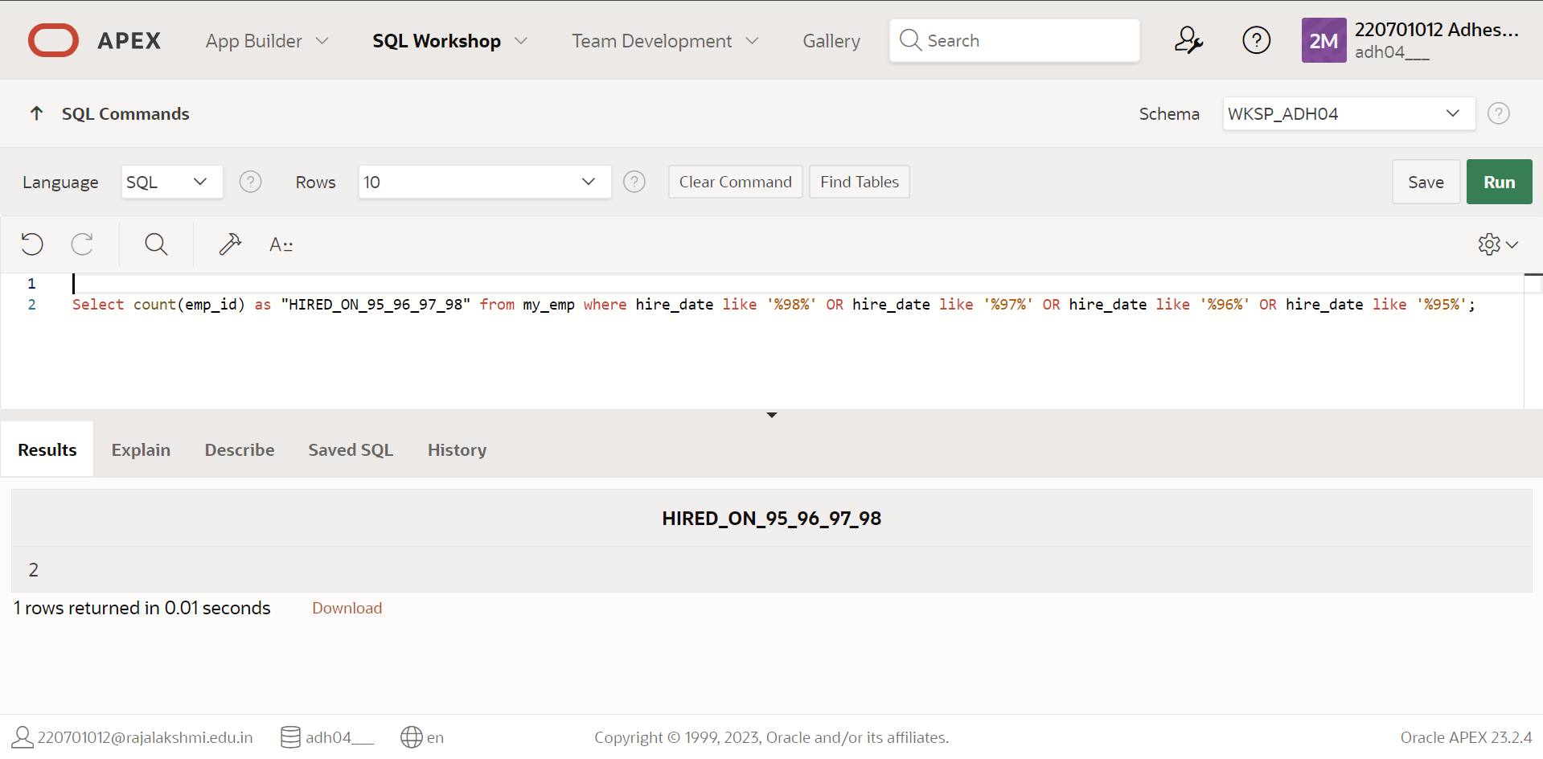

6. Write a query to display each department’s name, location, number of employees and the average salary for all the employees in that department. Name the column name- Location, Number of people and salary respectively. Round the average salary to 2 decimal places.

QUERY: select name, city_name as “location”, no_of_emp as “Number of People”, round(avg_salary,2) as “Average Salary” from dept;

OUTPUT:

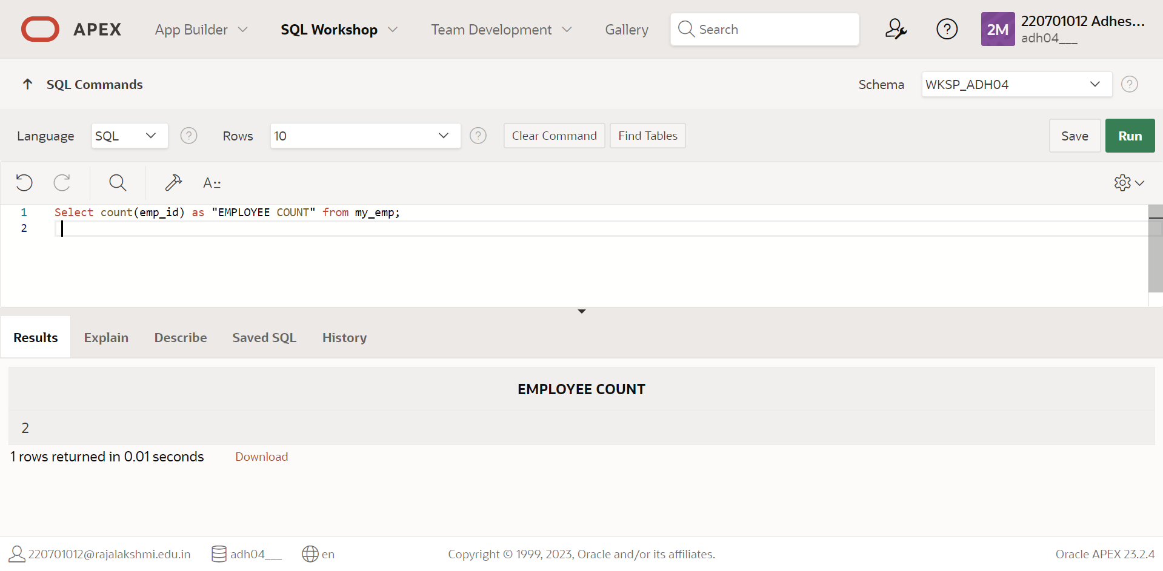

|  |  |
| --- | --- |
| Evaluation Procedure | Marks awarded |
| Query(5) |  |
| Execution (5) |  |
| Viva(5) |  |
| Total (15) |  |
| Faculty Signature |  |

**RESULT:**

**EXNO:9** **SUB QUERIES DATE:**

**1.The HR department needs a query that prompts the user for an employee last name. The query then displays the last name and hire date of any employee in the same department as the employee whose name they supply (excluding that employee). For example, if the user enters Zlotkey, find all employees who work with Zlotkey (excluding Zlotkey)**

**QUERY:** select * from My_emp where last_name='zlotkey';

**OUTPUT:**

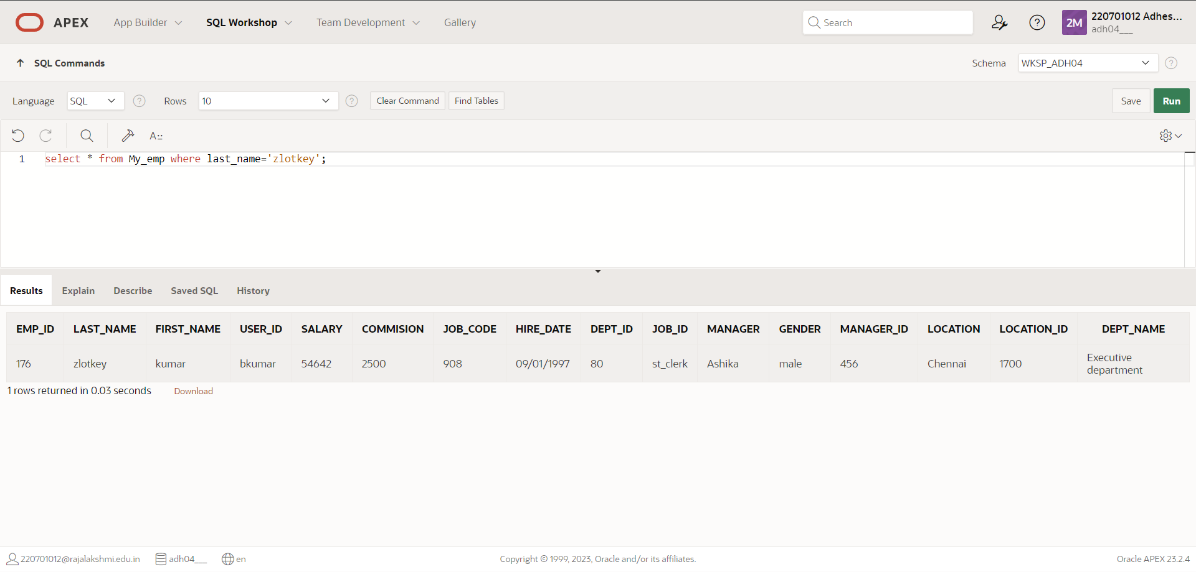

**2.** **Create a report that displays the employee number, last name, and salary of all employees who earn more than the average salary. Sort the results in order of ascending salary**.

**QUERY:** select emp_id, last_name, salary from My_emp where salary > (select avg(salary) from My_emp) order by salary asc;

**OUTPUT**:

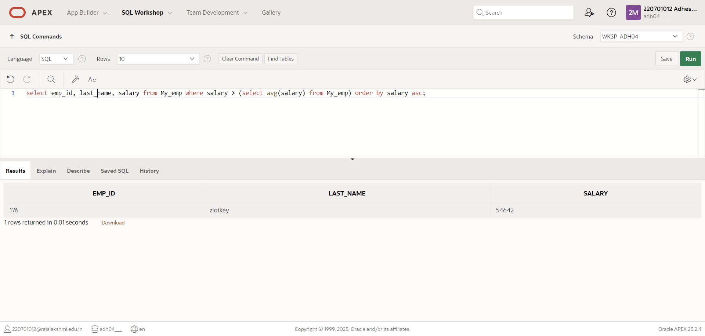

**3. Write a query that displays the employee number and last name of all employees who work in a  department with any employee whose last name contains a *u*.**

**QUERY:** select emp_id,last_name from My_emp where dept_id in(select dept_id from My_emp where last_name like '%u%');

**OUTPUT:**

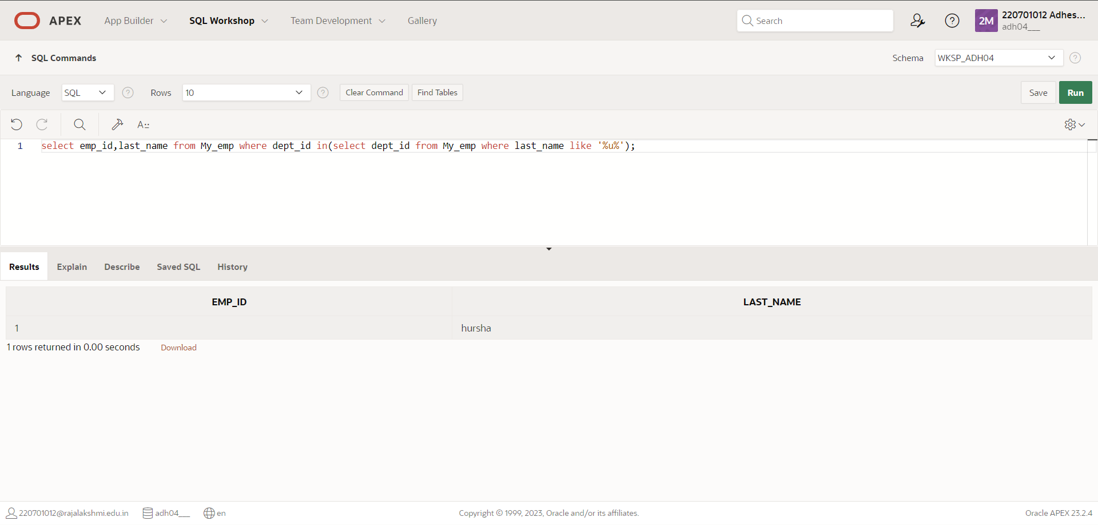

**4. The HR department needs a report that displays the last name, department number, and job ID of all employees whose department location ID is 1700.**

**QUERY:** select emp_id,last_name from my_emp where location_id in(select location_id from My_emp where location_id=1700);

**OUTPUT**:

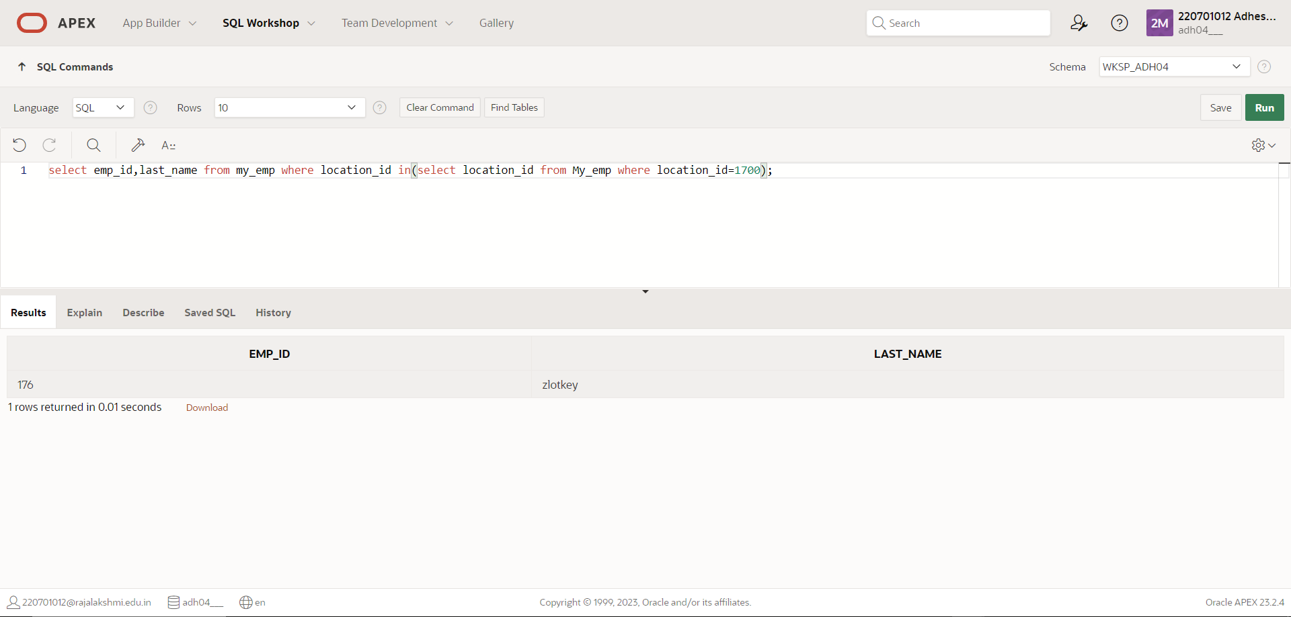

**6. Create a report for HR that displays the department number, last name, and job ID for every employee in the Executive department.**

**QUERY:** select emp_id, last_name, dept_id from My_emp where dept_id in (select dept_id from My_emp where dept_name = 'Executive department');

**OUTPUT**:

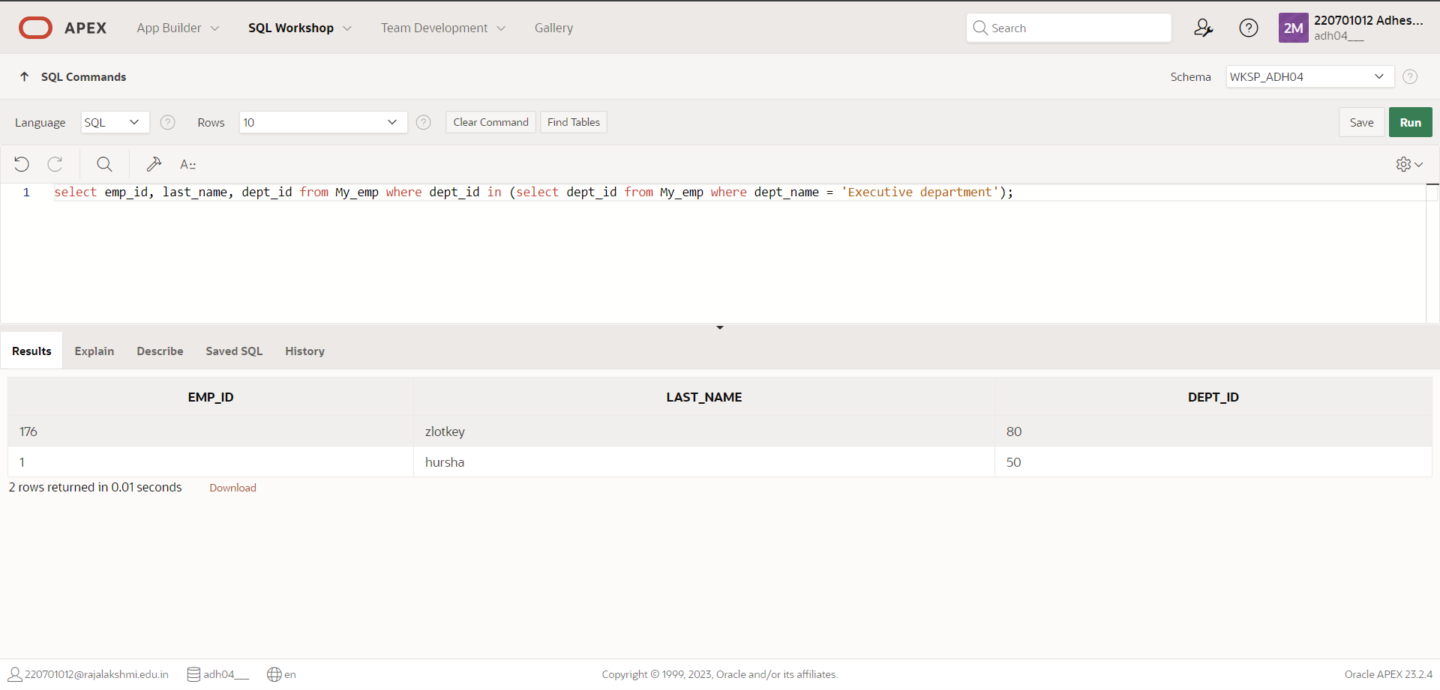

**7. Modify the query 3 to display the employee number, last name, and salary of all employees who earn more than the average salary and who work in a department with any employee whose last name contains a *u*.**

**QUERY:** select emp_id, last_name, salary from My_emp where salary > (select avg(salary) from my_emp) and dept_id in (select dept_id from My_emp where last_name like '%u%');

**OUTPUT:**

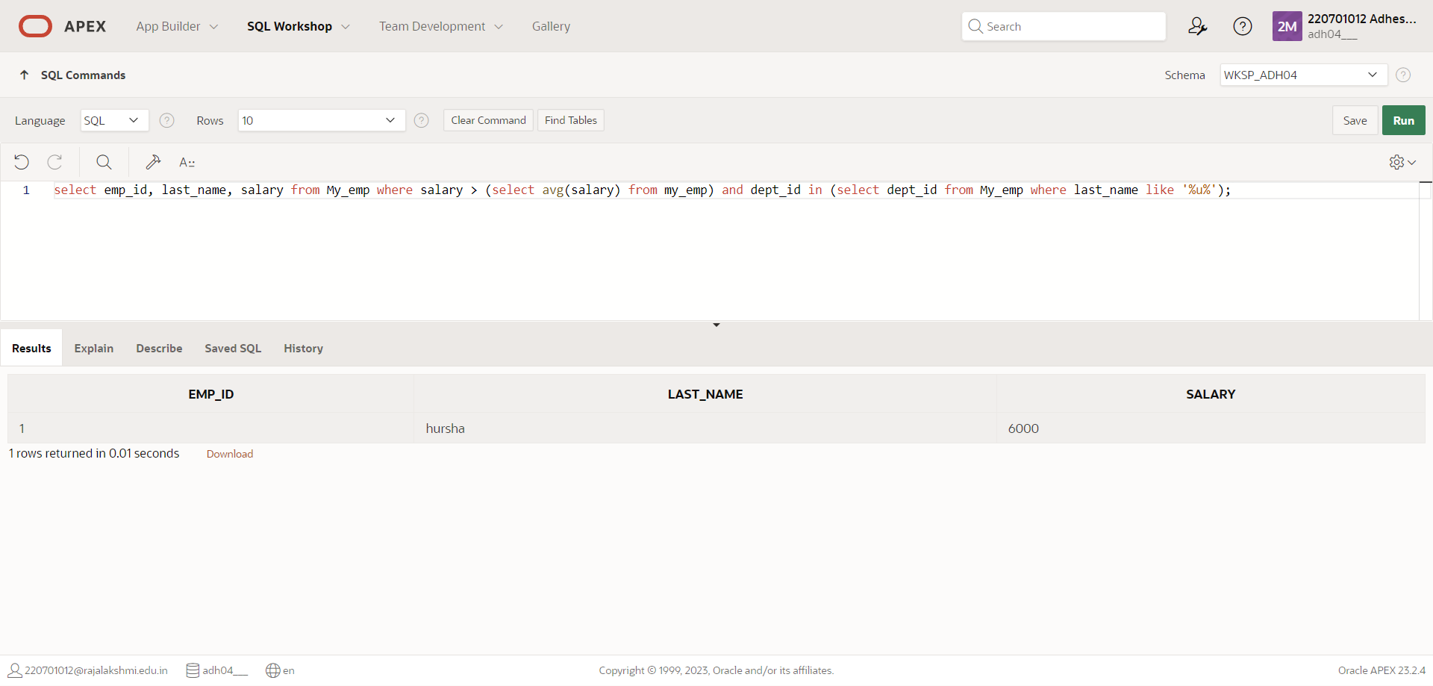

|  |  |
| --- | --- |
| Evaluation Procedure | Marks awarded |
| Query(5) |  |
| Execution (5) |  |
| Viva(5) |  |
| Total (15) |  |
| Faculty Signature |  |

# RESULT:

**EXNO:10** **USING THE SET OPERATORS DATE:**

**1. The HR department needs a list of department IDs for departments that do not contain the job ID ST_CLERK. Use set operators to create this report.**

**QUERY:** SELECT department_id FROM departments cMINUS SELECT department_id FROM employees WHERE job_id = 'st_clerk';

**OUTPUT:**

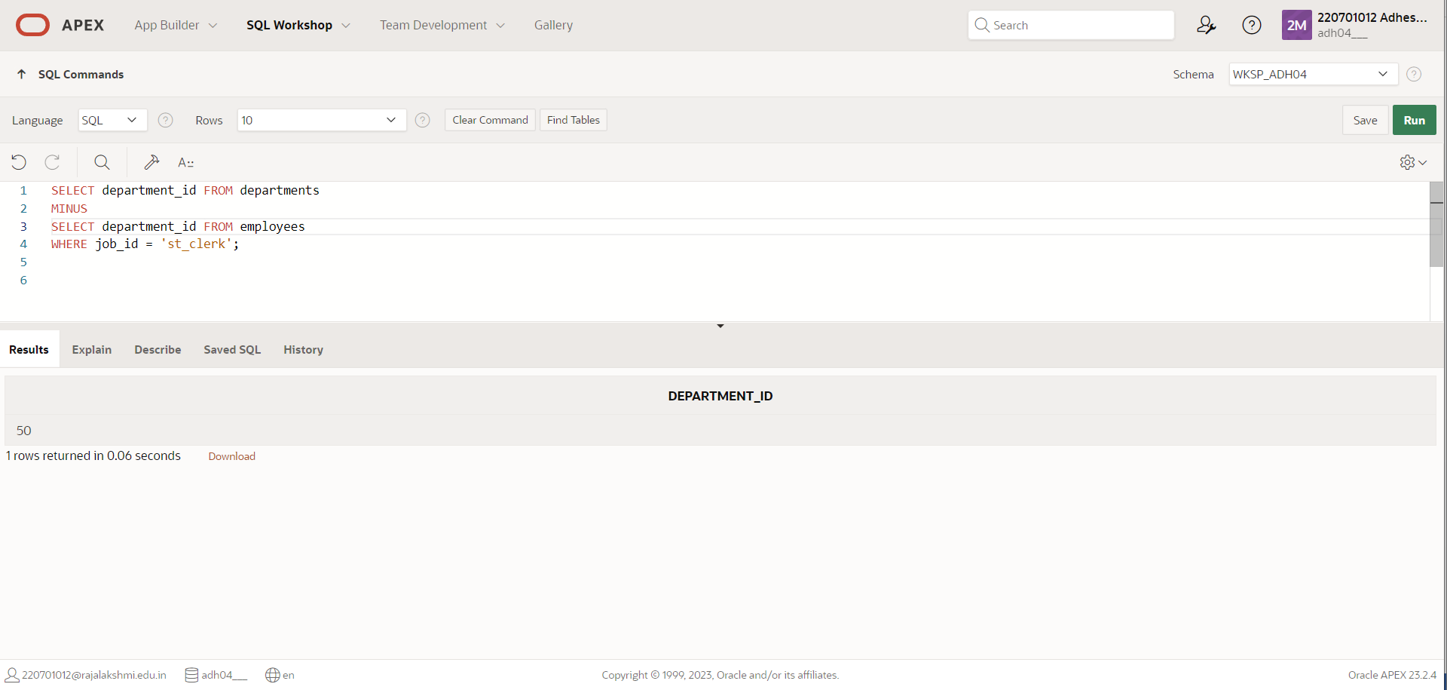

**2.** **Create a report that displays the employee number, last name, and salary of all employees who earn more than the average salary. Sort the results in order of ascending salary**.

**QUERY:** SELECT country_id,country_name FROM countries MINUS SELECT l.country_id,c.country_name FROM locations l, countries c WHERE l.country_id = c.country_id;

**OUTPUT**:

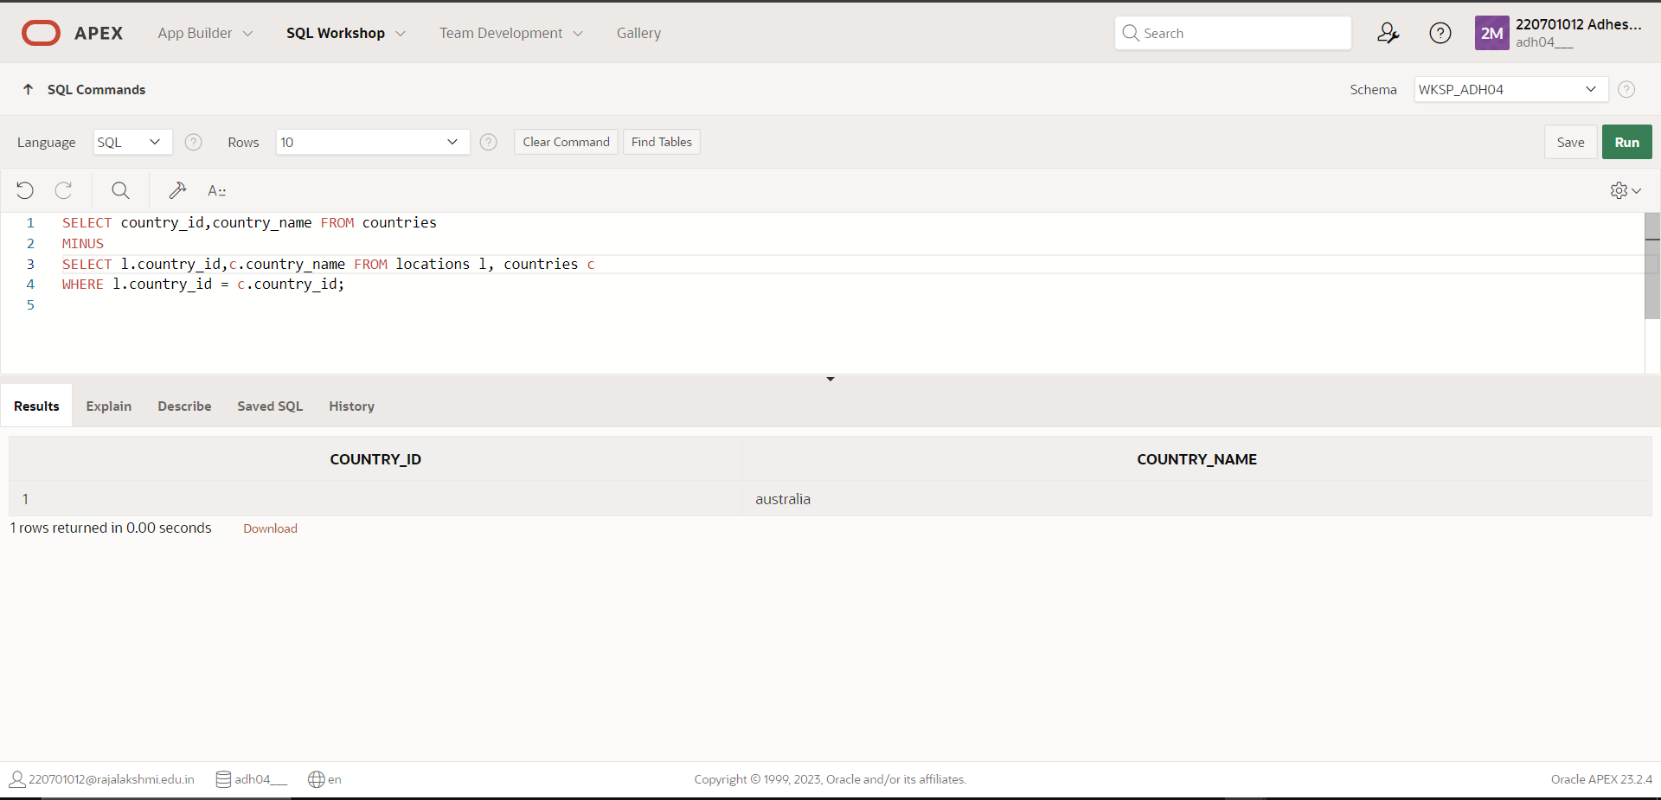\

**3. Produce a list of jobs for departments 10, 50, and 20, in that order. Display job ID and department ID using set operators.**

**QUERY:** SELECT DISTINCT job_code, dept_id FROM employees

WHERE dept_id = 10

UNION ALL

SELECT DISTINCT job_code, dept_id FROM employees

WHERE dept_id = 50

UNION ALL

SELECT DISTINCT job_code, dept_id FROM employees

WHERE dept_id = 20;

**OUTPUT:**

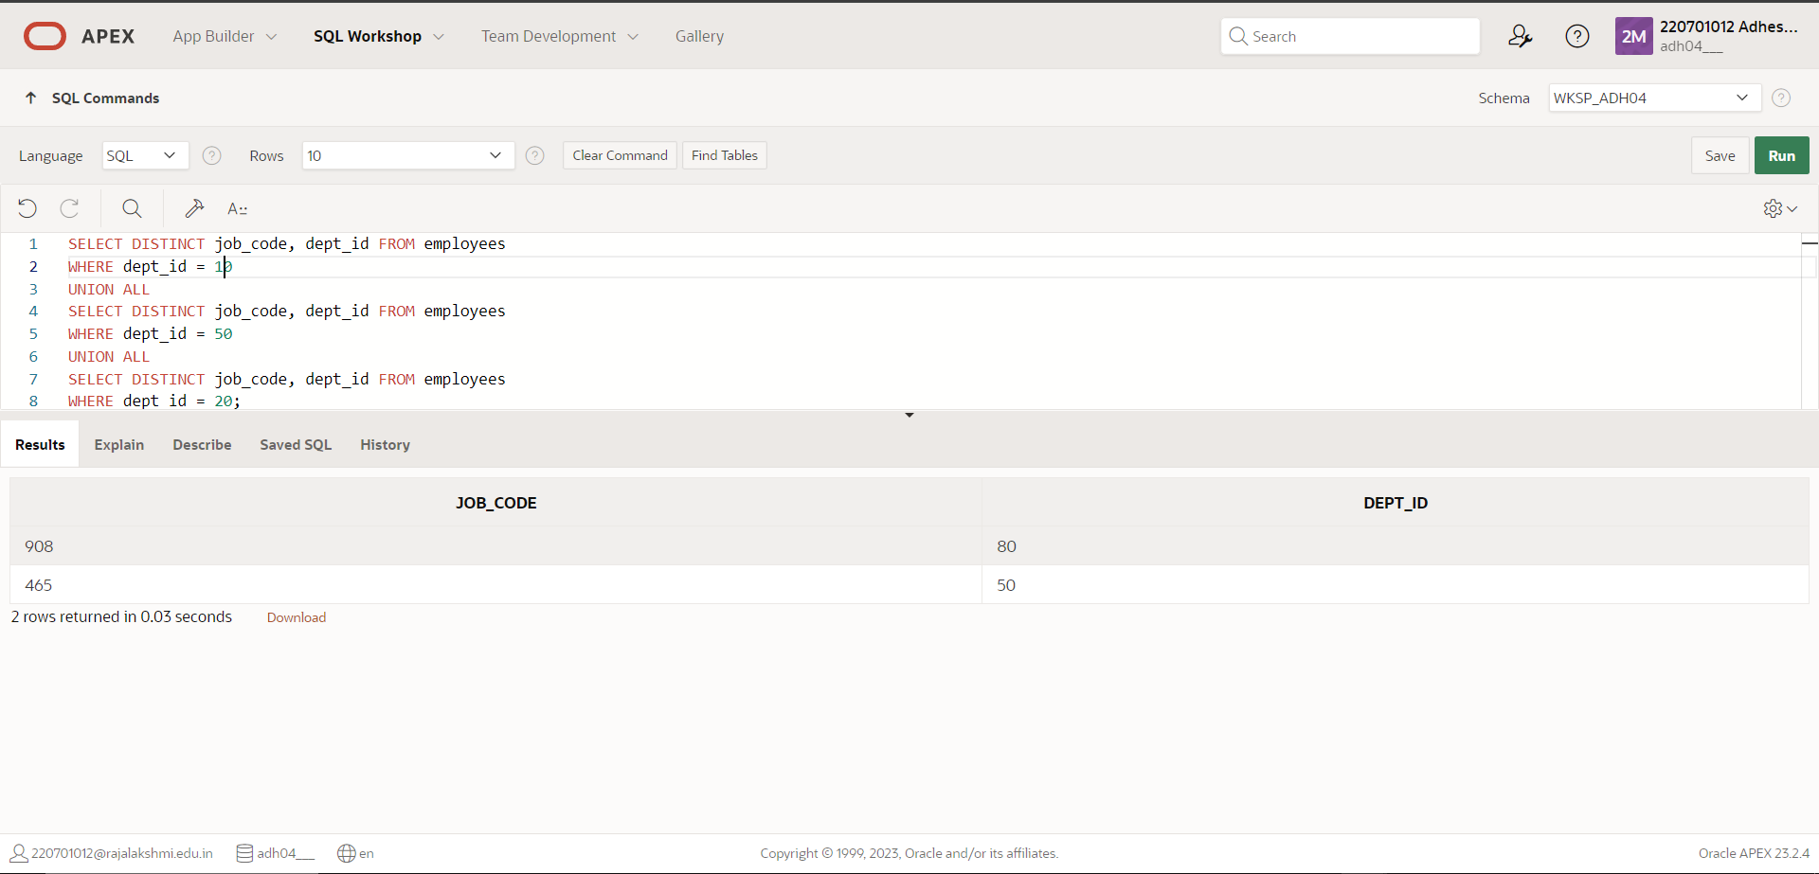

**4. Create a report that lists the employee IDs and job IDs of those employees who**

**currently have a job title that is the same as their job title when they were initially**

**hired by the company (that is, they changed jobs but have now gone back to doing**

**their original job).**

**QUERY:** SELECT emp_id,job_code FROM employees

INTERSECT

SELECT emp_id,job_code FROM employees;

**OUTPUT**:

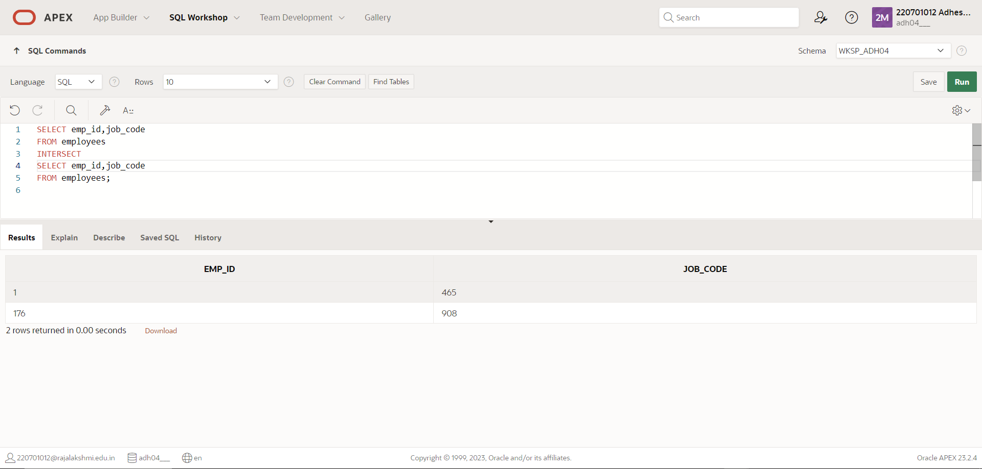

**5. The HR department needs a report with the following specifications:**

**- Last name and department ID of all the employees from the EMPLOYEES table, regardless of**

**whether or not they belong to a department.**

**- Department ID and department name of all the departments from the DEPARTMENTS table,**

**regardless of whether or not they have employees working in them Write a compound query to**

**accomplish this.**

**QUERY:** SELECT last_name,dept_id,TO_CHAR(null) FROM employees

UNION

SELECT TO_CHAR(null),dept_id,dept_name FROM departments;

**OUTPUT**:

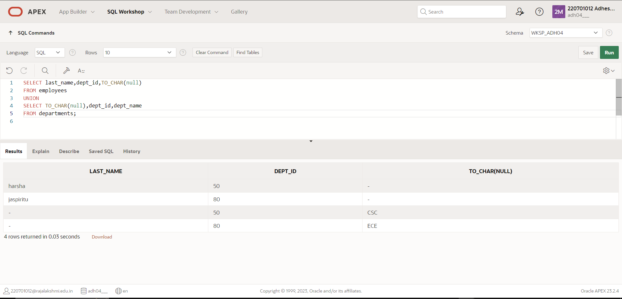

|  |  |
| --- | --- |
| Evaluation Procedure | Marks awarded |
| Query(5) |  |
| Execution (5) |  |
| Viva(5) |  |
| Total (15) |  |
| Faculty Signature |  |

# RESULT:

# 

# EXNO:11 CREATING VIEWS DATE:

1.Create a view called EMPLOYEE_VU based on the employee numbers, employee names and department numbers from the EMPLOYEES table. Change the heading for the employee name to EMPLOYEE.

QUERY: create view employee_vu as select emp_id,last_name EMPLOYEE,dept_id from my_emp;

OUTPUT:

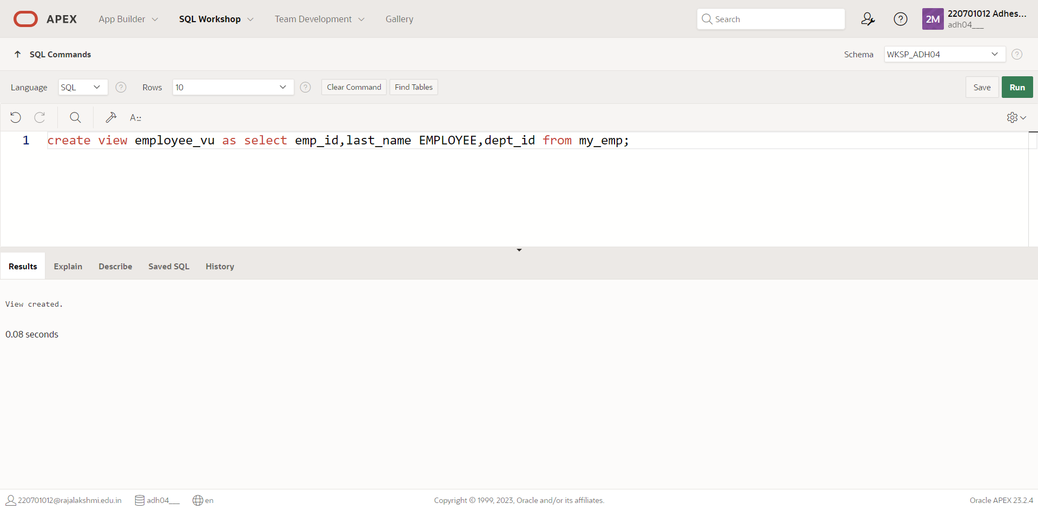

2.Display the contents of the EMPLOYEES_VU view.

QUERY: select * from employee_vu;

OUTPUT:

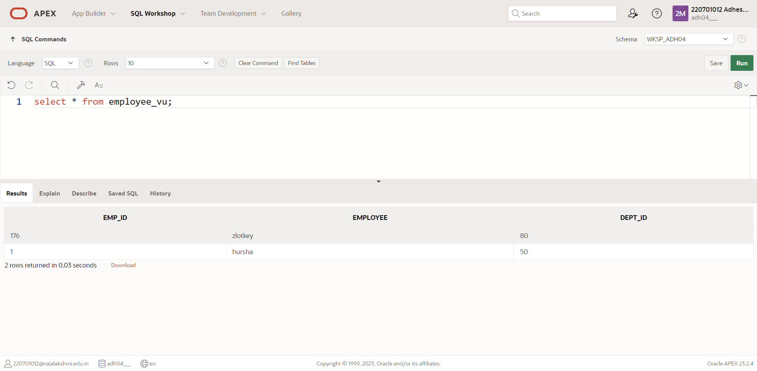

3.Using your EMPLOYEES_VU view, enter a query to display all employees names and department.

QUERY: select employee, dept_id from employee_vu;

OUTPUT:

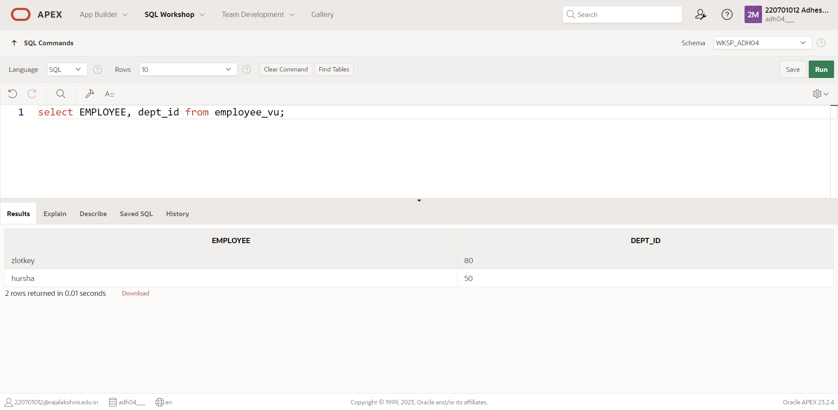

4.Create a view named DEPT50 that contains the employee number, employee last names and department numbers for all employees in department 50.Label the view columns EMPNO, EMPLOYEE and DEPTNO. Do not allow an employee to be reassigned to another department through the view.

QUERY: create view DEPT50 as select emp_id EMPNO,last_name EMPLOYEE,dept_id DEPTNO from my_emp where dept_id=50;

OUTPUT:

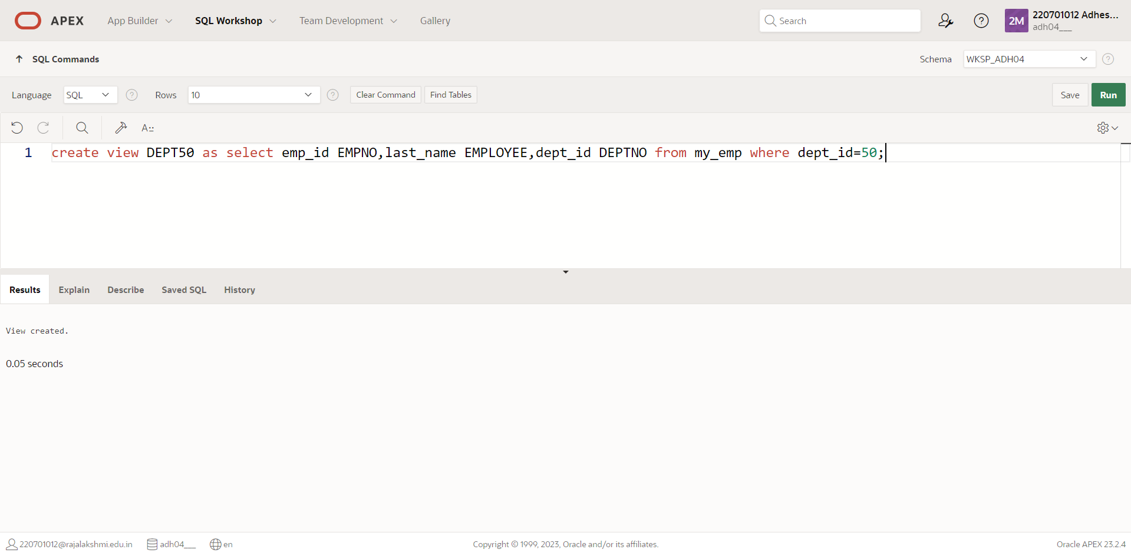

5.Display the structure and contents of the DEPT50 view.

QUERY: select * from dept50;

OUTPUT:

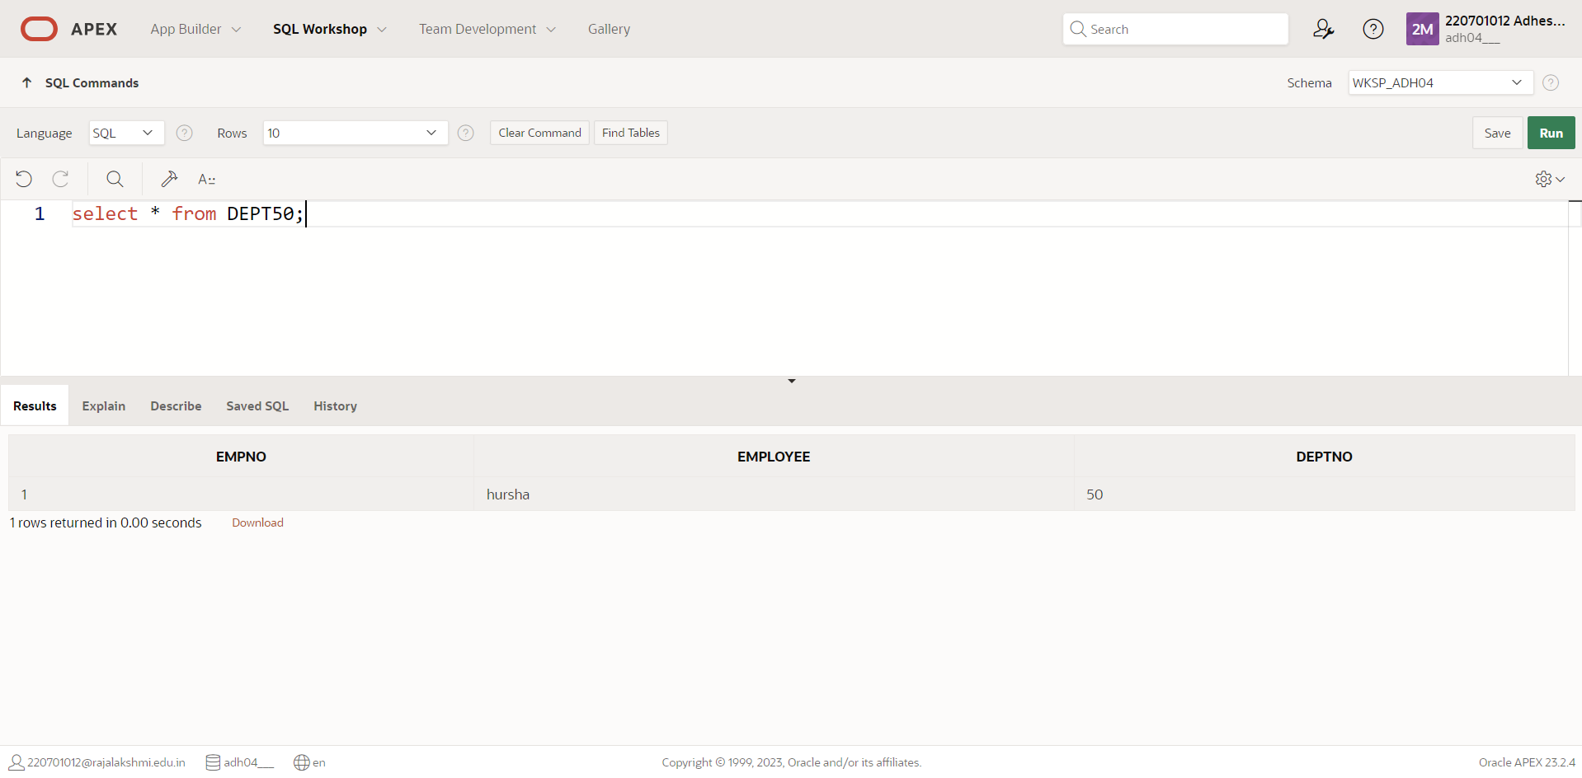

6.Attempt to reassign Matos to department 80.

QUERY: update dept50 set deptno=80 where employee='Matos';

OUTPUT:

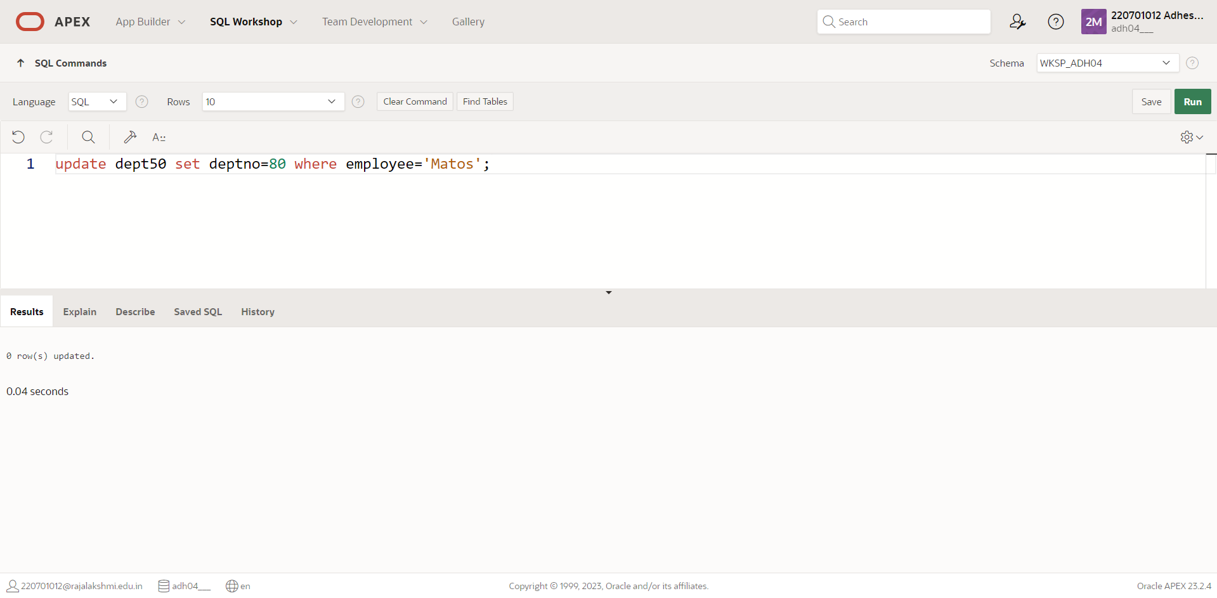

7.Create a view called SALARY_VU based on the employee last names, department names, salaries, and salary grades for all employees. Use the Employees, DEPARTMENTS and JOB_GRADE tables. Label the column Employee, Department, salary, and Grade respectively.

QUERY: create view salary_vu as select lname EMPLOYEE, dept_name DEPARTMENT, salary SALARY, sal_grade GRADE from my_emp;

OUTPUT:

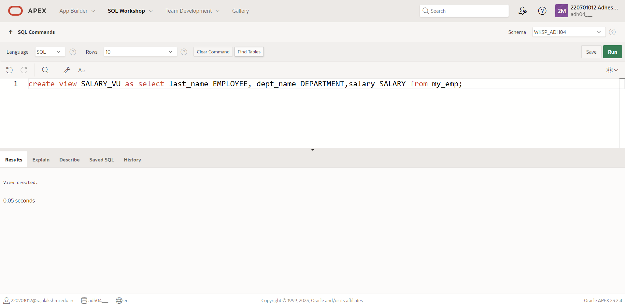

|  |  |
| --- | --- |
| Evaluation Procedure | Marks awarded |
| Query(5) |  |
| Execution (5) |  |
| Viva(5) |  |
| Total (15) |  |
| Faculty Signature |  |

RESULT:

**EXNO:12 INTRO TO CONSTRAINTS DATE:**

**NOT NULL AND UNIQUE CONSTRAINTS**

**6.Write the CREATE TABLE statement for the Global Fast Foods locations table to define the**

**constraints at the column level.**

**QUERY**: CREATE TABLE f_global_locations( id NUMBER(6,0) CONSTRAINT f_gln_id_pk PRIMARY KEY ,name VARCHAR2(50),

date_opened DATE CONSTRAINT f_gln_dt_opened_nn NOT NULL ENABLE,

address VARCHAR2(50) CONSTRAINT f_gln_add_nn NOT NULL ENABLE,

city VARCHAR2(30) CONSTRAINT f_gln_city_nn NOT NULL ENABLE,

zip_postal_code VARCHAR2(12),

phone VARCHAR2(20),

email VARCHAR2(75) CONSTRAINT f_gln_email_uk UNIQUE, manager_id NUMBER(6,0), emergency_contact VARCHAR2(20) );

**OUTPUT**:

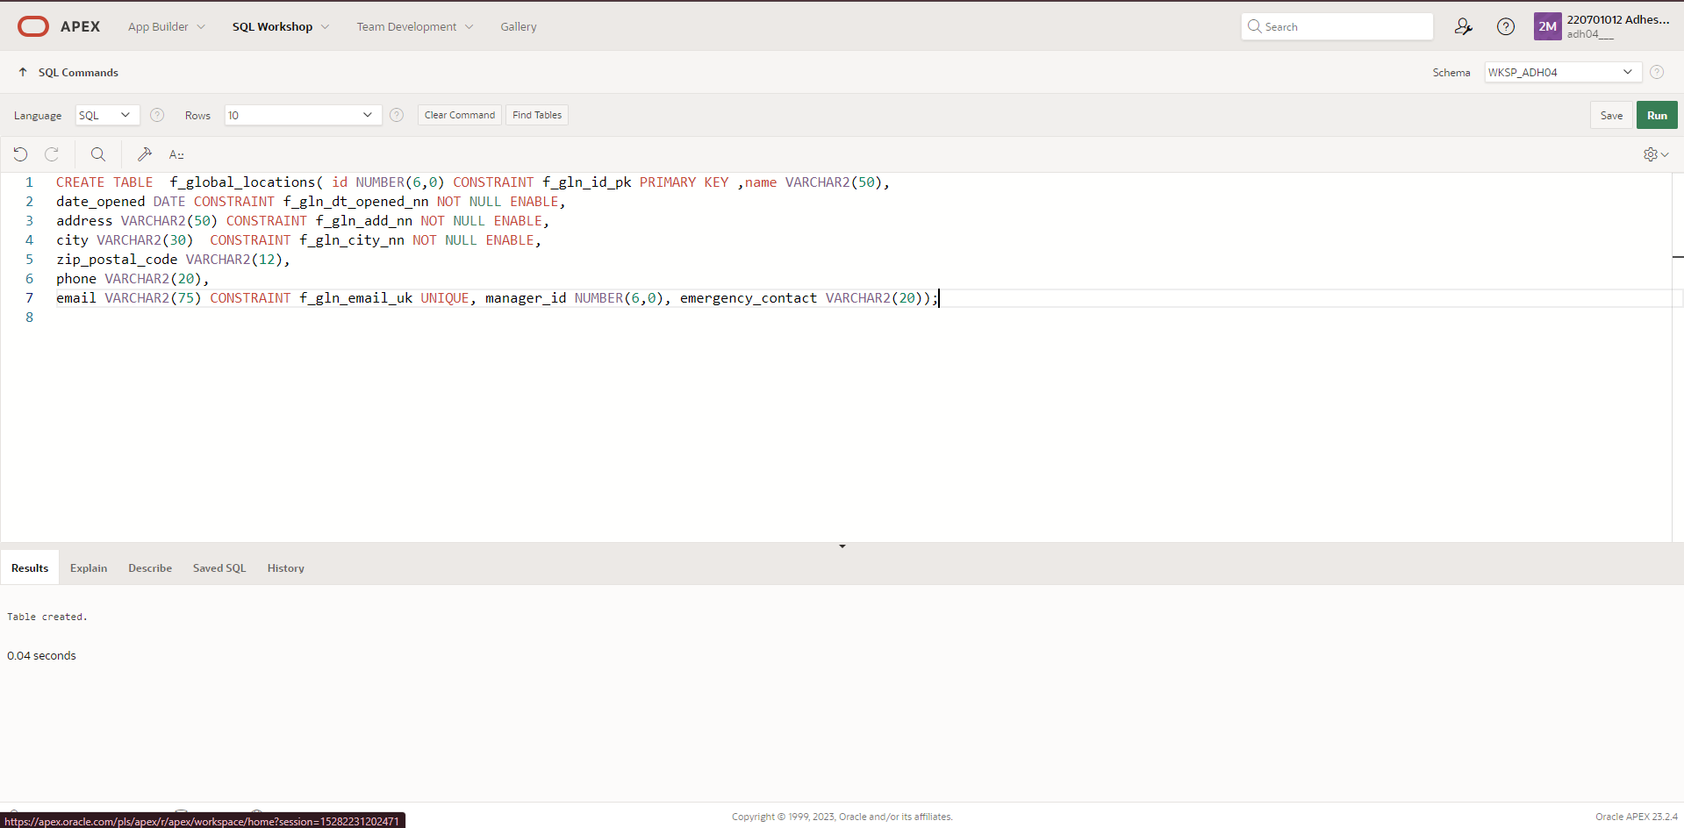

**8.Execute a DESCRIBE command to view the Table Summary information.**

**QUERY**: DESCRIBE f_global_locations;

**OUTPUT**: 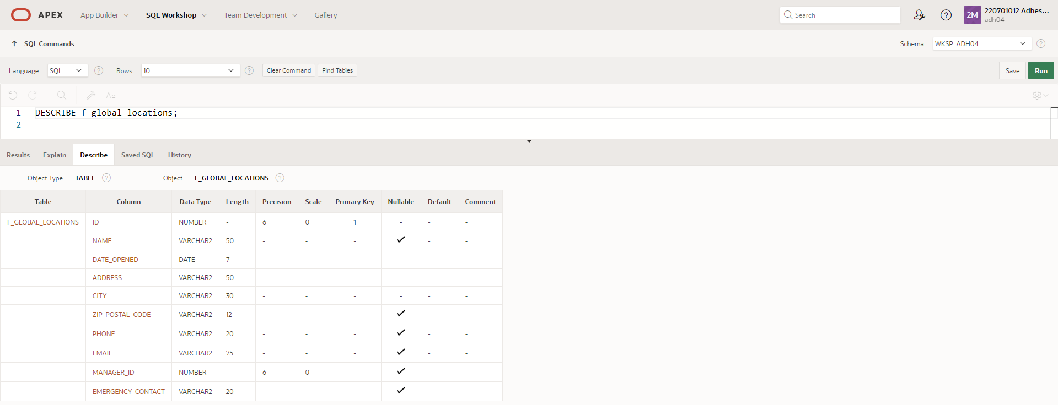

**9. Rewrite the CREATE TABLE statement for the Global Fast Foods locations table to define the UNIQUE constraints at the table level. Do not execute this statement.**

**QUERY**: CREATE TABLE f_global_locations

( id NUMBER(6,0) CONSTRAINT f_gln_id_pk PRIMARY KEY ,

name VARCHAR2(50),

date_opened DATE CONSTRAINT f_gln_dt_opened_nn NOT NULL ENABLE,

address VARCHAR2(50) CONSTRAINT f_gln_add_nn NOT NULL ENABLE,

city VARCHAR2(30) CONSTRAINT f_gln_city_nn NOT NULL ENABLE,

zip_postal_code VARCHAR2(12),

phone VARCHAR2(20),

email VARCHAR2(75) ,

manager_id NUMBER(6,0),

emergency_contact VARCHAR2(20),

CONSTRAINT f_gln_email_uk UNIQUE(email));

**PRIMARY KEY, FOREIGN KEY, AND CHECK CONSTRAINTS**

**3. Create the animals table. Write the syntax you will use to create the table.**

**QUERY**: CREATE TABLE animals

(animal_id NUMBER(6,0) CONSTRAINT anl_id_pk PRIMARY KEY ,

name VARCHAR2(25),

license_tag_number NUMBER(10,0) CONSTRAINT anl_l_tag_num_uk UNIQUE,

admit_date DATE CONSTRAINT anl_adt_dat_nn NOT NULL ENABLE,

adoption_id NUMBER(5,0),

vaccination_date DATE CONSTRAINT anl_vcc_dat_nn NOT NULL ENABLE);

**OUTPUT**: 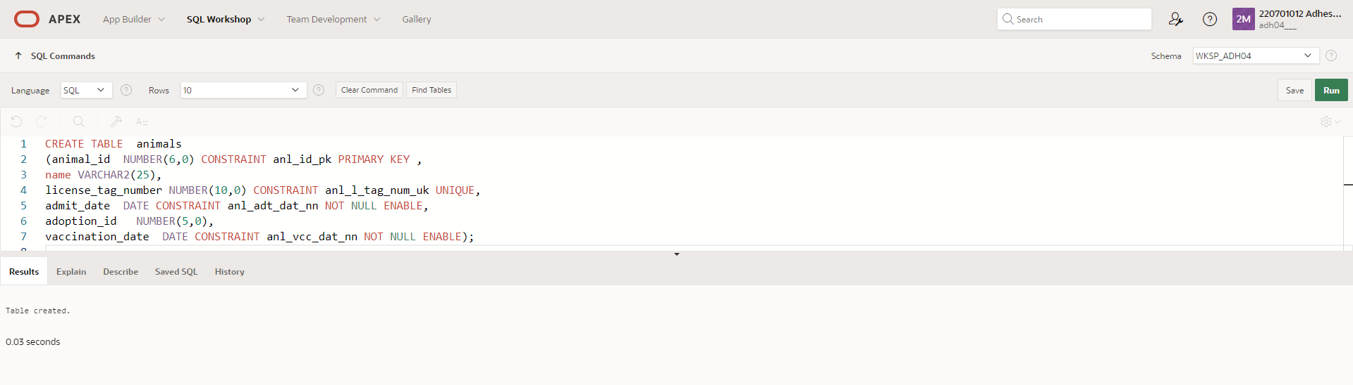

**4.Enter one row into the table. Execute a SELECT * statement to verify your input. Refer to the**

**graphic below for input.**

**QUERY**: INSERT INTO ANIMALS (ANIMAL_ID, NAME, LICENSE_TAG_NUMBER, ADMIT_DATE, ADOPTION_ID, VACCINATION_DATE)

VALUES (101, 'Spot', 35540, '10-10-2004', 205, '10-12-2004');

**OUTPUT**:

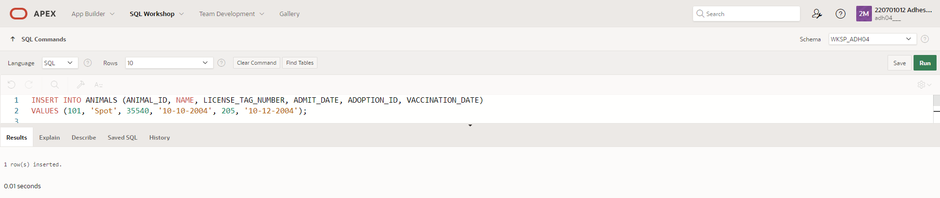

|  |  |
| --- | --- |
| Evaluation Procedure | Marks awarded |
| Query(5) |  |
| Execution (5) |  |
| Viva(5) |  |
| Total (15) |  |
| Faculty Signature |  |
|  |  |

# RESULT:

**EXNO:13** **CREATING VIEWS** **DATE:**

**1.Create a simple view called view_d_songs that contains the ID, title and artist from the DJs on Demand table for each “New Age” type code. In the subquery, use the alias “Song Title” for the title column.**

**QUERY:**  CREATE VIEW view_d_songs AS SELECT id, title as "Song Title",artist from d_songs;

**OUTPUT:**

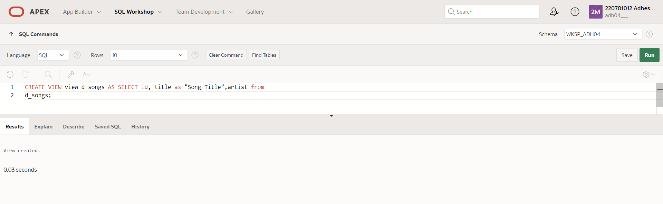

**2. SELECT * FROM view_d_songs. What was returned?**

**QUERY:** select * from d_songs;

**OUTPUT**:

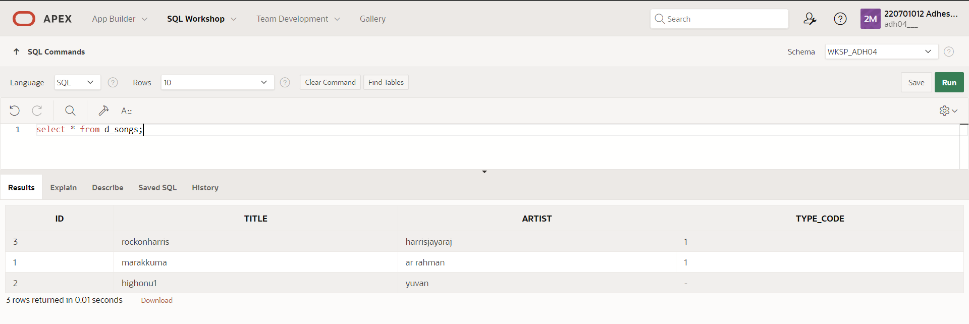

**3. REPLACE view_d_songs. Add type_code to the column list. Use aliases for all columns.**

**QUERY:** CREATE OR REPLACE VIEW view_d_songs AS SELECT d_songs.id, d_songs.title "Song Title", d_songs.artist, d_songs.type_code from d_songs;

**OUTPUT**:

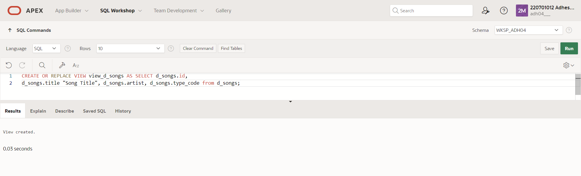

**4. Jason Tsang, the disk jockey for DJs on Demand, needs a list of the past events and those planned for the coming months so he can make arrangements for each event’s equipment setup. As the company manager, you do not want him to have access to the price that clients paid for their events. Create a view for Jason to use that displays the name of the event, the event date, and the theme description. Use aliases for each column name.**

**QUERY:** CREATE OR REPLACE VIEW view_d_events_pkgs AS SELECT d_name as "Name of Event", TO_CHAR(d_date, 'dd-Month-yyyy') as "Event date", theme as "Theme description" FROM d_events;

**OUTPUT**:

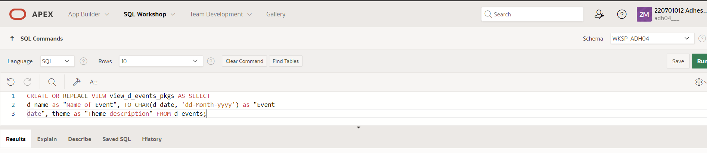

OTHER DATABASE OBJECTS

EXNO:14 DATE:

1. Create a sequence to be used with the primary key column of the DEPT table. The sequence should start at 200 and have a maximum value of 1000. Have your sequence increment by ten numbers. Name the sequence DEPT_ID_SEQ.

QUERY: CREATE SEQUENCE dept_id_seq

START WITH 200

INCREMENT BY 10

MAXVALUE 1000;

OUTPUT:

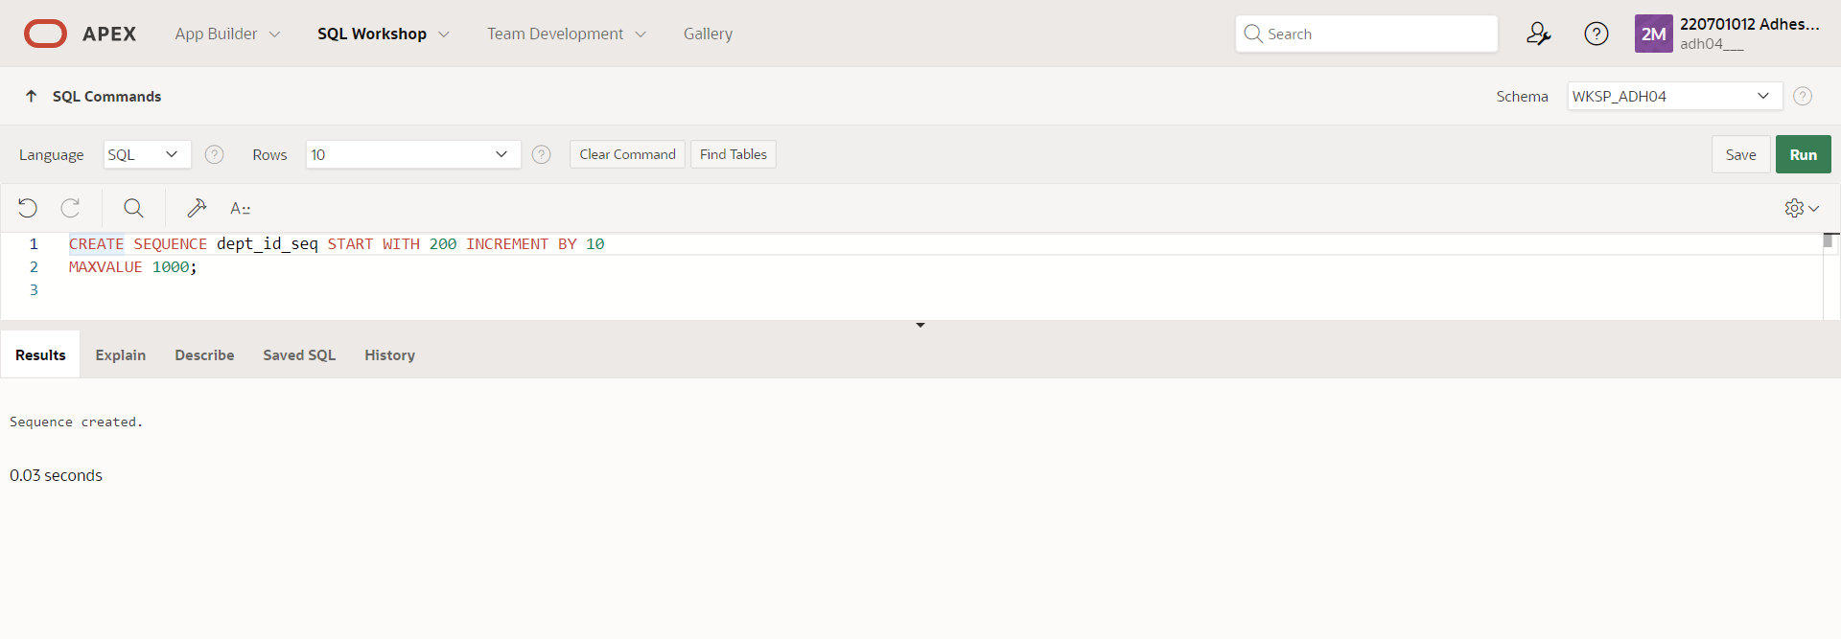

2. Write a query in a script to display the following information about your sequences: sequence name, maximum value, increment size, and last number

QUERY: SELECT sequence_name, max_value, increment_by, last_number

FROM user_sequences;

OUTPUT:

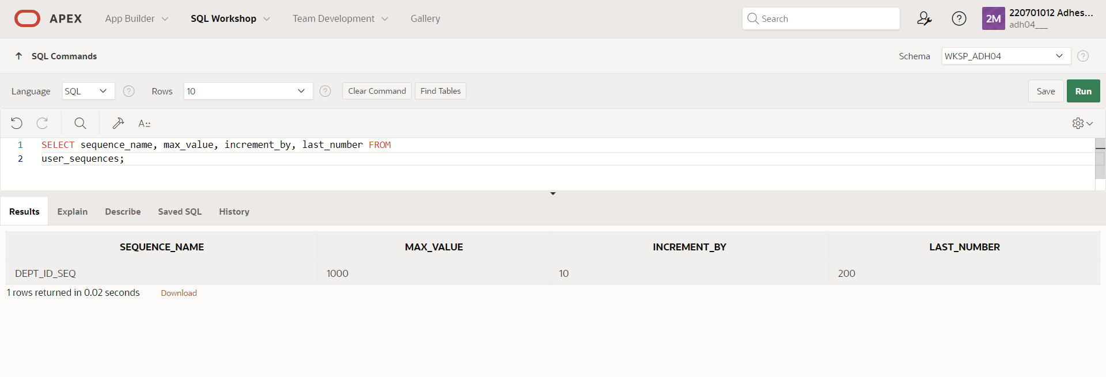

3. Write a script to insert two rows into the DEPT table. Name your script lab12_3.sql. Be sure to use the sequence that you created for the ID column. Add two departments named Education and Administration. Confirm your additions. Run the commands in your script.

QUERY: INSERT INTO dept

VALUES (dept_id_seq.nextval, ’Education’);

INSERT INTO dept

VALUES (dept_id_seq.nextval, ’Administration’);

OUTPUT:

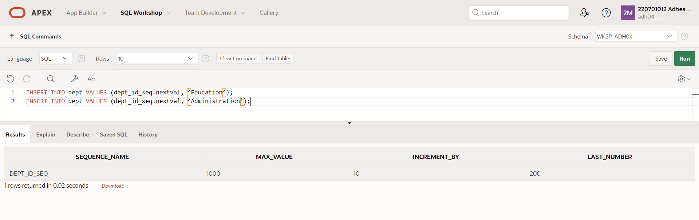

4. Create a nonunique index on the foreign key column (DEPT_ID) in the EMP table.

QUERY: CREATE INDEX emp_dept_id_idx ON my_emp (dept_id);

OUTPUT:

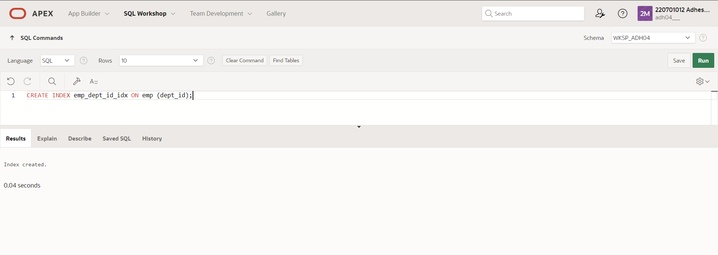

5. Display the indexes and uniqueness that exist in the data dictionary for the EMP table.

QUERY: SELECT index_name, table_name, uniqueness

FROM user_indexes

WHERE table_name = 'my_emp';

OUTPUT:

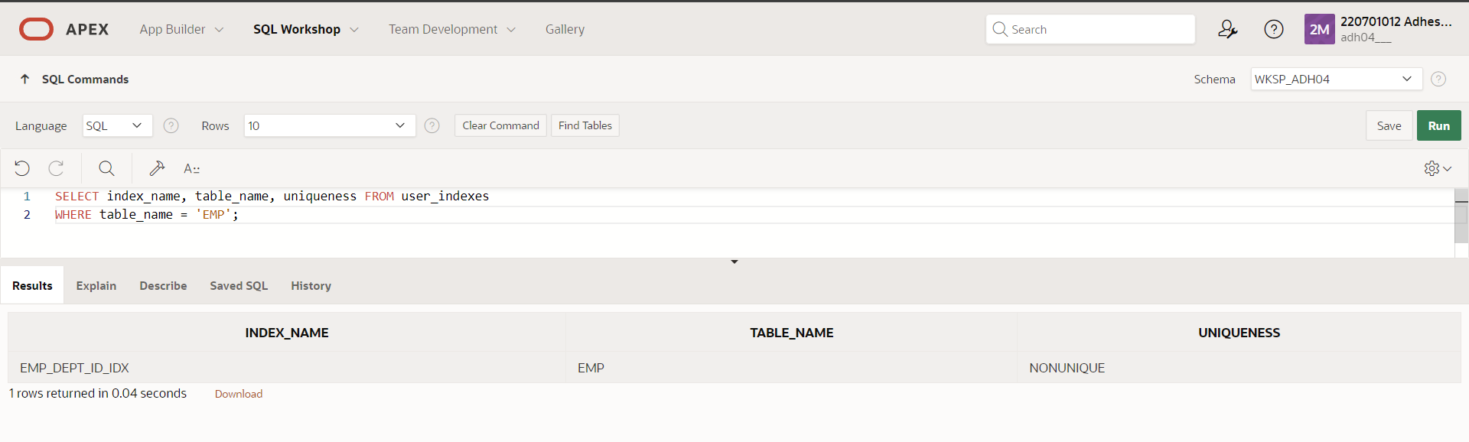

|  |  |
| --- | --- |
| Evaluation Procedure | Marks awarded |
| Query(5) |  |
| Execution (5) |  |
| Viva(5) |  |
| Total (15) |  |
| Faculty Signature |  |

RESULT:

CONTROLLING USER ACCESS

EXNO:15 DATE:

1. What privilege should a user be given to log on to the Oracle Server? Is this a system or an object privilege?

Ans: The CREATE SESSION system privilege

1. What privilege should a user be given to create tables?

**Ans :** The CREATE TABLE privilege

3. If you create a table, who can pass along privileges to other users on your table?

Ans: You can, or anyone you have given those privileges to by using the WITH

GRANT OPTION.

4. You are the DBA. You are creating many users who require the same system privileges. What should you use to make your job easier?

Ans: Create a role containing the system privileges and grant the role to the users

5. What command do you use to change your password?

Ans: The ALTER USER statement

6. Grant another user access to your DEPARTMENTS table. Have the user grant you query access to his or her DEPARTMENTS table.

Ans: Team 2 executes the GRANT statement. GRANT select ON departments TO ; Team 1 executes the GRANT statement. GRANT select ON departments TO ; WHERE user1 is the name of team 1 and user2 is the name of team 2.

7. Query all the rows in your DEPARTMENTS table.

Ans: SELECT * FROM departments;

8. Add a new row to your DEPARTMENTS table. Team 1 should add Education as department number 500. Team 2 should add Human Resources department number 510. Query the other team’s table.

Ans: Team 1 executes this INSERT statement. INSERT INTO departments(department_id, department_name) VALUES (500, ’Education’); COMMIT; Team 2 executes this INSERT statement. INSERT INTO departments(department_id, department_name) VALUES (510, ’Administration’); COMMIT;

9. Create a synonym for the other team’s DEPARTMENTS table.

Ans: Team 1 creates a synonym named team2. CREATE SYNONYM team2 FOR .DEPARTMENTS; Team 2 creates a synonym named team1. CREATE SYNONYM team1 FOR . DEPARTMENTS;

10. Query all the rows in the other team’s DEPARTMENTS table by using your synonym.

Ans: Team 1 executes this SELECT statement. SELECT * FROM team2; Team 2 executes this SELECT statement. SELECT * FROM team1;

11. Query the USER_TABLES data dictionary to see information about the tables that you own.

Ans: SELECT table_name FROM user_tables;

12. Query the ALL_TABLES data dictionary view to see information about all the tables that you can access. Exclude tables that you own.

Ans: SELECT table_name, owner FROM all_tables WHERE owner <> ;

13. Revoke the SELECT privilege from the other team.

Ans: Team 1 revokes the privilege. REVOKE select ON departments FROM user2; Team 2 revokes the privilege. REVOKE select ON departments FROM user1;

14. Remove the row you inserted into the DEPARTMENTS table in step 8 and save the changes. Team 1 executes this INSERT statement.

Ans: DELETE FROM departments WHERE department_id = 500; COMMIT; Team 2 executes this INSERT statement. DELETE FROM departments WHERE department_id = 510; COMMIT;

PL/SQL

CONTROL STRUCTURES

EXNO:16 DATE:

1. Write a PL/SQL block to calculate the incentive of an employee whose ID is 110.

QUERY: DECLARE

incentive NUMBER(8,2);

BEGIN

SELECT salary*0.12 INTO incentive

FROM employees

WHERE employee_id = 110;

DBMS_OUTPUT.PUT_LINE('Incentive = ' || TO_CHAR(incentive));

END;

OUTPUT:

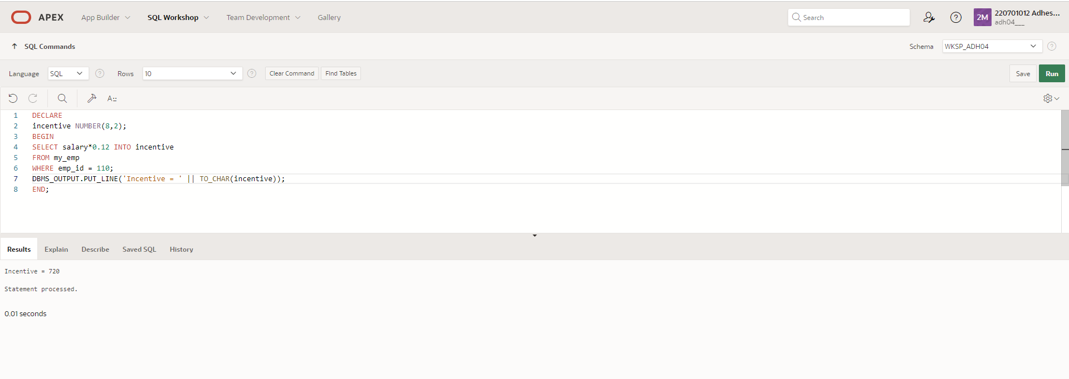

2. Write a PL/SQL block to show an invalid case-insensitive reference to a quoted and without quoted user-defined identifier

QUERY: DECLARE

WELCOME varchar2(10) := 'welcome';

BEGIN

DBMS_Output.Put_Line("Welcome");

END;

/

OUTPUT:

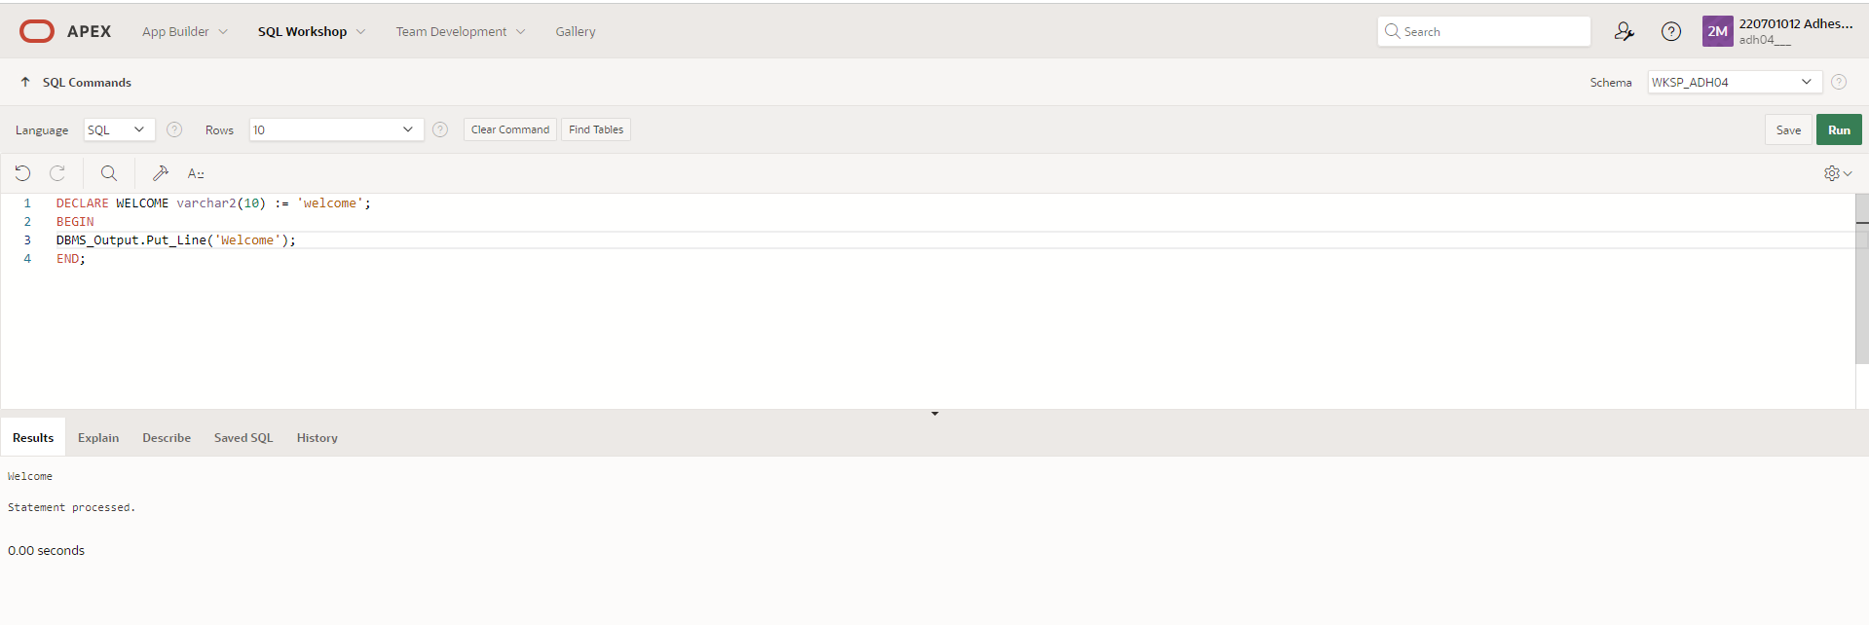

3. Write a PL/SQL block to adjust the salary of the employee whose ID 122.  
  
QUERY: DECLARE

salary_of_emp NUMBER(8,2);

PROCEDURE approx_salary (

emp NUMBER,

empsal IN OUT NUMBER,

addless NUMBER

) IS

BEGIN

empsal := empsal + addless;

END;

BEGIN

SELECT salary INTO salary_of_emp

FROM employees

WHERE employee_id = 122;

DBMS_OUTPUT.PUT_LINE

('Before invoking procedure, salary_of_emp: ' || salary_of_emp);

approx_salary (100, salary_of_emp, 1000);

DBMS_OUTPUT.PUT_LINE

('After invoking procedure, salary_of_emp: ' || salary_of_emp);

END;

/

OUTPUT:

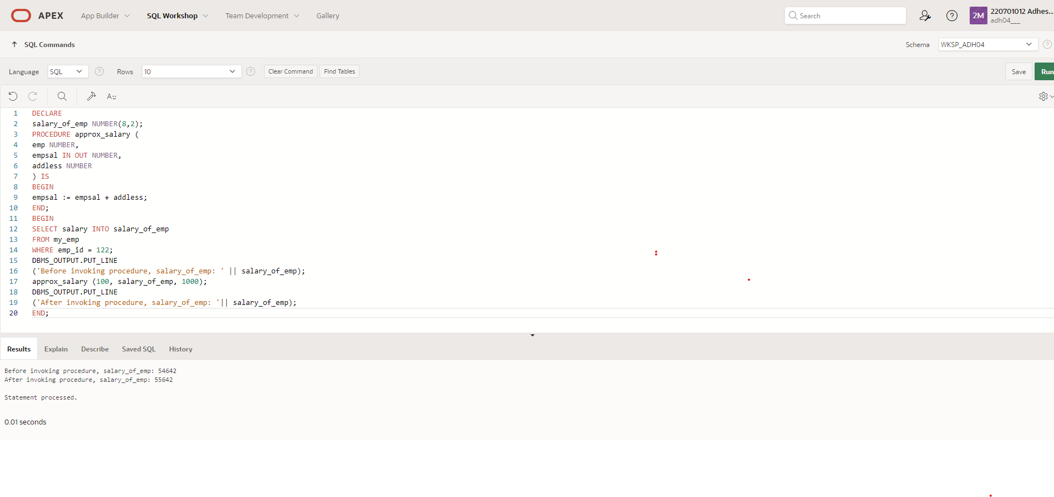

4. Write a PL/SQL block to create a procedure using the "IS [NOT] NULL Operator" and show AND operator returns TRUE if and only if both operands are TRUE.  
  
QUERY: CREATE OR REPLACE PROCEDURE pri_bool(

boo_name VARCHAR2,

boo_val BOOLEAN

) IS

BEGIN

IF boo_val IS NULL THEN

DBMS_OUTPUT.PUT_LINE( boo_name || ' = NULL');

ELSIF boo_val = TRUE THEN

DBMS_OUTPUT.PUT_LINE( boo_name || ' = TRUE');

ELSE

DBMS_OUTPUT.PUT_LINE( boo_name || ' = FALSE');

END IF;

END;

/

OUTPUT:

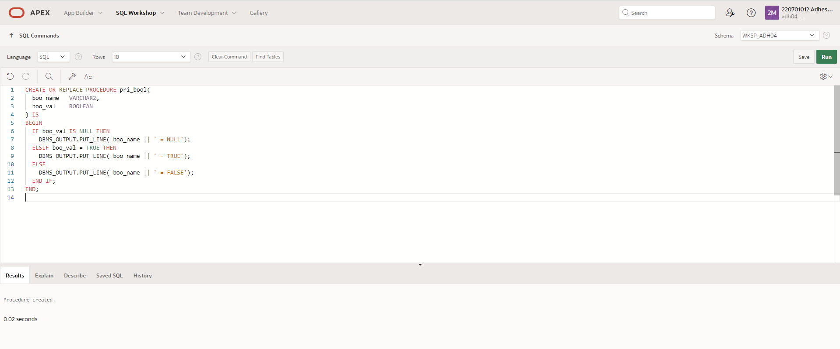

5. Write a PL/SQL block to describe the usage of LIKE operator including wildcard characters and escape character.

QUERY: DECLARE

PROCEDURE pat_match (

test_string VARCHAR2,

pattern VARCHAR2

) IS

BEGIN

IF test_string LIKE pattern THEN

DBMS_OUTPUT.PUT_LINE ('TRUE');

ELSE

DBMS_OUTPUT.PUT_LINE ('FALSE');

END IF;

END;

BEGIN

pat_match('Blweate', 'B%a_e');

pat_match('Blweate', 'B%A_E');

END;

/

OUTPUT:

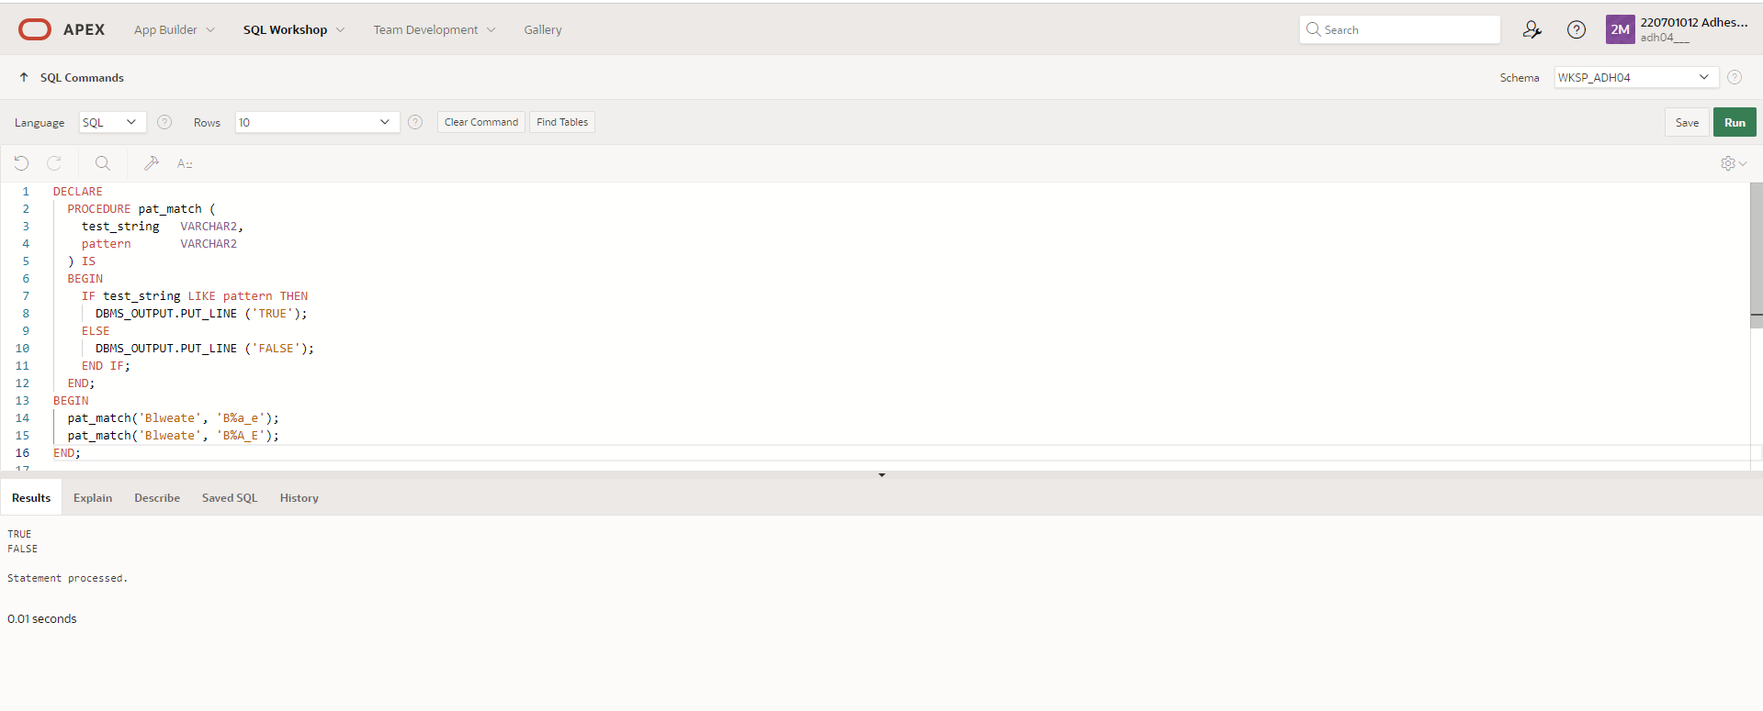

6. Write a PL/SQL program to arrange the number of two variable in such a way that the small number will store in num_small variable and large number will store in num_large variable

QUERY: DECLARE

num_small NUMBER := 8;

num_large NUMBER := 5;

num_temp NUMBER;

BEGIN

IF num_small > num_large THEN

num_temp := num_small;

num_small := num_large;

num_large := num_temp;

END IF;

DBMS_OUTPUT.PUT_LINE ('num_small = '||num_small);

DBMS_OUTPUT.PUT_LINE ('num_large = '||num_large);

END;

/

OUTPUT:

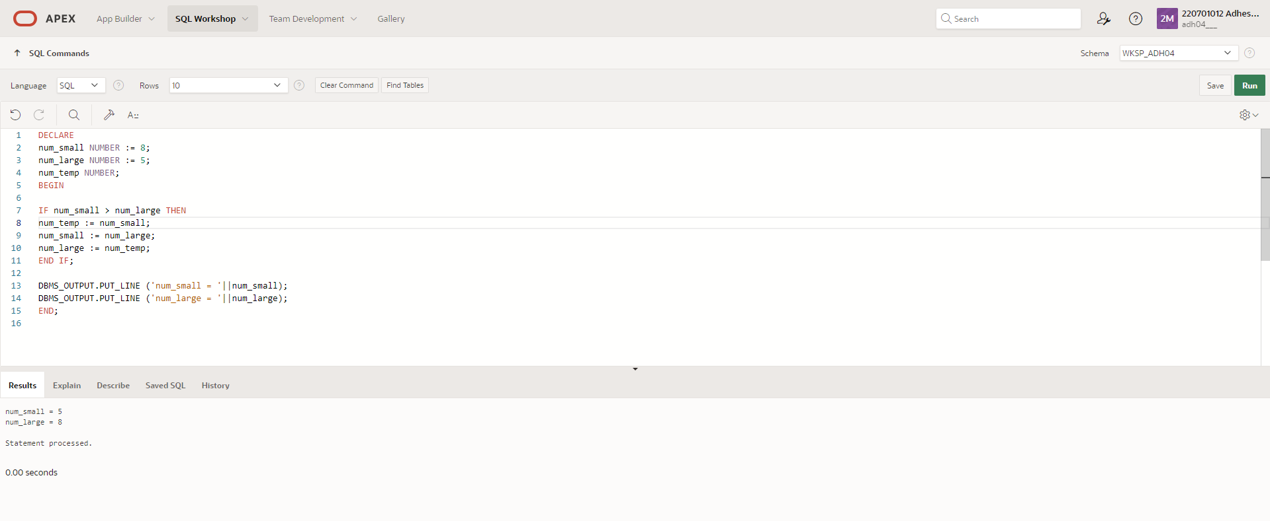

7. Write a PL/SQL procedure to calculate the incentive on a target achieved and display the message either the record updated or not.  
  
QUERY: DECLARE

PROCEDURE test1 (

sal_achieve NUMBER,

target_qty NUMBER,

emp_id NUMBER

)

IS

incentive NUMBER := 0;

updated VARCHAR2(3) := 'No';

BEGIN

IF sal_achieve > (target_qty + 200) THEN

incentive := (sal_achieve - target_qty)/4;

UPDATE employees

SET salary = salary + incentive

WHERE employee_id = emp_id;

updated := 'Yes';

END IF;

DBMS_OUTPUT.PUT_LINE (

'Table updated? ' || updated || ', ' ||

'incentive = ' || incentive || '.'

);

END test1;

BEGIN

test1(2300, 2000, 144);

test1(3600, 3000, 145);

END;

/

OUTPUT:

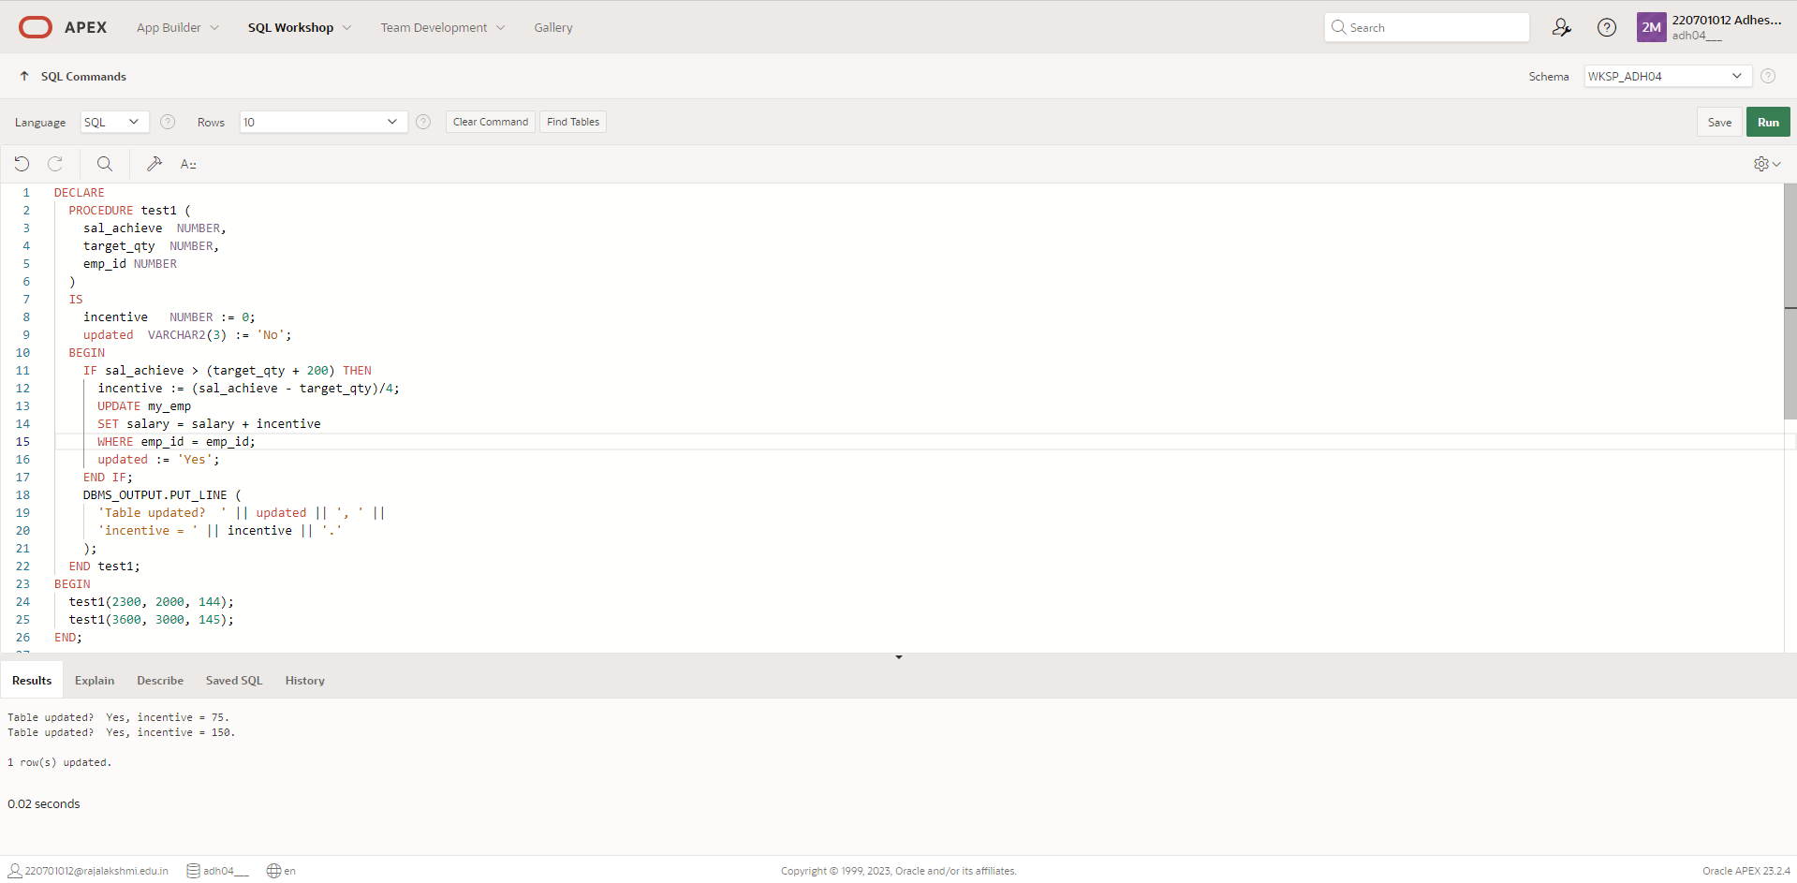

8. Write a PL/SQL procedure to calculate incentive achieved according to the specific sale limit

QUERY: DECLARE

PROCEDURE test1 (sal_achieve NUMBER)

IS

incentive NUMBER := 0;

BEGIN

IF sal_achieve > 44000 THEN

incentive := 1800;

ELSIF sal_achieve > 32000 THEN

incentive := 800;

ELSE

incentive := 500;

END IF;

DBMS_OUTPUT.NEW_LINE;

DBMS_OUTPUT.PUT_LINE (

'Sale achieved : ' || sal_achieve || ', incentive : ' || incentive || '.'

);

END test1;

BEGIN

test1(45000);

test1(36000);

test1(28000);

END;

/

OUTPUT:

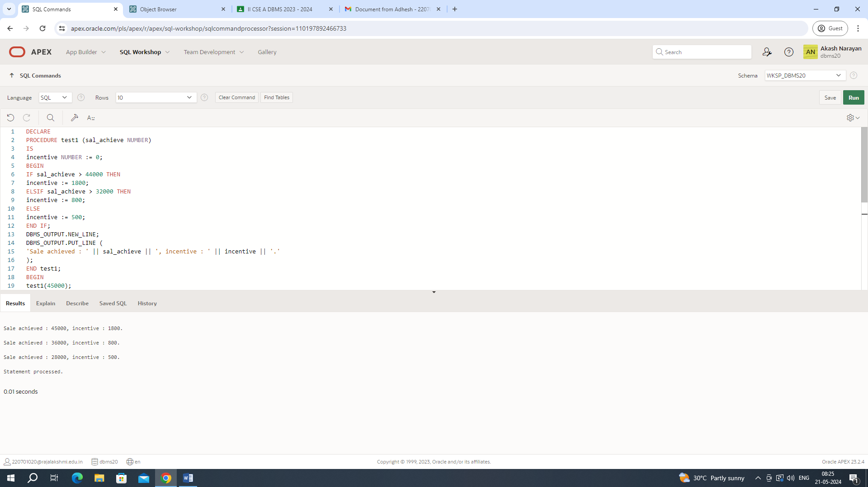

9. Write a PL/SQL program to count number of employees in department 50 and check whether this department have any vacancies or not. There are 45 vacancies in this department.

QUERY: DECLARE

tot_emp NUMBER;

get_dep_id NUMBER;

BEGIN

get_dep_id := 80;

SELECT Count(*)

INTO tot_emp

FROM employees e

join departments d

ON e.department_id = d.department_id

WHERE e.department_id = get_dep_id;

dbms_output.Put_line ('The employees are in the department '||get_dep_id||' is: '

||To_char(tot_emp));

IF tot_emp >= 45 THEN

dbms_output.Put_line ('There are no vacancies in the department '||get_dep_id);

ELSE

dbms_output.Put_line ('There are '||to_char(45-tot_emp)||' vacancies in department '|| get_dep_id );

END IF;

END;

/

OUTPUT:

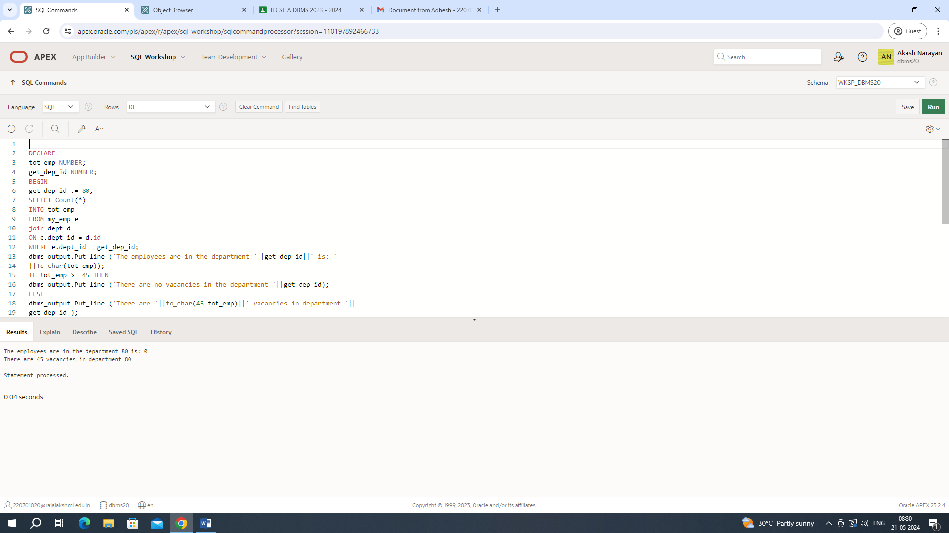

10. Write a PL/SQL program to count number of employees in a specific department and check whether this department have any vacancies or not. If any vacancies, how many vacancies are in that department.

QUERY: DECLARE

tot_emp NUMBER;

get_dep_id NUMBER;

BEGIN

get_dep_id := 80;

SELECT Count(*)

INTO tot_emp

FROM employees e

join departments d

ON e.department_id = d.dept_id

WHERE e.department_id = get_dep_id;

dbms_output.Put_line ('The employees are in the department '||get_dep_id||' is: '

||To_char(tot_emp));

IF tot_emp >= 45 THEN

dbms_output.Put_line ('There are no vacancies in the department '||get_dep_id);

ELSE

dbms_output.Put_line ('There are '||to_char(45-tot_emp)||' vacancies in department '|| get_dep_id );

END IF;

END;

/

OUTPUT:

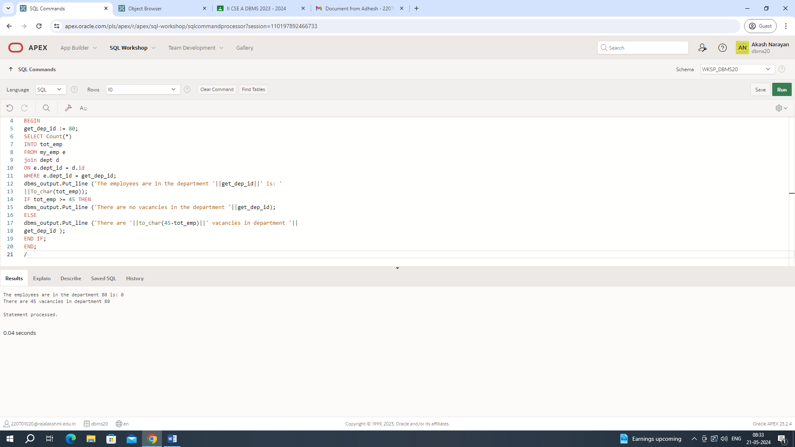

11. Write a PL/SQL program to display the employee IDs, names, job titles, hire dates, and salaries of all employees

QUERY: DECLARE

v_employee_id employees.employee_id%TYPE;

v_full_name employees.first_name%TYPE;

v_job_id employees.job_id%TYPE;

v_hire_date employees.hire_date%TYPE;

v_salary employees.salary%TYPE;

CURSOR c_employees IS

SELECT employee_id, first_name || ' ' || last_name AS full_name, job_id, hire_date, salary

FROM employees;

BEGIN

DBMS_OUTPUT.PUT_LINE('Employee ID | Full Name | Job Title | Hire Date | Salary');

DBMS_OUTPUT.PUT_LINE('-------------------------------------------------------------------');

OPEN c_employees;

FETCH c_employees INTO v_employee_id, v_full_name, v_job_id, v_hire_date, v_salary;

WHILE c_employees%FOUND LOOP

DBMS_OUTPUT.PUT_LINE(v_employee_id || ' | ' || v_full_name || ' | ' || v_job_id || ' | ' || v_hire_date || ' | ' || v_salary);

FETCH c_employees INTO v_employee_id, v_full_name, v_job_id, v_hire_date, v_salary;

END LOOP;

CLOSE c_employees;

END;

/

OUTPUT:

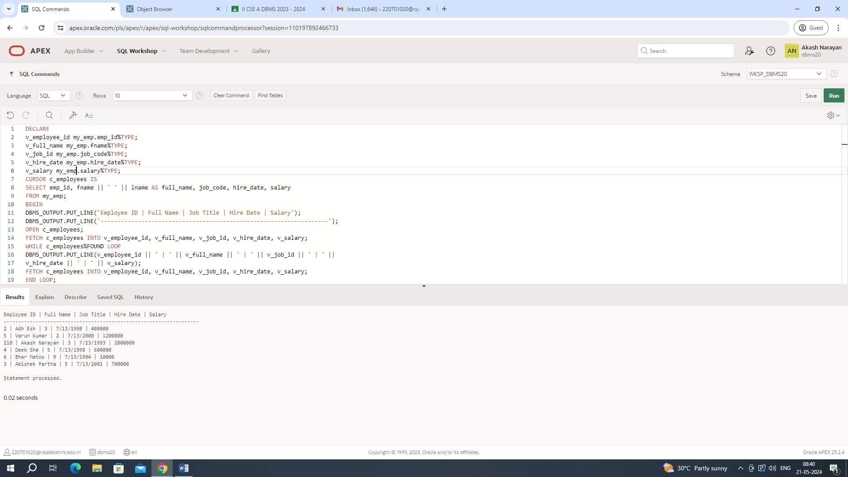

12. Write a PL/SQL program to display the employee IDs, names, and department names of all employees.

QUERY: DECLARE

CURSOR emp_cursor IS

SELECT e.employee_id, e.first_name, m.first_name AS manager_name

FROM employees e

LEFT JOIN employees m ON e.manager_id = m.employee_id;

emp_record emp_cursor%ROWTYPE;

BEGIN

OPEN emp_cursor;

FETCH emp_cursor INTO emp_record;

WHILE emp_cursor%FOUND LOOP

DBMS_OUTPUT.PUT_LINE('Employee ID: ' || emp_record.employee_id);

DBMS_OUTPUT.PUT_LINE('Employee Name: ' || emp_record.first_name);

DBMS_OUTPUT.PUT_LINE('Manager Name: ' || emp_record.manager_name);

DBMS_OUTPUT.PUT_LINE('-------------------------');

FETCH emp_cursor INTO emp_record;

END LOOP;

CLOSE emp_cursor;

END;

/

OUTPUT:

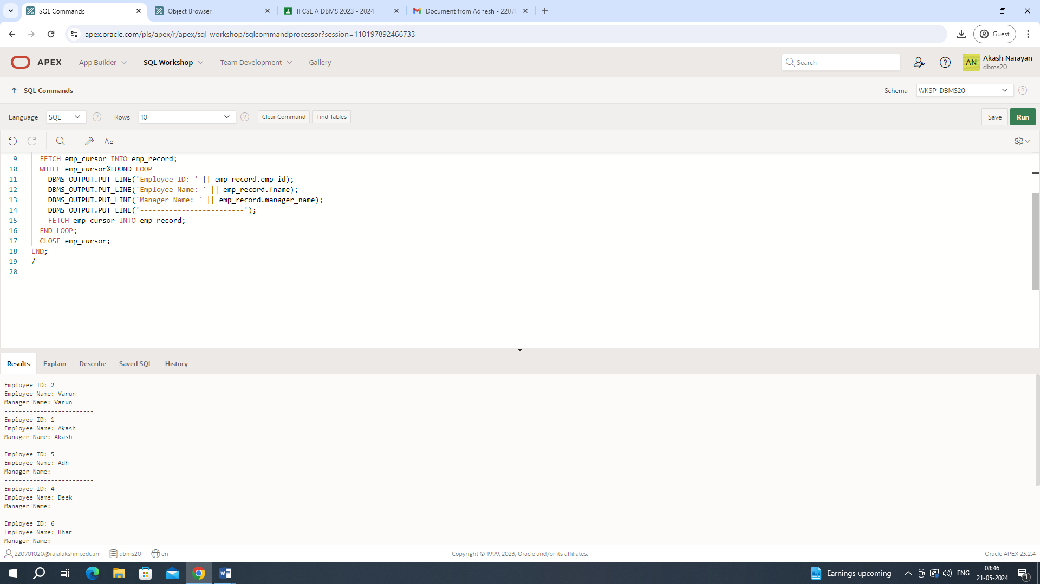

13. Write a PL/SQL program to display the job IDs, titles, and minimum salaries of all jobs

QUERY: DECLARE

CURSOR job_cursor IS

SELECT e.job_id, j.lowest_sal

FROM job_grade j,employees e;

job_record job_cursor%ROWTYPE;

BEGIN

OPEN job_cursor;

FETCH job_cursor INTO job_record;

WHILE job_cursor%FOUND LOOP

DBMS_OUTPUT.PUT_LINE('Job ID: ' || job_record.job_id);

DBMS_OUTPUT.PUT_LINE('Minimum Salary: ' || job_record.lowest_sal);

DBMS_OUTPUT.PUT_LINE('-------------------------');

FETCH job_cursor INTO job_record;

END LOOP;

CLOSE job_cursor;

END;

/

OUTPUT:

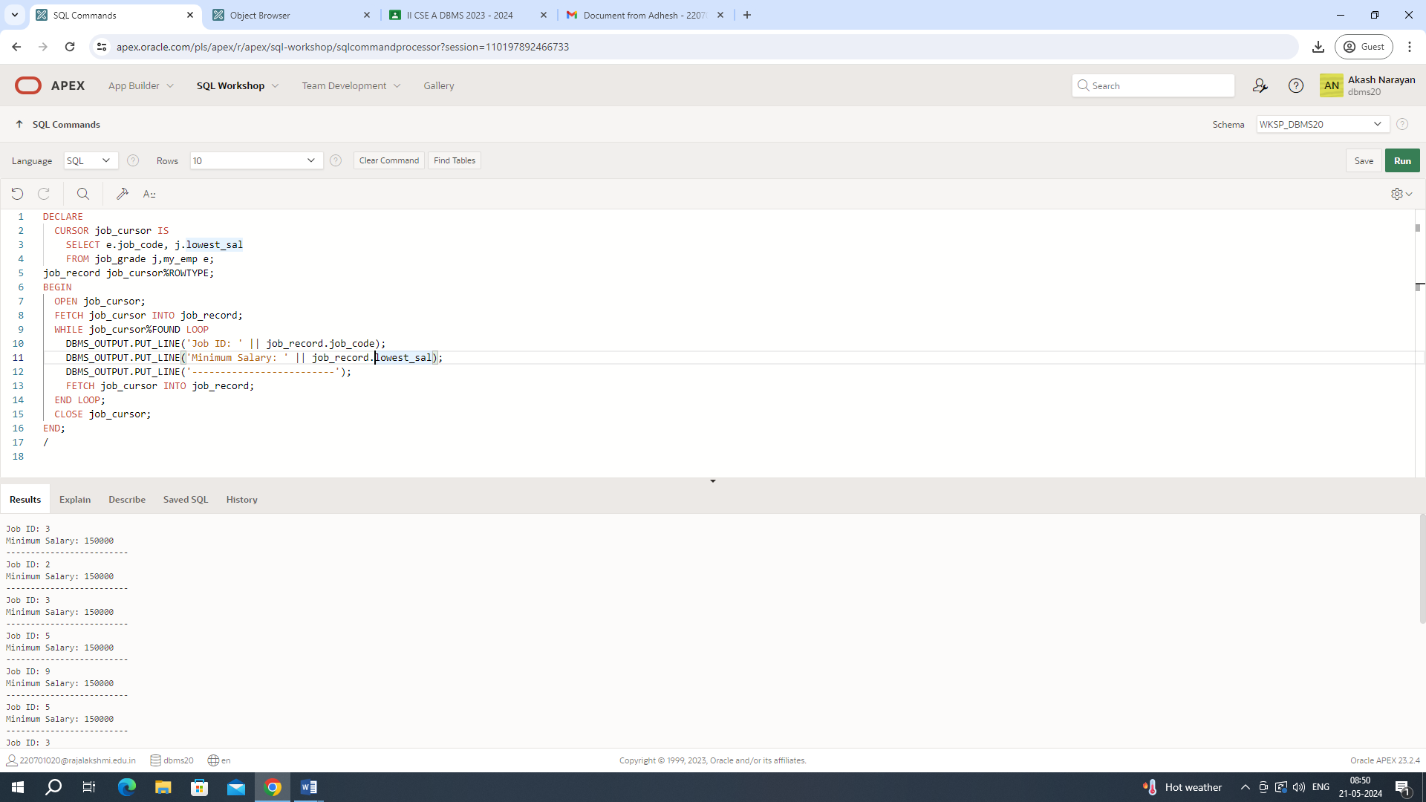

14. Write a PL/SQL program to display the employee IDs, names, and job history start dates of all employees.

QUERY: DECLARE

CURSOR employees_cur IS

SELECT employee_id,last_name, job_id,start_date

FROM employees NATURAL join job_history;

emp_start_date DATE;

BEGIN

dbms_output.Put_line(Rpad('Employee ID', 15)||Rpad('Last Name', 25)|| Rpad('Job Id', 35) ||'Start Date');

dbms_output.Put_line('-----------------------------------------------------------------------------------------');

FOR emp_sal_rec IN employees_cur LOOP

-- find out most recent end_date in job_history

SELECT Max(end_date) + 1

INTO emp_start_date

FROM job_history

WHERE employee_id = emp_sal_rec.employee_id;

IF emp_start_date IS NULL THEN

emp_start_date := emp_sal_rec.start_date;

END IF;

dbms_output.Put_line(Rpad(emp_sal_rec.employee_id, 15)

||Rpad(emp_sal_rec.last_name, 25)

|| Rpad(emp_sal_rec.job_id, 35)

|| To_char(emp_start_date, 'dd-mon-yyyy'));

END LOOP;

END;

/

OUTPUT:

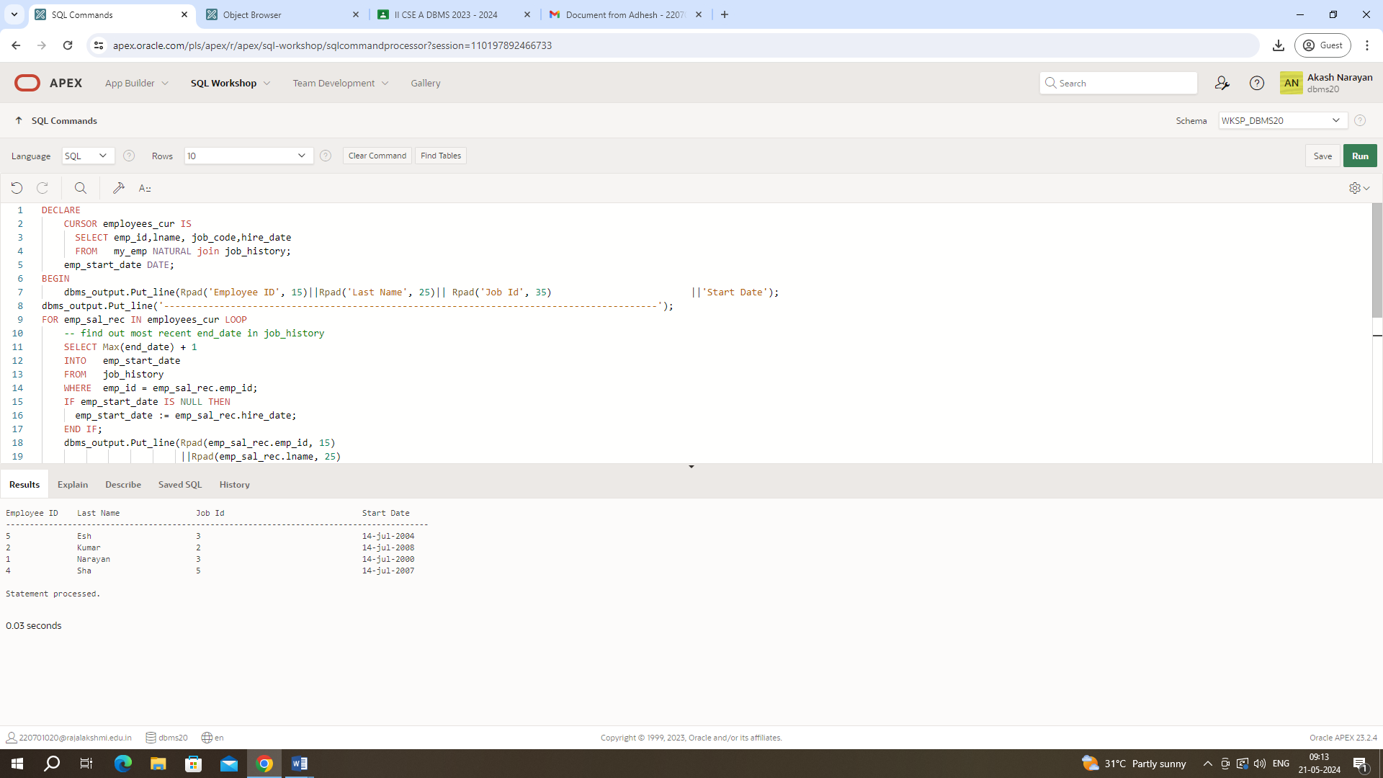

15. Write a PL/SQL program to display the employee IDs, names, and job history end dates of all employees.

QUERY: DECLARE

v_employee_id employees.employee_id%TYPE;

v_first_name employees.last_name%TYPE;

v_end_date job_history.end_date%TYPE;

CURSOR c_employees IS

SELECT e.employee_id, e.first_name, jh.end_date

FROM employees e

JOIN job_history jh ON e.employee_id = jh.employee_id;

BEGIN

OPEN c_employees;

FETCH c_employees INTO v_employee_id, v_first_name, v_end_date;

WHILE c_employees%FOUND LOOP

DBMS_OUTPUT.PUT_LINE('Employee ID: ' || v_employee_id);

DBMS_OUTPUT.PUT_LINE('Employee Name: ' || v_first_name);

DBMS_OUTPUT.PUT_LINE('End Date: ' || v_end_date);

DBMS_OUTPUT.PUT_LINE('----------------------');

FETCH c_employees INTO v_employee_id, v_first_name, v_end_date;

END LOOP;

CLOSE c_employees;

END;

OUTPUT:

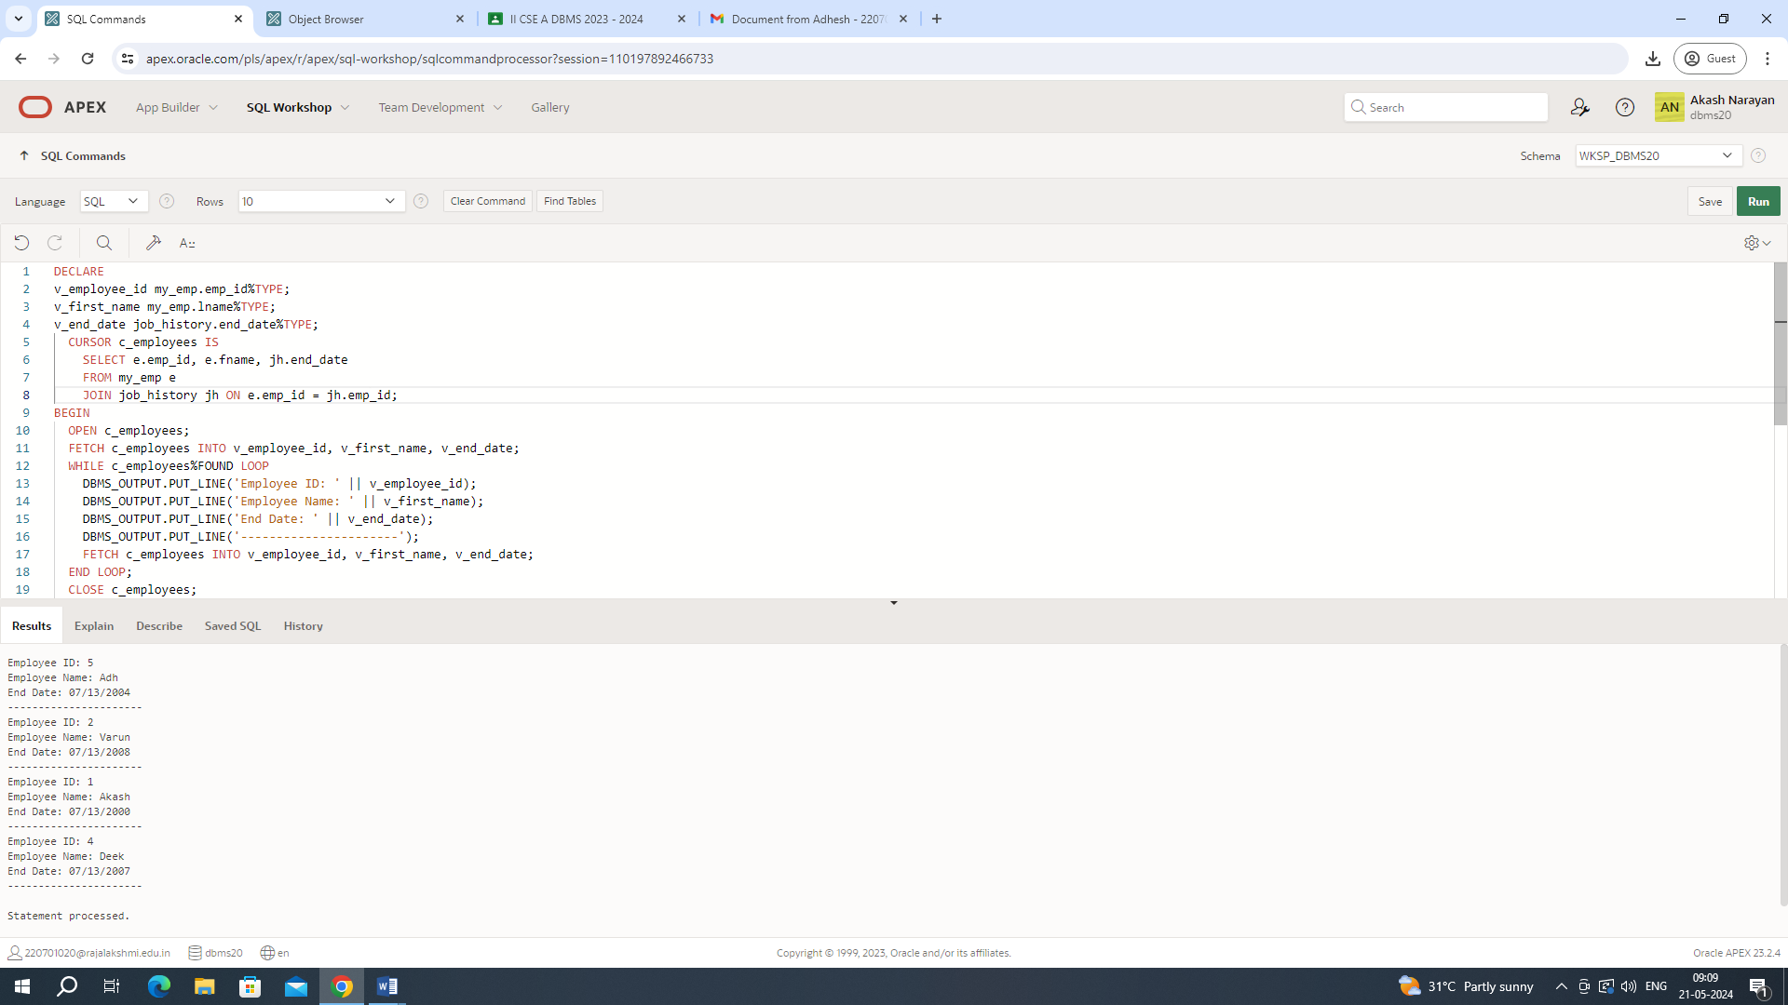

|  |  |
| --- | --- |
| Evaluation Procedure | Marks awarded |
| Query(5) |  |
| Execution (5) |  |
| Viva(5) |  |
| Total (15) |  |
| Faculty Signature |  |

RESULT:

PROCEDURES AND FUNCTIONS

EXNO:17 DATE:

1. Factorial of a number using function.

QUERY:

DECLARE

fac NUMBER := 1;

n NUMBER := :1;

BEGIN

WHILE n > 0 LOOP

fac := n * fac;

n := n - 1;

END LOOP;

DBMS_OUTPUT.PUT_LINE(fac);

END;

OUTPUT:

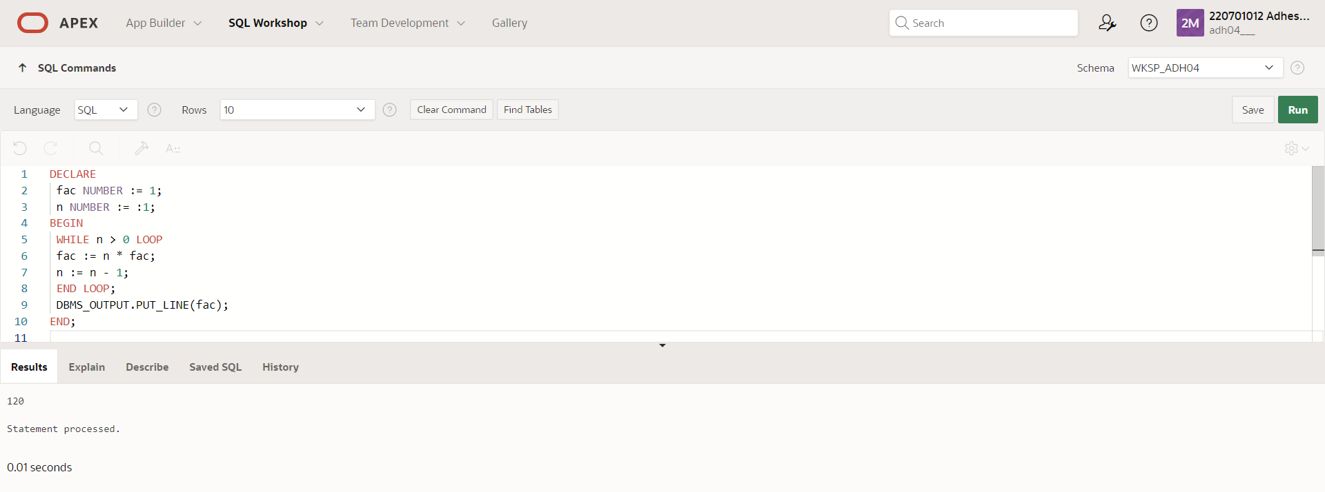

2. Write a PL/SQL program using Procedures IN,INOUT,OUT parameters to retrieve the corresponding book information in library.

QUERY: CREATE OR REPLACE PROCEDURE get_book_info (

p_book_id IN NUMBER,

p_title IN OUT VARCHAR2,

p_author OUT VARCHAR2,

p_year_published OUT NUMBER

)

AS

BEGIN

SELECT title, author, year_published INTO p_title, p_author, p_year_published

FROM books

WHERE book_id = p_book_id;

p_title := p_title || ' - Retrieved';

EXCEPTION

WHEN NO_DATA_FOUND THEN

p_title := NULL;

p_author := NULL;

p_year_published := NULL;

END;

DECLARE

v_book_id NUMBER := 1;

v_title VARCHAR2(100);

v_author VARCHAR2(100);

v_year_published NUMBER;

BEGIN

v_title := 'Initial Title';

get_book_info(p_book_id => v_book_id, p_title => v_title, p_author => v_author, p_year_published => v_year_published);

DBMS_OUTPUT.PUT_LINE('Title: ' || v_title);

DBMS_OUTPUT.PUT_LINE('Author: ' || v_author);

DBMS_OUTPUT.PUT_LINE('Year Published: ' || v_year_published);

END;

OUTPUT:

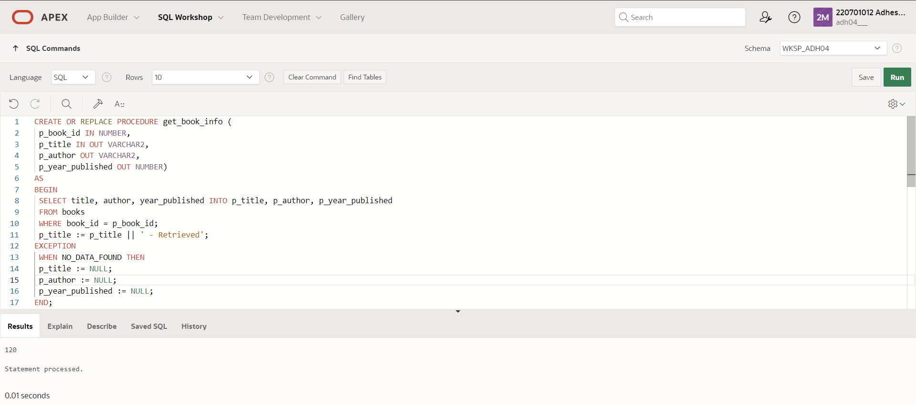

|  |  |
| --- | --- |
| Evaluation Procedure | Marks awarded |
| Query(5) |  |
| Execution (5) |  |
| Viva(5) |  |
| Total (15) |  |
| Faculty Signature |  |

RESULT:

**EXNO:18 TRIGGER DATE:**

**1.)Write a code in PL/SQL to develop a trigger that enforces referential integrity by preventing the deletion of a parent record if child records exist**

**QUERY:**

CREATE OR REPLACE TRIGGER prevent_parent_deletion

BEFORE DELETE ON parent_table

FOR EACH ROW

DECLARE

child_exists EXCEPTION;

PRAGMA EXCEPTION_INIT(child_exists, -20001);

v_child_count NUMBER;

BEGIN

SELECT COUNT(*) INTO v_child_count FROM child_table WHERE parent_id = :OLD.parent_id;

IF v_child_count > 0 THEN

RAISE child_exists;

END IF;

EXCEPTION

WHEN child_exists THEN

RAISE_APPLICATION_ERROR(-20001, 'Cannot delete parent record while child records exist.');

END;

**OUTPUT**:

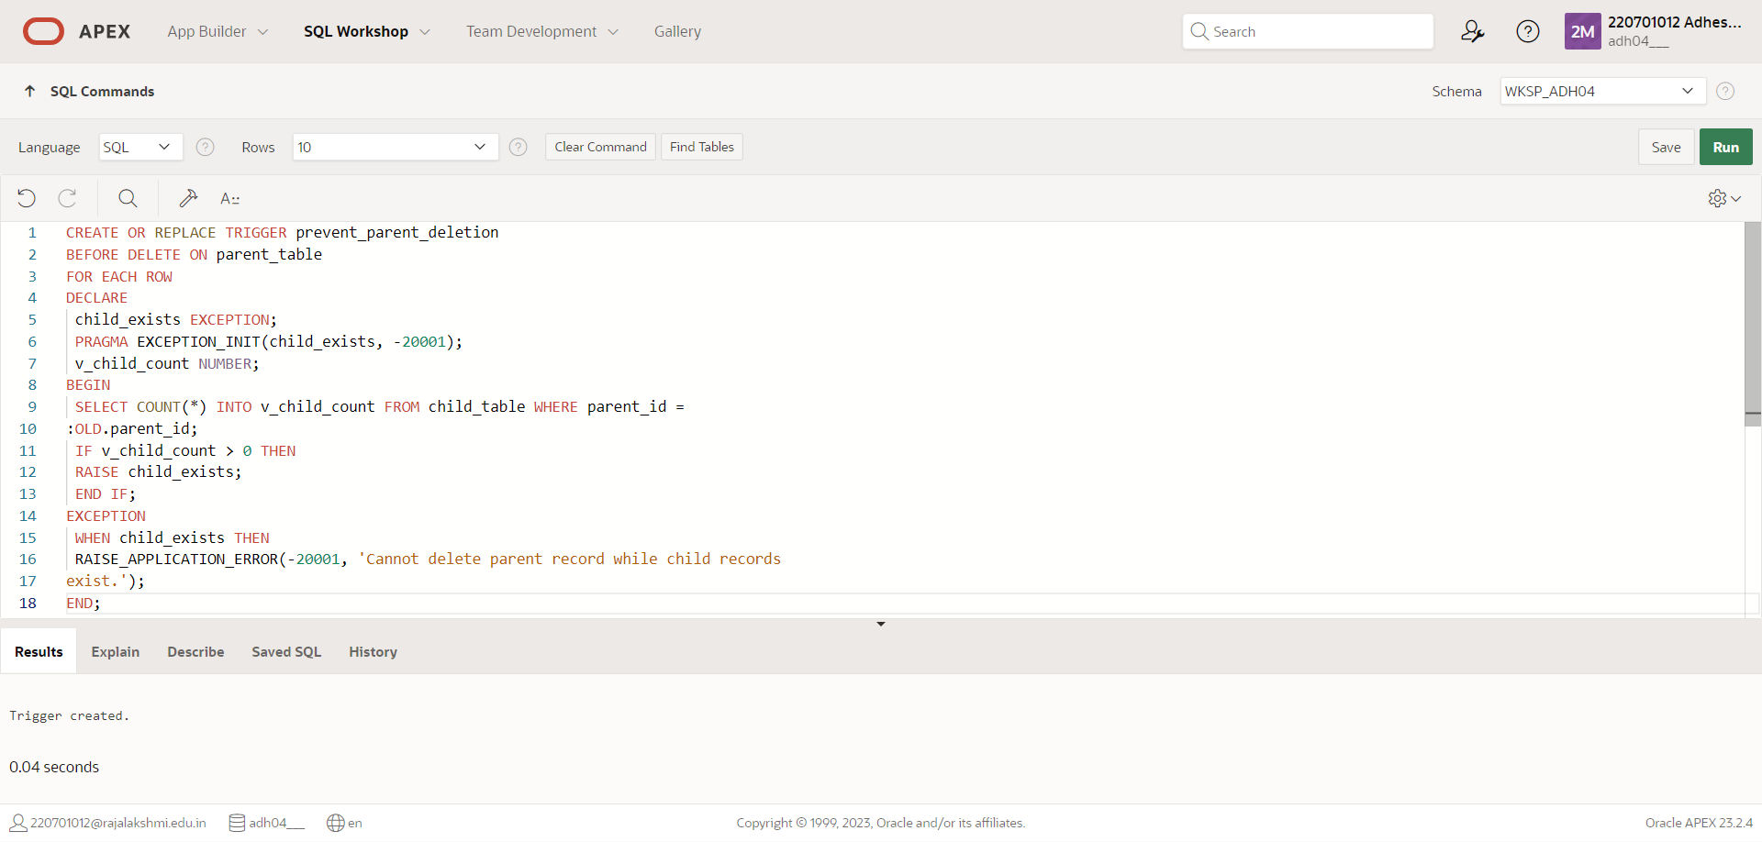

**2.)** **Write a code in PL/SQL to create a trigger that checks for duplicate values in a specific column and raises an exception if found**

**QUERY:**

CREATE OR REPLACE TRIGGER check_duplicates

BEFORE INSERT OR UPDATE ON unique_values_table

FOR EACH ROW

DECLARE

duplicate_found EXCEPTION;

PRAGMA EXCEPTION_INIT(duplicate_found, -20002);

v_count NUMBER;

BEGIN

SELECT COUNT(*) INTO v_count FROM unique_values_table

WHERE unique_col = :NEW.unique_col AND id != :NEW.id;

IF v_count > 0 THEN

RAISE duplicate_found;

END IF;

EXCEPTION

WHEN duplicate_found THEN

RAISE_APPLICATION_ERROR(-20002, 'Duplicate value found in unique_col.');

END;

**OUTPUT:**

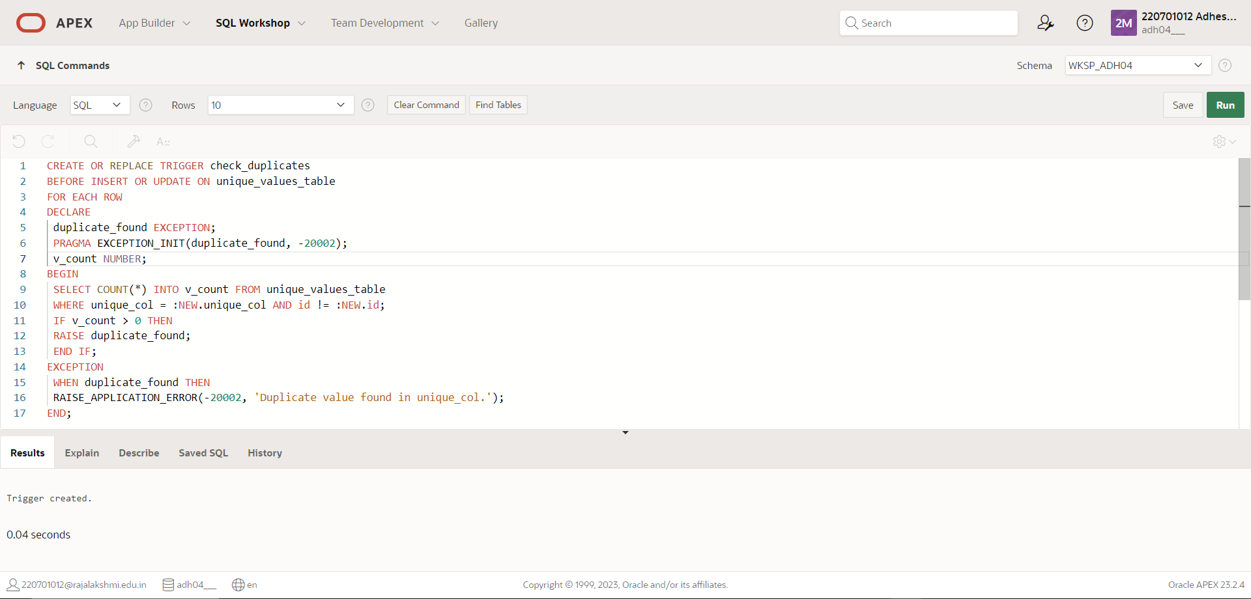

**3.)** **Write a code in PL/SQL to create a trigger that restricts the insertion of new rows if the total of a column's values exceeds a certain threshold**

**QUERY:**

CREATE OR REPLACE TRIGGER check_threshold

BEFORE INSERT OR UPDATE ON threshold_table

FOR EACH ROW

DECLARE

threshold_exceeded EXCEPTION;

PRAGMA EXCEPTION_INIT(threshold_exceeded, -20003);

v_sum NUMBER;

v_threshold NUMBER := 10000; -- Set your threshold here

BEGIN

SELECT SUM(value_col) INTO v_sum FROM threshold_table;

v_sum := v_sum + :NEW.value_col;

IF v_sum > v_threshold THEN

RAISE threshold_exceeded;

END IF;

EXCEPTION

WHEN threshold_exceeded THEN

RAISE_APPLICATION_ERROR(-20003, 'Threshold exceeded for value_col.');

END;

**OUTPUT:**

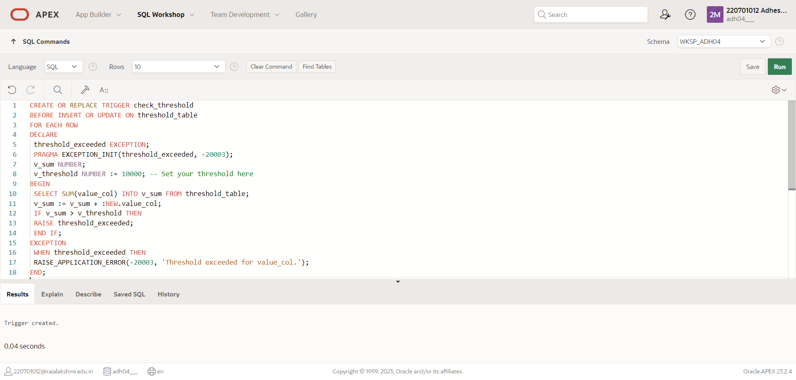

**4.)** **Write a code in PL/SQL to design a trigger that captures changes made to specific columns and logs them in an audit table.**

**QUERY:**

CREATE OR REPLACE TRIGGER log_changes

AFTER UPDATE ON main_table

FOR EACH ROW

BEGIN

INSERT INTO audit_table (audit_id, changed_id, old_col1, new_col1, old_col2, new_col2, change_time)

VALUES (audit_seq.NEXTVAL, :OLD.id, :OLD.col1, :NEW.col1, :OLD.col2, :NEW.col2, SYSTIMESTAMP);

END;

**OUTPUT:**

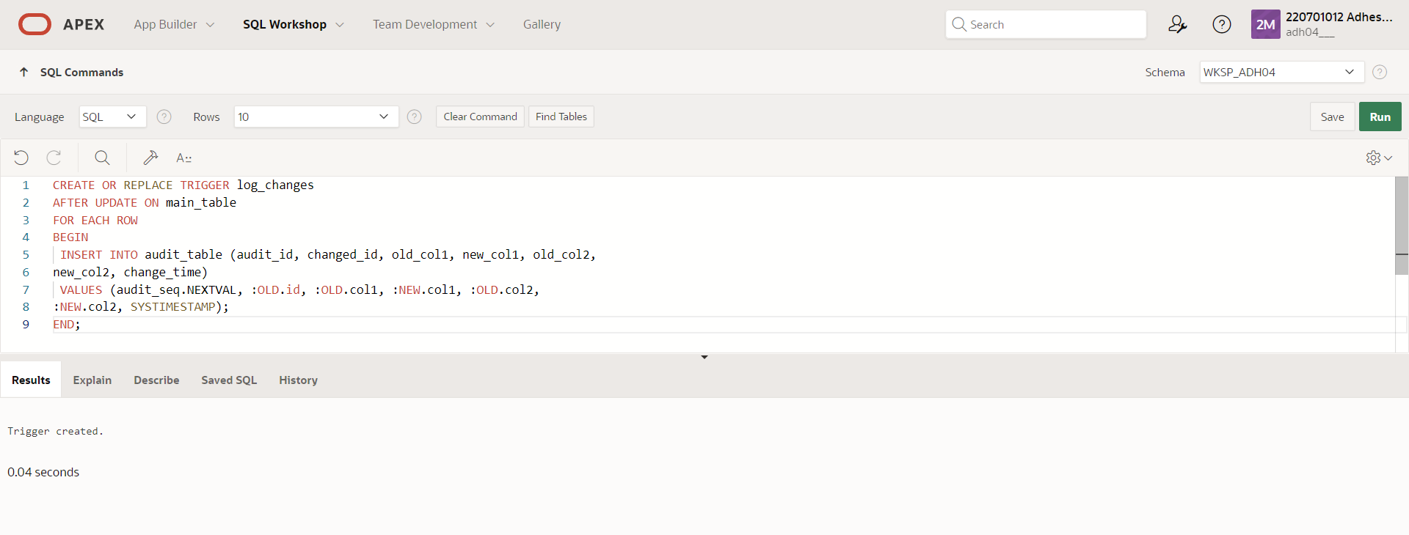

**5.)** **Write a code in PL/SQL to implement a trigger that records user activity (inserts, updates, deletes) in an audit log for a given set of tables.**

**QUERY:**

CREATE OR REPLACE TRIGGER log_user_activity

AFTER INSERT OR UPDATE OR DELETE ON activity_table

FOR EACH ROW

BEGIN

IF INSERTING THEN

INSERT INTO user_activity_log (log_id, action, table_name, record_id, change_time)

VALUES (activity_log_seq.NEXTVAL, 'INSERT', 'activity_table', :NEW.id, SYSTIMESTAMP);

ELSIF UPDATING THEN

INSERT INTO user_activity_log (log_id, action, table_name, record_id, change_time)

VALUES (activity_log_seq.NEXTVAL, 'UPDATE', 'activity_table', :NEW.id, SYSTIMESTAMP);

ELSIF DELETING THEN

INSERT INTO user_activity_log (log_id, action, table_name, record_id, change_time)

VALUES (activity_log_seq.NEXTVAL, 'DELETE', 'activity_table', :OLD.id, SYSTIMESTAMP);

END IF;

END;

**OUTPUT:**

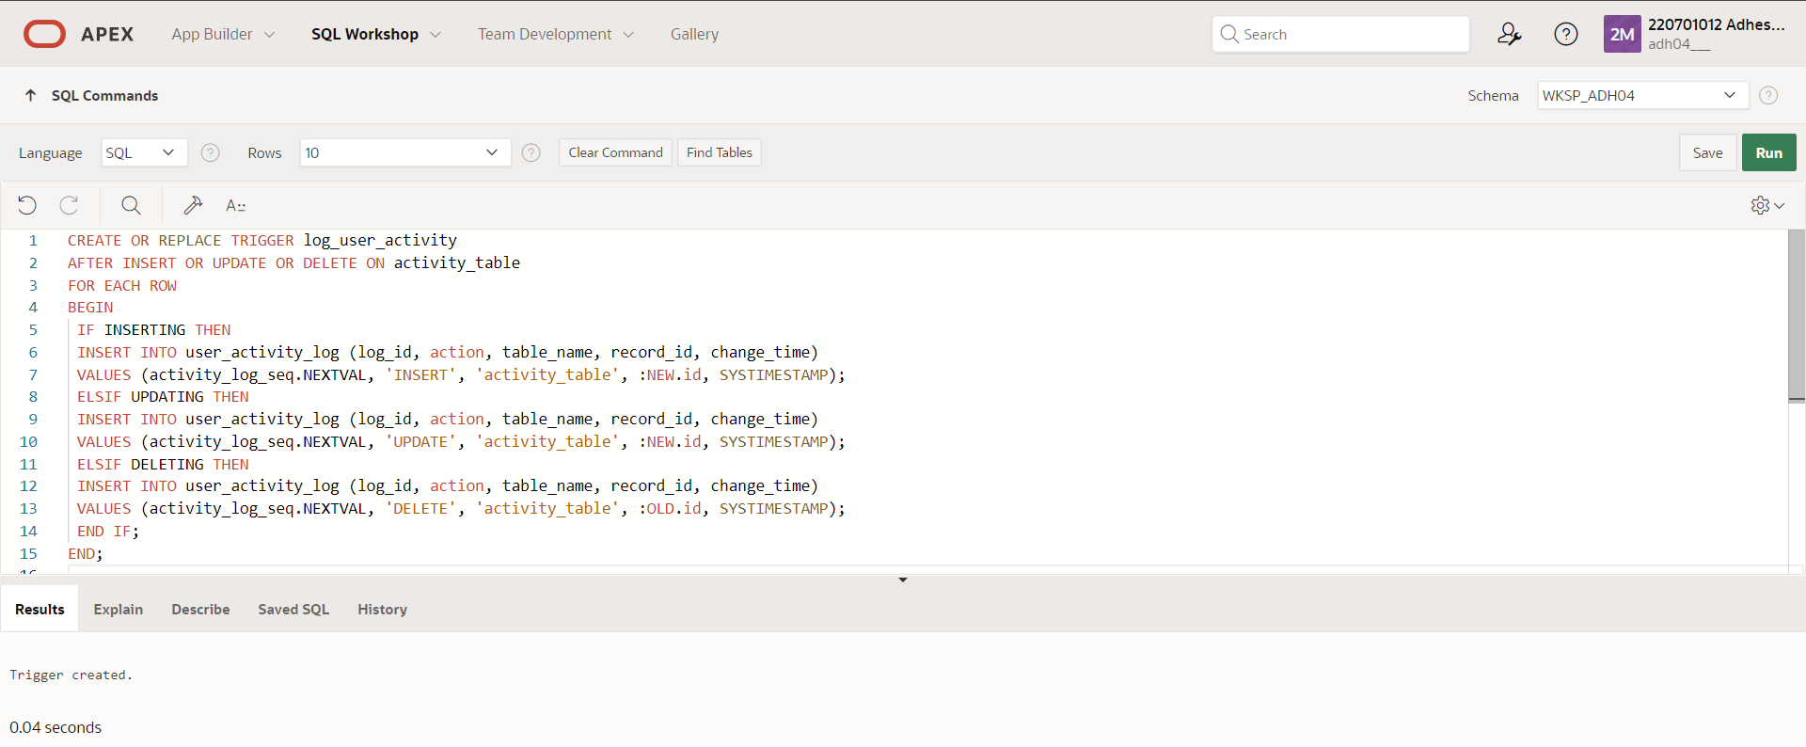

**6.)** **Write a code in PL/SQL to implement a trigger that automatically calculates and updates a running total column for a table whenever new rows are inserted**

**QUERY:**

CREATE OR REPLACE TRIGGER update_running_total

BEFORE INSERT ON running_total_table

FOR EACH ROW

DECLARE

v_total NUMBER;

BEGIN

SELECT NVL(SUM(amount), 0) INTO v_total FROM running_total_table;

:NEW.running_total := v_total + :NEW.amount;

END;

**OUTPUT:**

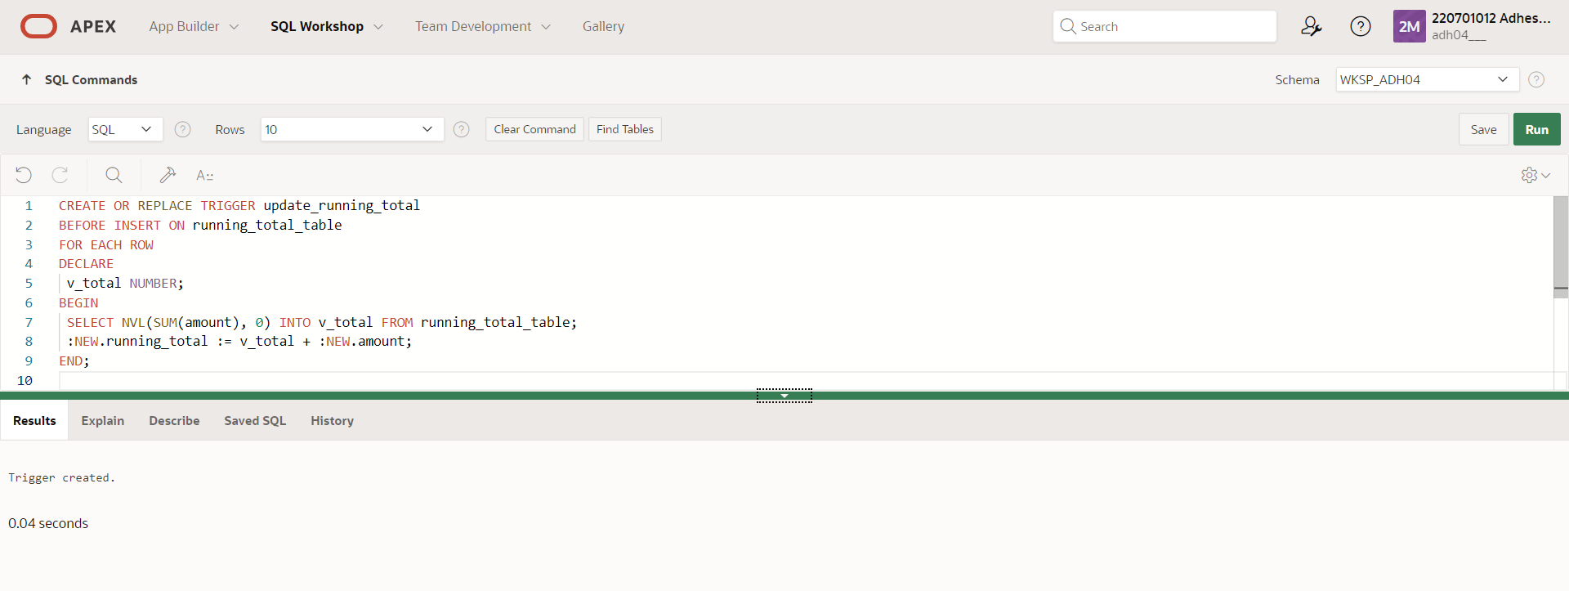

**MONGO DB**

**EX_NO: 19 DATE:**

**1.)**Write a MongoDB query to find the restaurant Id, name, borough and cuisine for those restaurants which prepared dish except 'American' and 'Chinees' or restaurant's name begins with letter 'Wil'.

**QUERY:**

db.restaurants.find( { $or: [{ name: /^Wil/ }, { cuisine: { $nin: ['American', 'Chinese'] } } ] , { restaurant_id: 1, name: 1, borough: 1, cuisine: 1 });

**OUTPUT:**

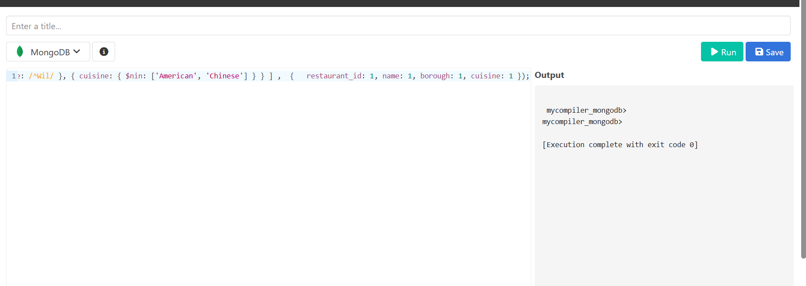

**2.)**Write a MongoDB query to find the restaurant Id, name, and grades for those restaurants which achieved a grade of "A" and scored 11 on an ISODate "2014-08- 11T00:00:00Z" among many of survey dates.

**QUERY:**

db.restaurants.find( { grades: { $elemMatch: { grade: "A",score: 11, date: ISODate("2014-08-11T00:00:00Z")} }},{ restaurant_id: 1,name: 1,grades: 1 });

**OUTPUT:**

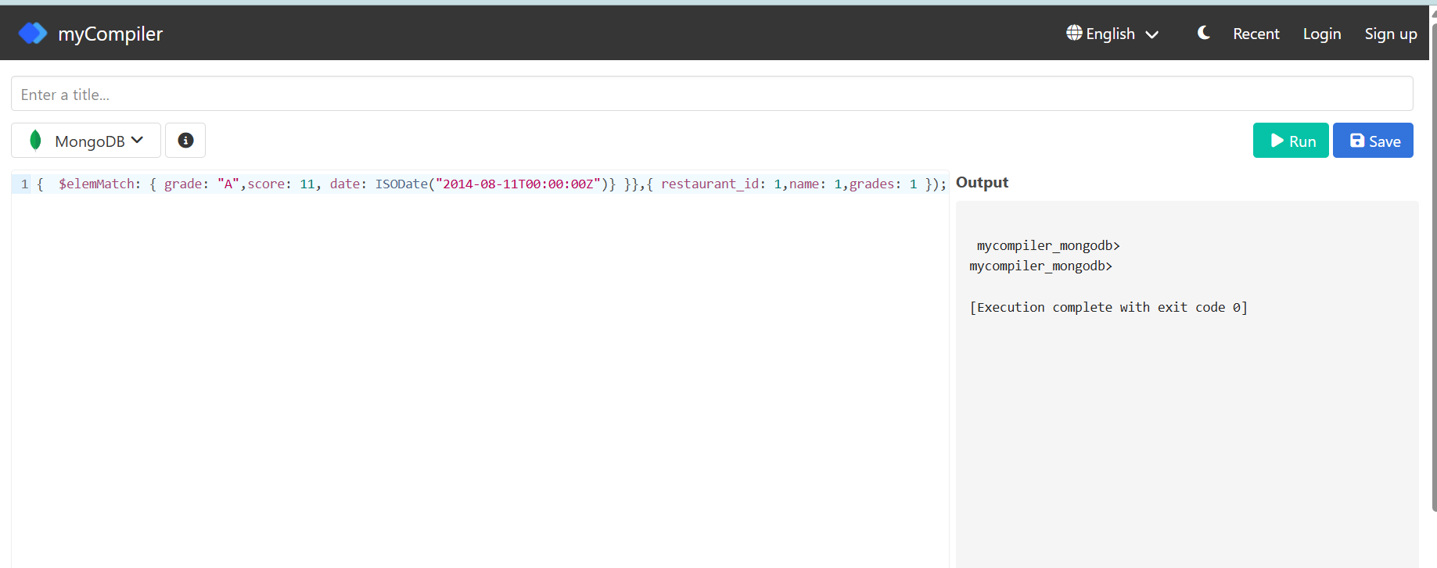

**3.)**Write a MongoDB query to find the restaurant Id, name and grades for those restaurants where the 2nd element of grades array contains a grade of "A" and score 9 on an ISODate "2014-08-11T00:00:00Z".

**QUERY:**

db.restaurants.find( {"grades.1.grade": "A", "grades.1.score": 9, "grades.1.date": ISODate("2014-08-1T00:00:00Z") },{ restaurant_id: 1, name: 1, grades: 1 });

**OUTPUT:**

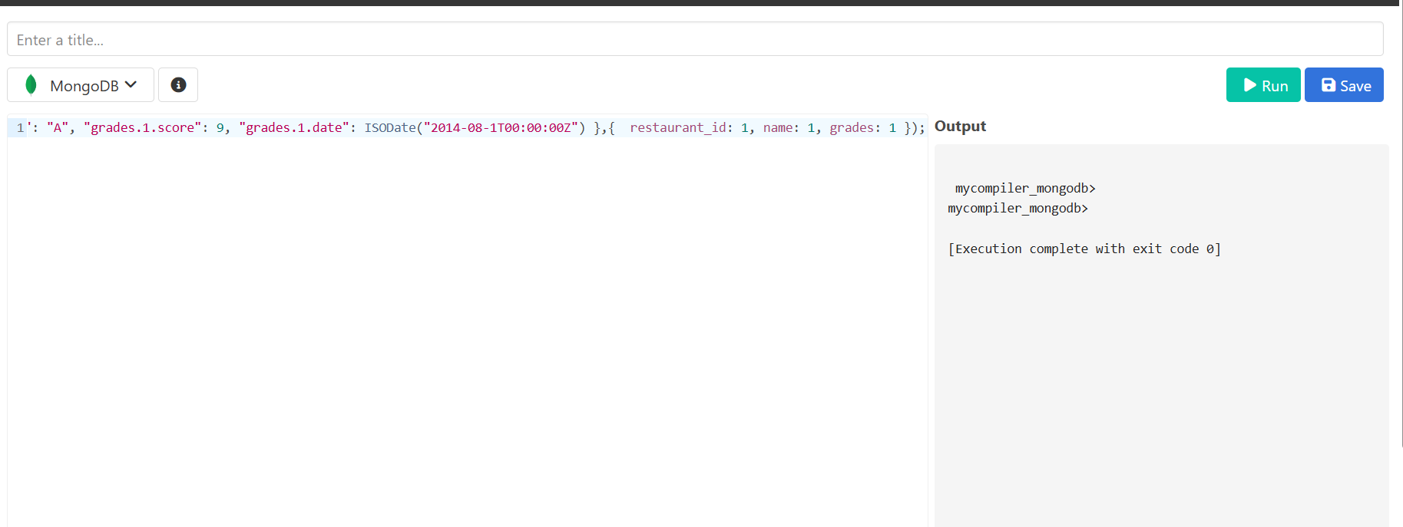

**4.)**Write a MongoDB query to find the restaurant Id, name, address and geographical location for those restaurants where 2nd element of coord array contains a value which is more than 42 and upto 52

**QUERY:**

db.restaurants.find({$and : [{"address.coord.1": {$gt : 42}},{"address.coord.1": {$lte : 52}}]}, {_id:0, restaurant_id:1, name:1, address:1})

**OUTPUT:**

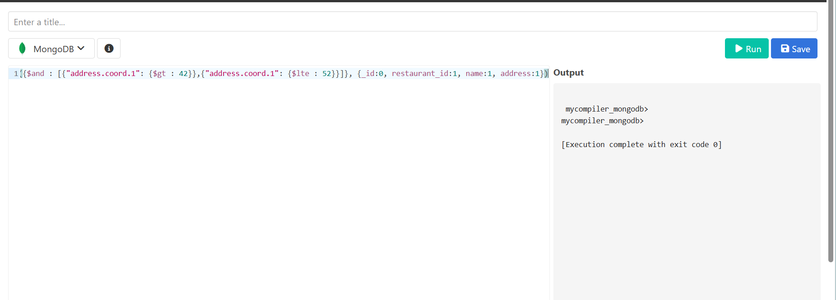

**5.)** Write a MongoDB query to arrange the name of the restaurants in ascending order along with all the columns.

**QUERY:**

db.restaurants.find({}, { _id: 0 }).sort({ name: 1 });

**OUTPUT:**

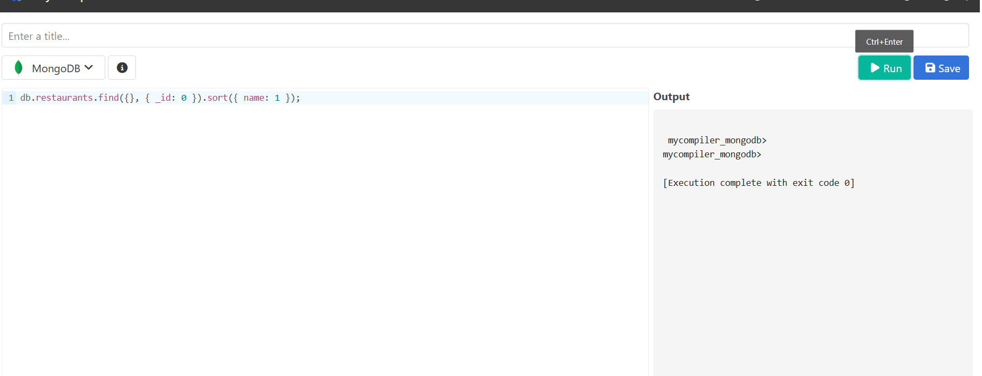

**6.)** Write a MongoDB query to arrange the name of the restaurants in descending along with all the columns.

**QUERY:**

db.restaurants.find({}, { _id: 0 }).sort({ name: 1 })

**OUTPUT:**



**7.)** Write a MongoDB query to arranged the name of the cuisine in ascending order and for that same cuisine borough should be in descending order.

**QUERY:**

db.restaurants.find({}, { _id: 0 }).sort({ cuisine: 1, borough: -1 })

**OUTPUT:**

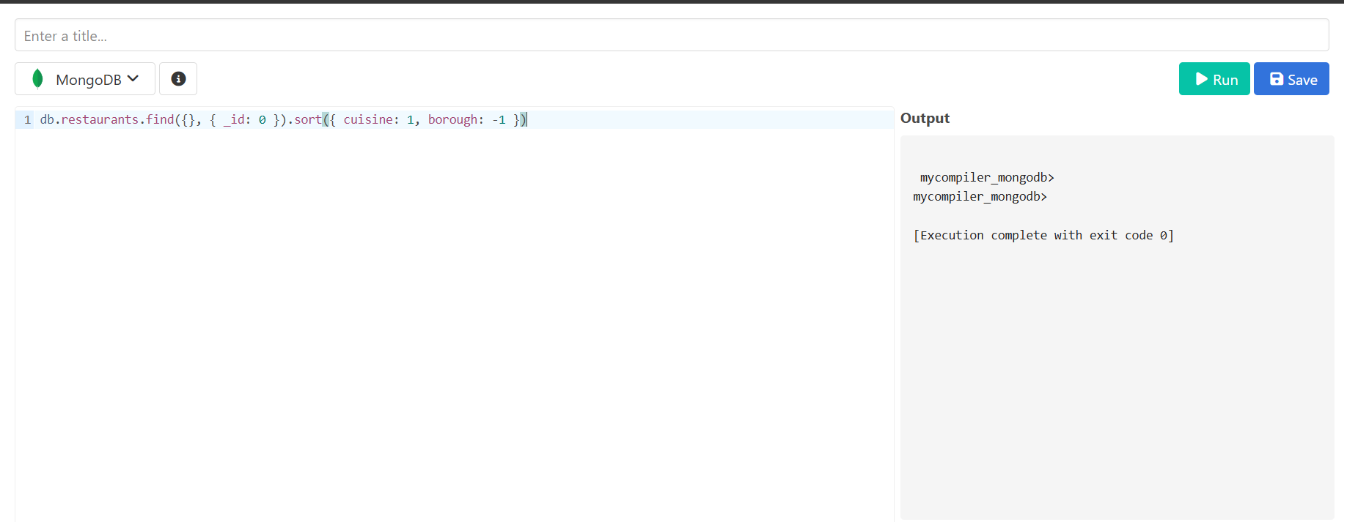

**8.)** Write a MongoDB query to know whether all the addresses contains the street or not.

**QUERY:**

db.restaurants.find({ "address.street": { $exists: true, $ne: "" } })

**OUTPUT:**

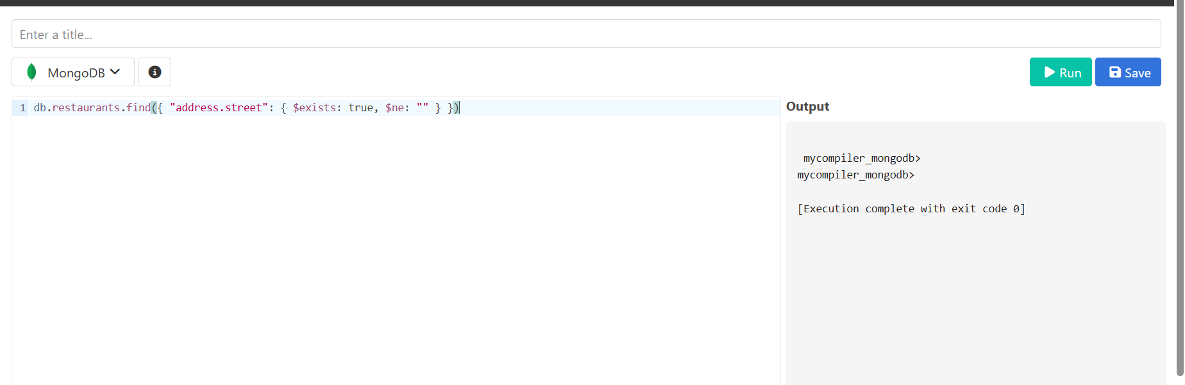

**9.)** Write a MongoDB query which will select all documents in the restaurants collection where the coord field value is Double.

**QUERY:**

db.restaurants.find({ "address.coord": { $elemMatch: { $type: "double" } } })

**OUTPUT:**

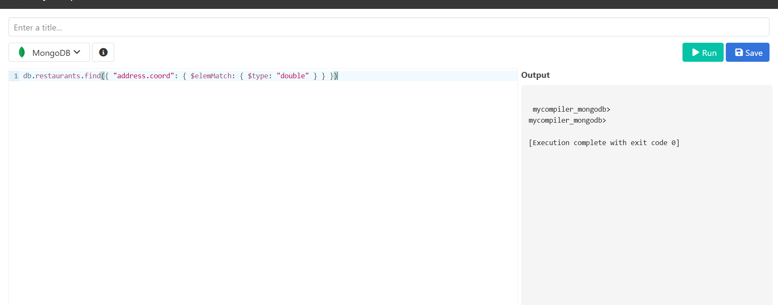

10. Write a MongoDB query which will select the restaurant Id, name and grades for those restaurants which returns 0 as a remainder after dividing the score by 7.

**QUERY:**

db.restaurants.find({ "grades.score": { $mod: [7, 0] } }, { restaurant_id: 1, name: 1, grades: 1 });

**OUTPUT:**

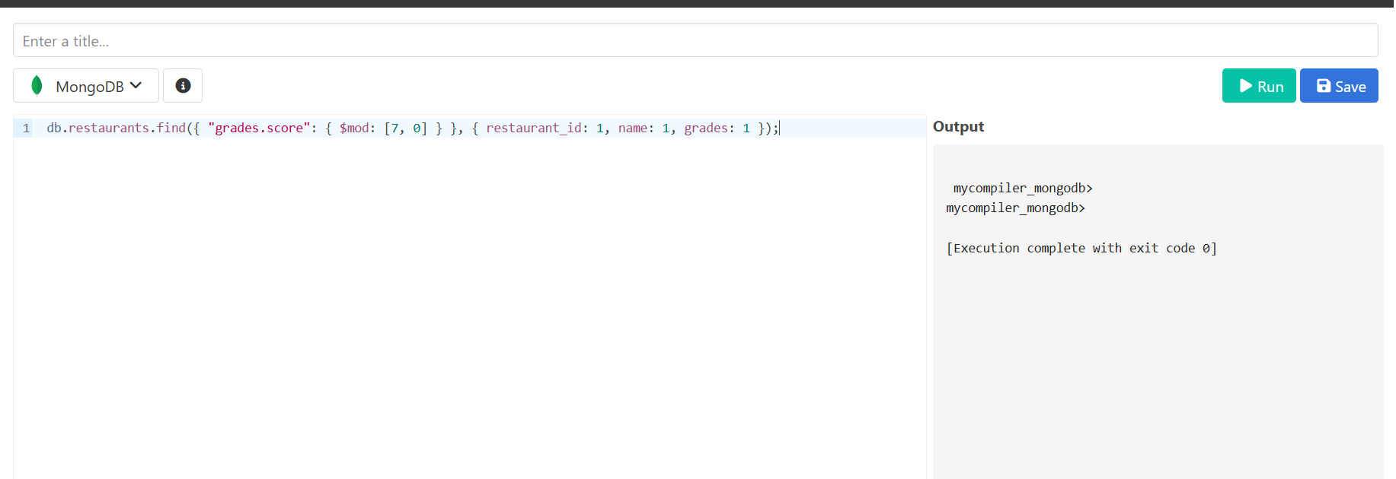

11. Write a MongoDB query to find the restaurant name, borough, longitude and attitude and cuisine for those restaurants which contains 'mon' as three letters somewhere in its name.

**QUERY:**

db.restaurants.find({ name: /mon/i }, { name: 1, borough: 1, "address.coord": 1, cuisine: 1 })

**OUTPUT:**

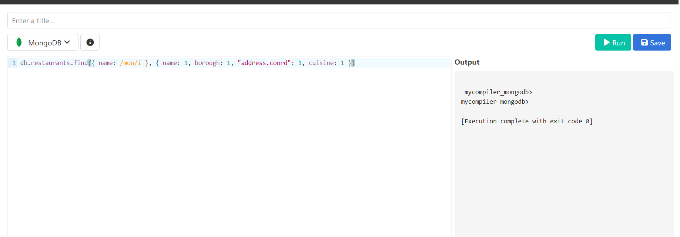

12. Write a MongoDB query to find the restaurant name, borough, longitude and latitude and cuisine for those restaurants which contain 'Mad' as first three letters of its name.

**QUERY:**

db.restaurants.find({ name: /^Mad/i }, { name: 1, borough: 1, "address.coord": 1, cuisine: 1 })

**OUTPUT:**

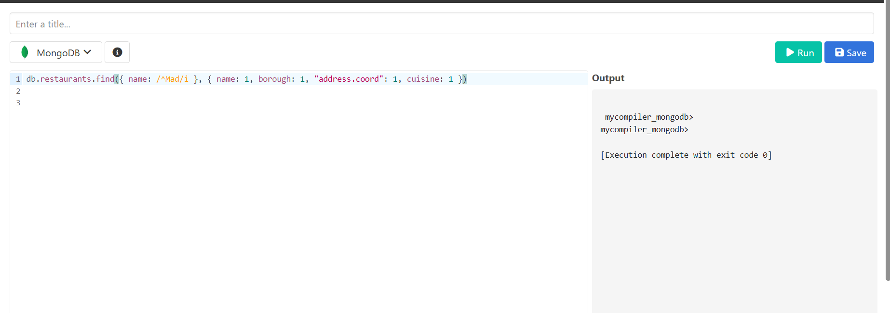

13. Write a MongoDB query to find the restaurants that have at least one grade with a score of less than 5.

**QUERY:**

db.restaurants.find({ "grades": { $elemMatch: { "score": { $lt: 5 } } } })

**OUTPUT:**

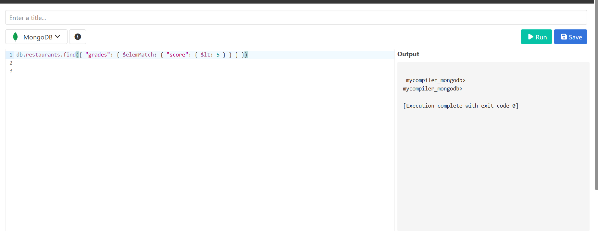

14. Write a MongoDB query to find the restaurants that have at least one grade with a score of less than 5 and that are located in the borough of Manhattan.

**QUERY:**

db.restaurants.find({ "grades": { $elemMatch: { "score": { $lt: 5 } } }, "borough": "Manhattan" })

**OUTPUT:**

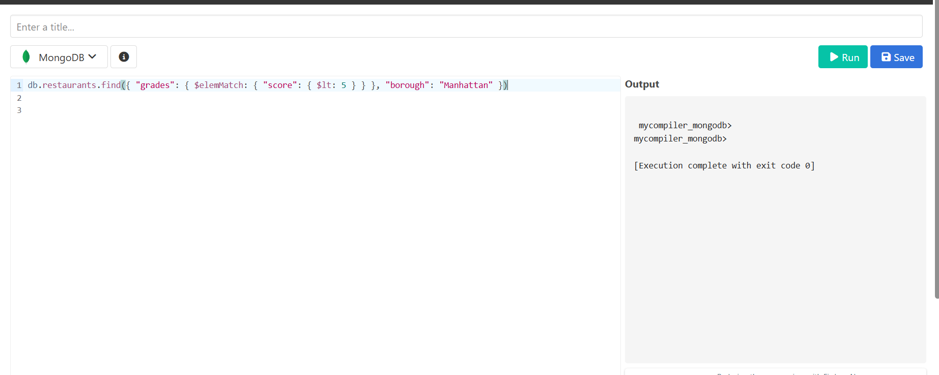

15.Write a MongoDB query to find the restaurants that have at least one grade with a score of less than 5 and that are located in the borough of Manhattan or Brooklyn.

**QUERY:**

db.restaurants.find({ "grades": { $elemMatch: { "score": { $lt: 5 } } }, $or: [{ "borough": "Manhattan" }, { "borough": "Brooklyn" }] })

**OUTPUT:**

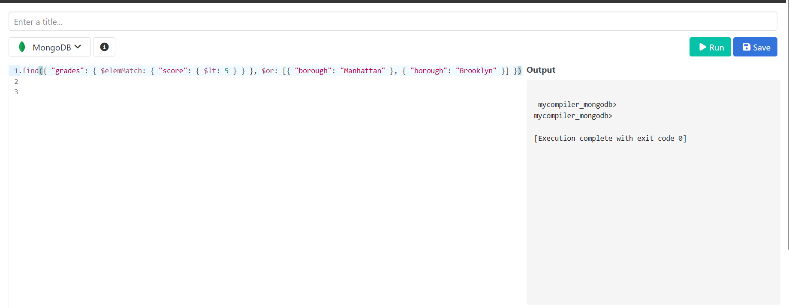

16. Write a MongoDB query to find the restaurants that have at least one grade with a score of less than 5 and that are located in the borough of Manhattan or Brooklyn, and their cuisine is not American.

**QUERY:**

db.restaurants.find({ "grades": { $elemMatch: { "score": { $lt: 5 } } }, $or: [{ "borough": "Manhattan" }, { "borough": "Brooklyn" }], "cuisine": { $ne: "American" } })

**OUTPUT:**

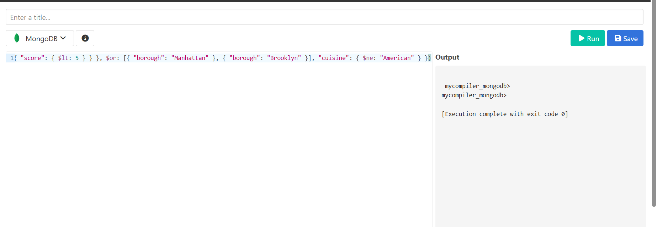

17. Write a MongoDB query to find the restaurants that have at least one grade with a score of less than 5 and that are located in the borough of Manhattan or Brooklyn, and their cuisine is not American or Chinese.

**QUERY:**

db.restaurants.find({ "grades": { $elemMatch: { "score": { $lt: 5 } } }, $or: [{ "borough": "Manhattan" }, { "borough": "Brooklyn" }], "cuisine": { $nin: ["American", "Chinese"] } })

**OUTPUT:**

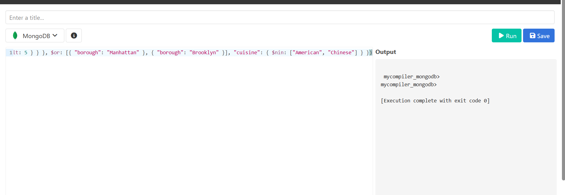

18. Write a MongoDB query to find the restaurants that have a grade with a score of 2 and a grade with a score of 6.

**QUERY:**

db.restaurants.find({ $and: [{ "grades.grade": "A", "grades.score": 2 }, { "grades.grade": "A", "grades.score": 6 }] })

**OUTPUT:**

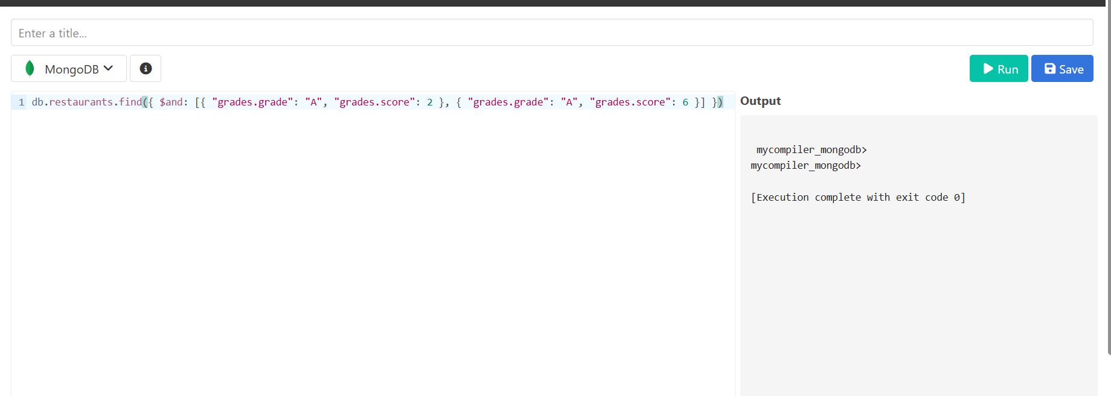

19. Write a MongoDB query to find the restaurants that have a grade with a score of 2 and a grade with a score of 6 and are located in the borough of Manhattan.

**QUERY:**

db.restaurants.find({ $and: [{ "grades.grade": "A", "grades.score": 2 }, { "grades.grade": "A", "grades.score": 6 }], "borough": "Manhattan" })

**OUTPUT:**

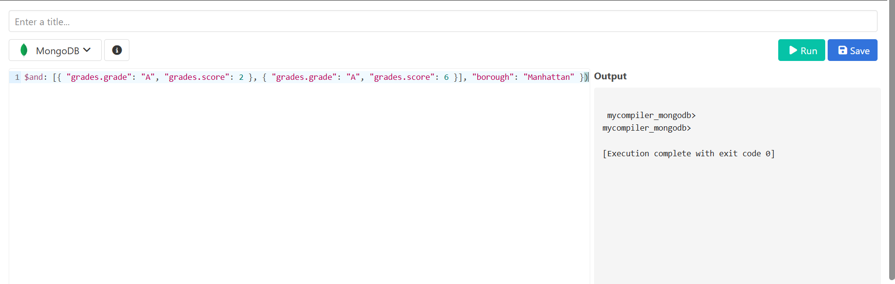

20. Write a MongoDB query to find the restaurants that have a grade with a score of 2 and a grade with a score of 6 and are located in the borough of Manhattan or Brooklyn.

**QUERY:**

db.restaurants.find({ $and: [{ "grades.grade": "A", "grades.score": 2 }, { "grades.grade": "A", "grades.score": 6 }], $or: [{ "borough": "Manhattan" }, { "borough": "Brooklyn" }] })

**OUTPUT:**

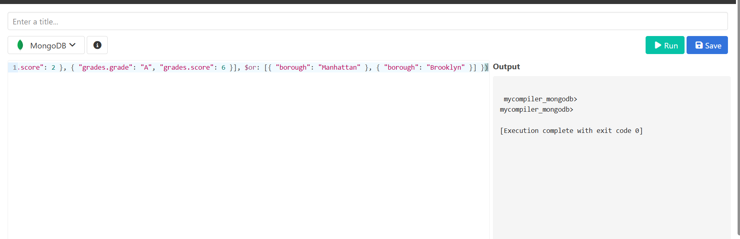

21. Write a MongoDB query to find the restaurants that have a grade with a score of 2 and a grade with a score of 6 and are located in the borough of Manhattan or Brooklyn, and their cuisine is not American.

**QUERY:**

db.restaurants.find({ $and: [{ "grades.grade": "A", "grades.score": 2 }, { "grades.grade": "A", "grades.score": 6 }], $or: [{ "borough": "Manhattan" }, { "borough": "Brooklyn" }], "cuisine": { $ne: "American" } })

**OUTPUT:**

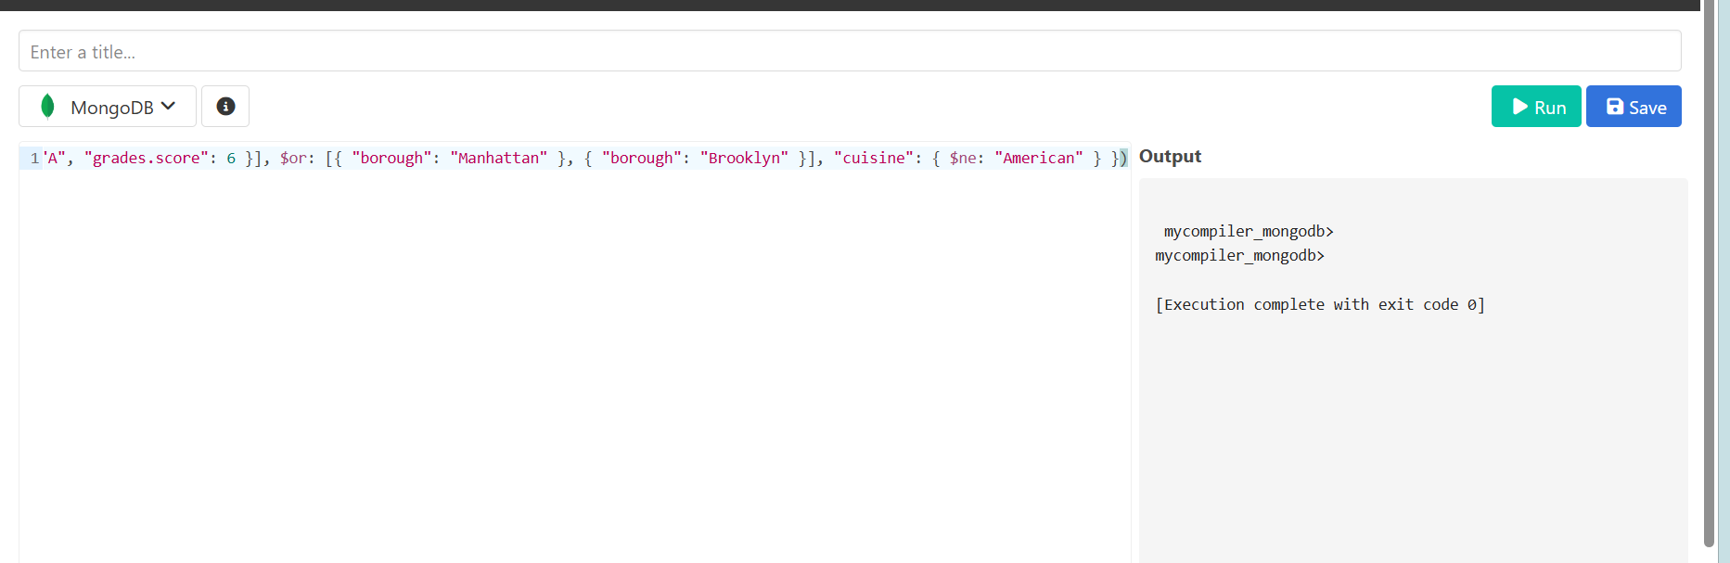

22. Write a MongoDB query to find the restaurants that have a grade with a score of 2 and a grade with a score of 6 and are located in the borough of Manhattan or Brooklyn, and their cuisine is not American or Chinese.

**QUERY:**

db.restaurants.find({ $and: [{ "grades.grade": "A", "grades.score": 2 }, { "grades.grade": "A", "grades.score": 6 }], $or: [{ "borough": "Manhattan" }, { "borough": "Brooklyn" }], "cuisine": { $nin: ["American", "Chinese"] } })

**OUTPUT:**

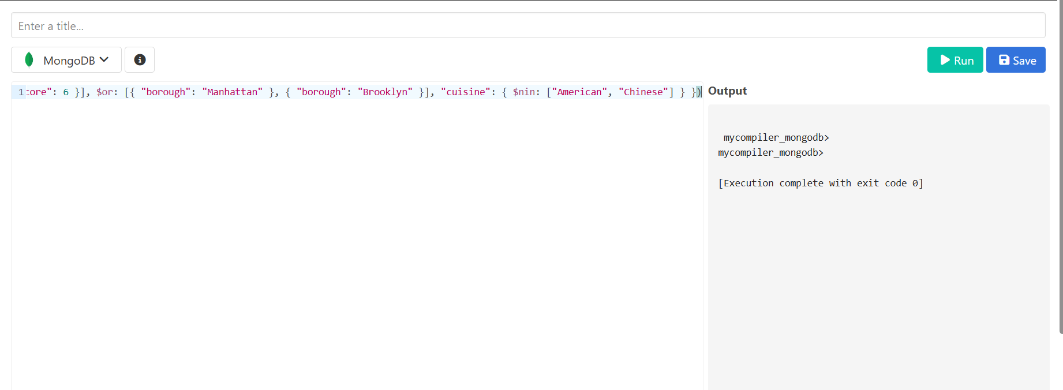

23. Write a MongoDB query to find the restaurants that have a grade with a score of 2 or a grade with a score of 6.

**QUERY:**

db.restaurants.find({ $or: [{ "grades.score": 2 }, { "grades.score": 6 }] })

**OUTPUT:**

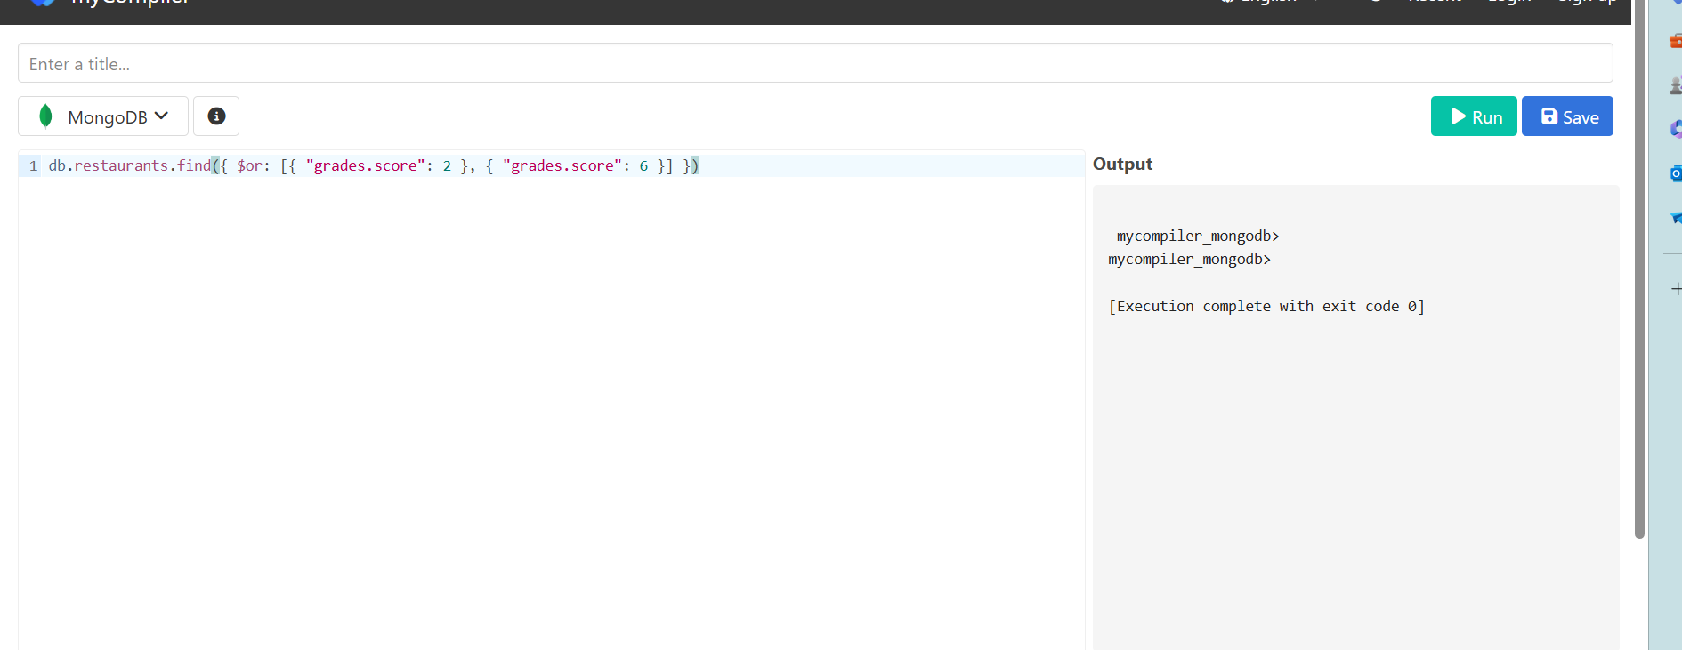

|  |  |
| --- | --- |
| Evaluation Procedure | Marks awarded |
| Query(5) |  |
| Execution (5) |  |
| Viva(5) |  |
| Total (15) |  |
| Faculty Signature |  |

**RESULT:**

**MONGO DB**

**EX_NO: 20 DATE:**

**1.)** **Find all movies with full information from the 'movies' collection that released in the year 1893.**

**QUERY:**

db.movies.find({ year: 1893 })

**OUTPUT:**

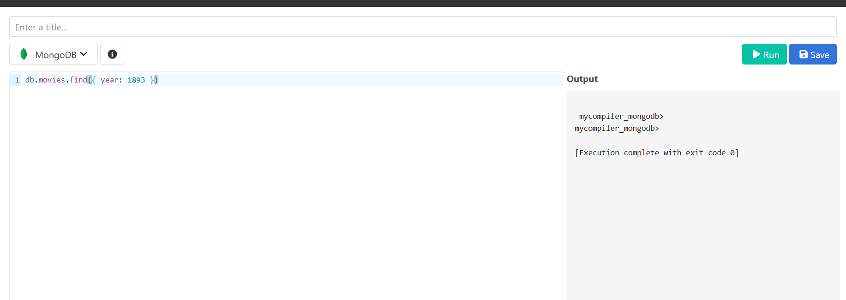

**2.)** **Find all movies with full information from the 'movies' collection that have a runtime greater than 120 minutes.**

**QUERY:**

db.movies.find({ runtime: { $gt: 120 } })

**OUTPUT:**

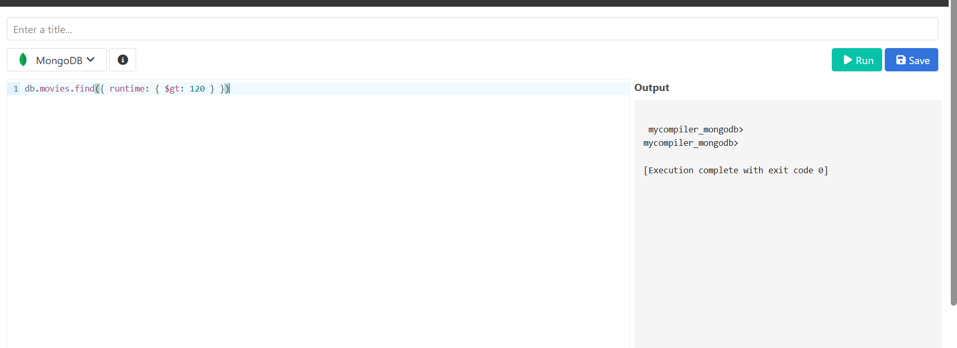

**3.)** **Find all movies with full information from the 'movies' collection that have "Short" genre.**

**QUERY:**

db.movies.find({ genres: 'Short' })

**OUTPUT:**

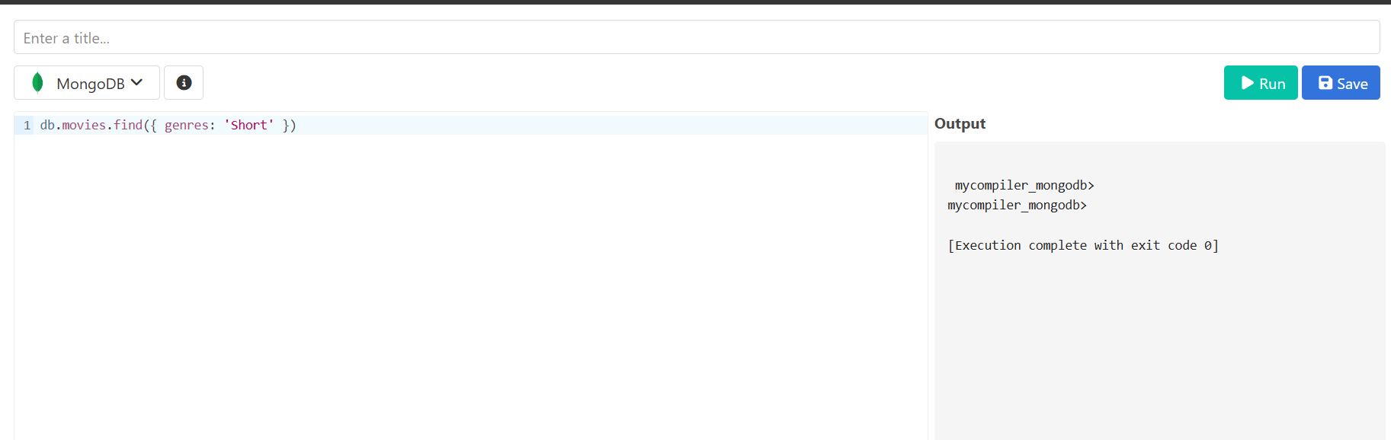

**4.)** **Retrieve all movies from the 'movies' collection that were directed by "William K.L. Dickson" and include complete information for each movie.**

**QUERY:**

db.movies.find({ directors: 'William K.L. Dickson' })

**OUTPUT:**

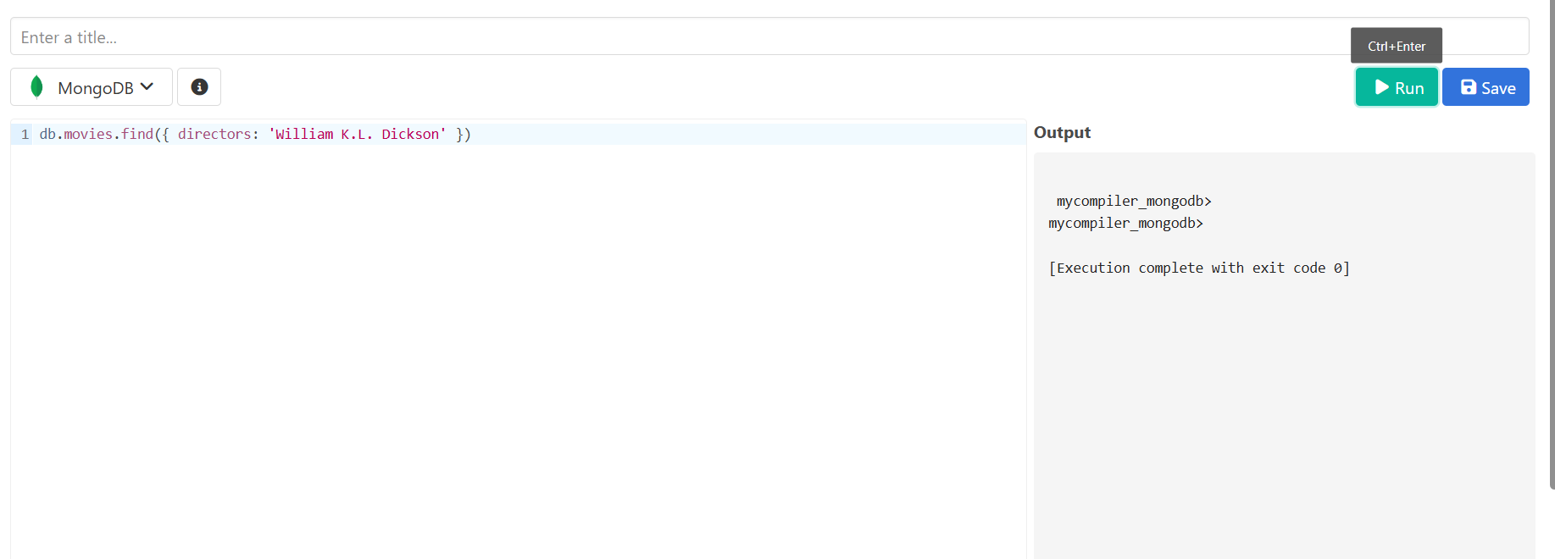

**5.)** **Retrieve all movies from the 'movies' collection that were released in the USA and include complete information for each movie.**

**QUERY:**

db.movies.find({ countries: 'USA' })

**OUTPUT:**

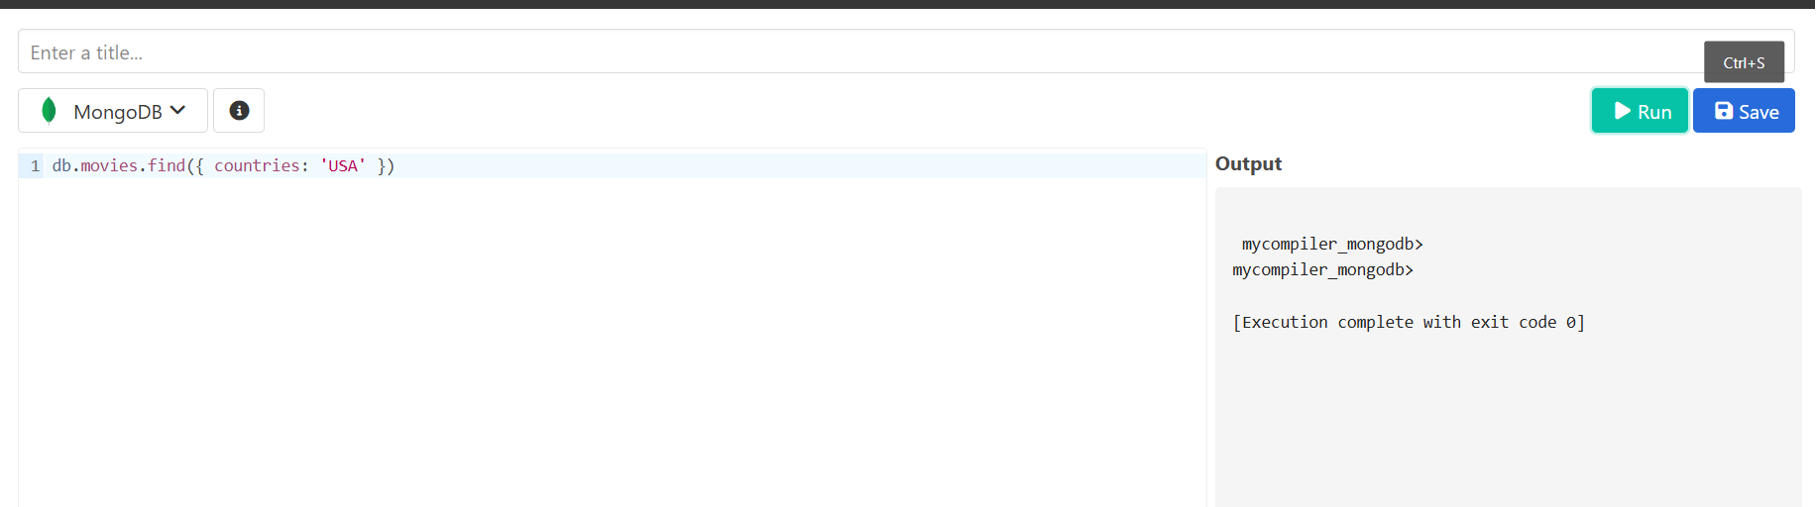

**6.)** **Retrieve all movies from the 'movies' collection that have complete information and are rated as "UNRATED".**

**QUERY:**

db.movies.find({ rated: 'UNRATED' })

**OUTPUT:**

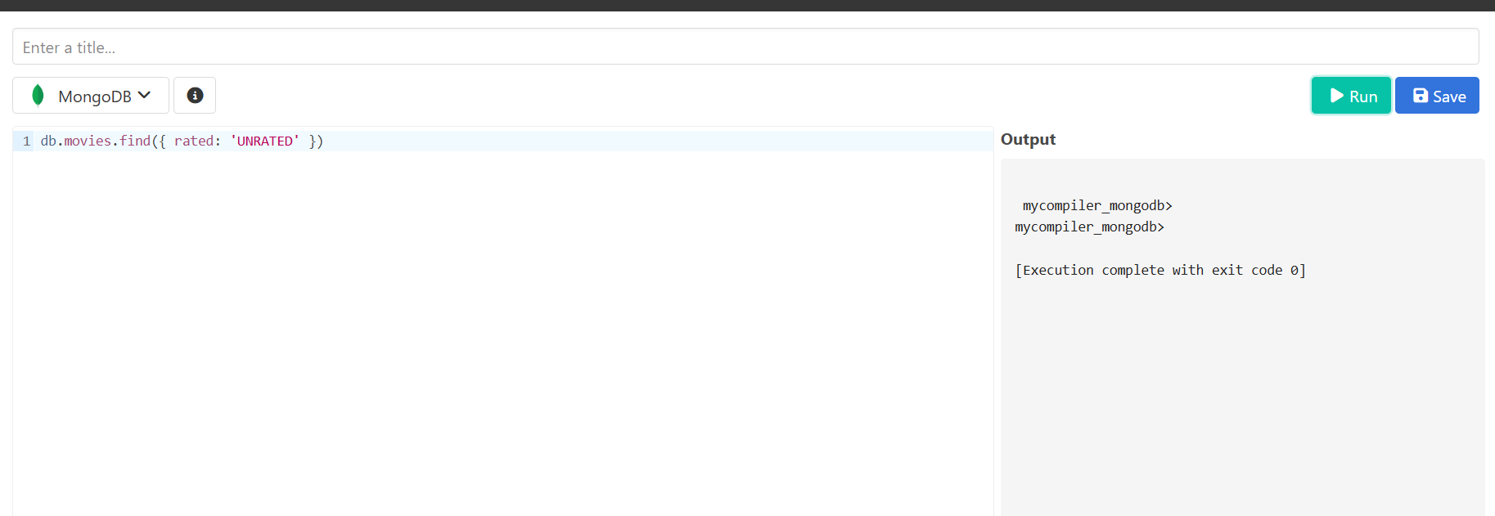

**7.)** **Retrieve all movies from the 'movies' collection that have complete information and have received more than 1000 votes on IMDb.**

**QUERY:**

db.movies.find({ 'imdb.votes': { $gt: 1000 } })

**OUTPUT:**

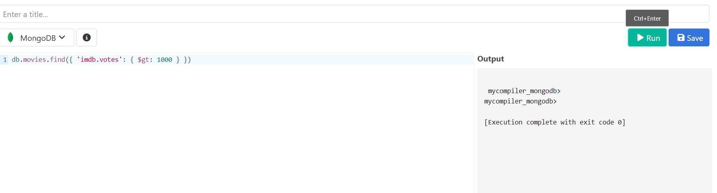

**8.)** **Retrieve all movies from the 'movies' collection that have complete information and have an IMDb rating higher than 7.**

**QUERY:**

db.movies.find({ 'imdb.rating': { $gt: 7 } })

**OUTPUT:**

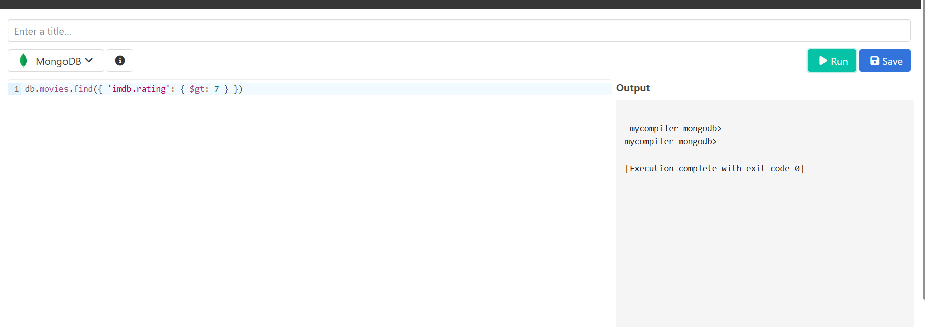

**9.)** **Retrieve all movies from the 'movies' collection that have complete information and have a viewer rating higher than 4 on Tomatoes.**

**QUERY:**

db.movies.find({ 'tomatoes.viewer.rating': { $gt: 4 } })

**OUTPUT:**

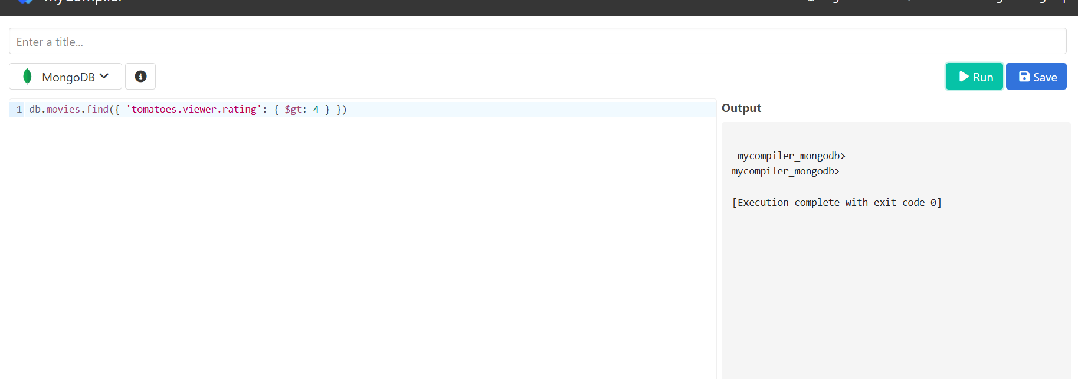

**10.)** **Retrieve all movies from the 'movies' collection that have received an award.**

**QUERY:**

db.movies.find({ 'awards.wins': { $gt: 0 } })

**OUTPUT:**

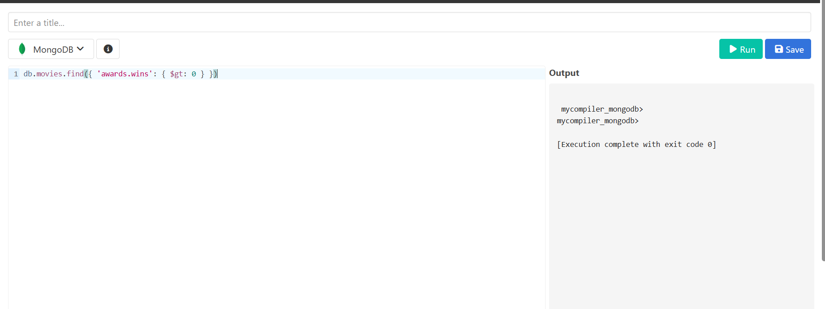

**11.)** **Find all movies with title, languages, released, directors, writers, awards, year, genres, runtime, cast, countries from the 'movies' collection in MongoDB that have at least one nomination.**

**QUERY:**

db.movies.find( { 'awards.nominations': { $gt: 0 } }, { title: 1, languages: 1, released: 1, directors: 1, writers: 1, awards: 1, year: 1, genres: 1, runtime: 1, cast: 1, countries: 1 })

**OUTPUT:**

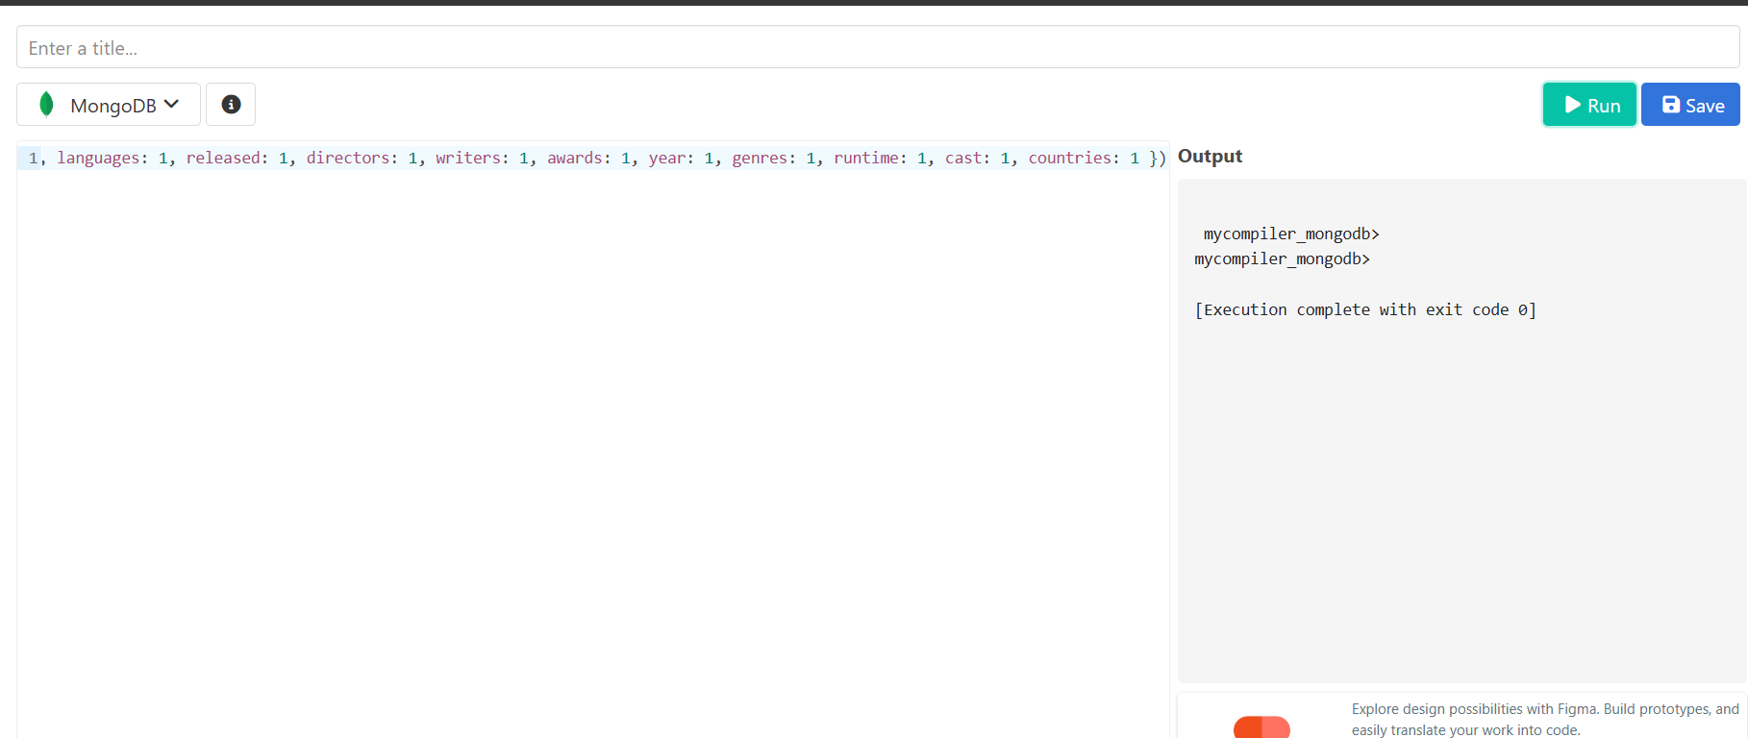

**12.)** **Find all movies with title, languages, released, directors, writers, awards, year, genres, runtime, cast, countries from the 'movies' collection in MongoDB with cast including "Charles Kayser".**

**QUERY:**

db.movies.find( { cast: 'Charles Kayser' }, { title: 1, languages: 1, released: 1, directors: 1, writers: 1, awards: 1, year: 1, genres: 1, runtime: 1, cast: 1, countries: 1 })

**OUTPUT:**

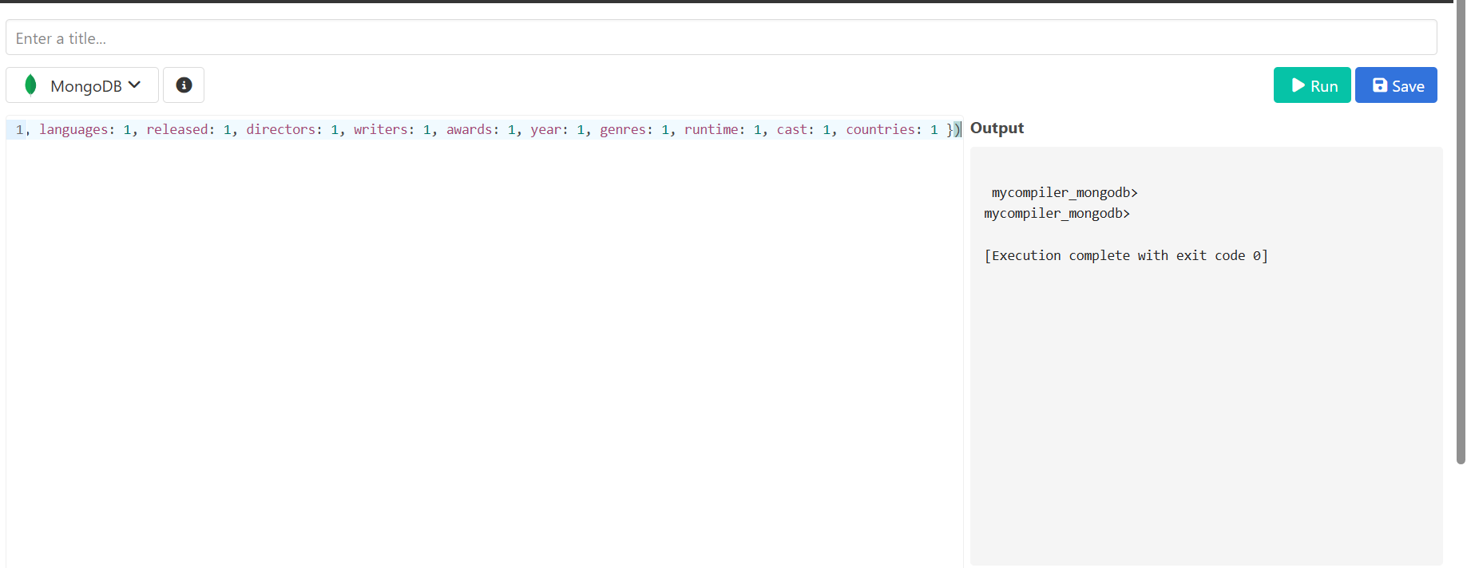

**13.)** **Retrieve all movies with title, languages, released, directors, writers, countries from the 'movies' collection in MongoDB that released on May 9, 1893.**

**QUERY:**

db.movies.find( { released: ISODate("1893-05-09T00:00:00.000Z") }, { title: 1, languages: 1, released: 1, directors: 1, writers: 1, countries: 1 })

**OUTPUT:**

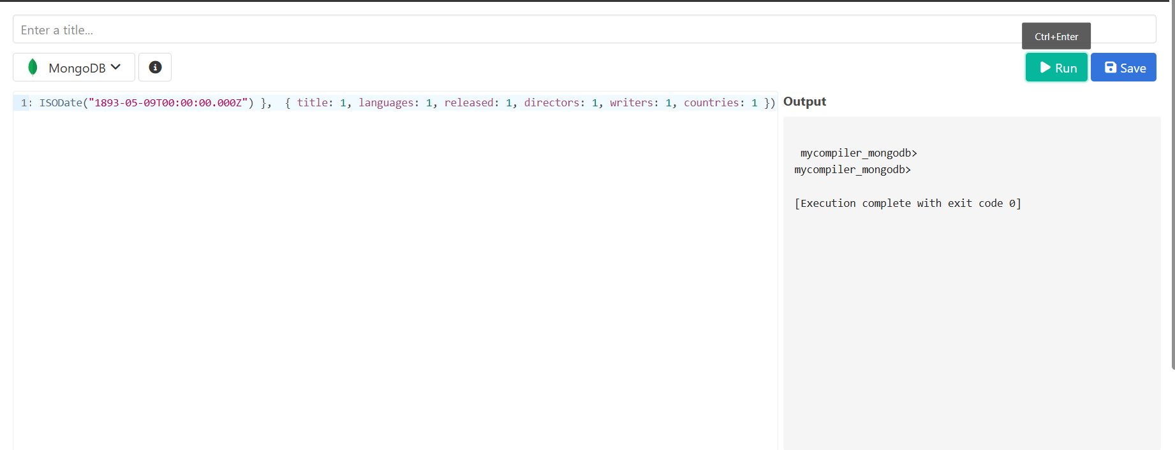

**14.)** **Retrieve all movies with title, languages, released, directors, writers, countries from the 'movies' collection in MongoDB that have a word "scene" in the title.**

**QUERY:**

db.movies.find( { title: /scene/i }, { title: 1, languages: 1, released: 1, directors: 1, writers: 1, countries: 1 })

**OUTPUT:**

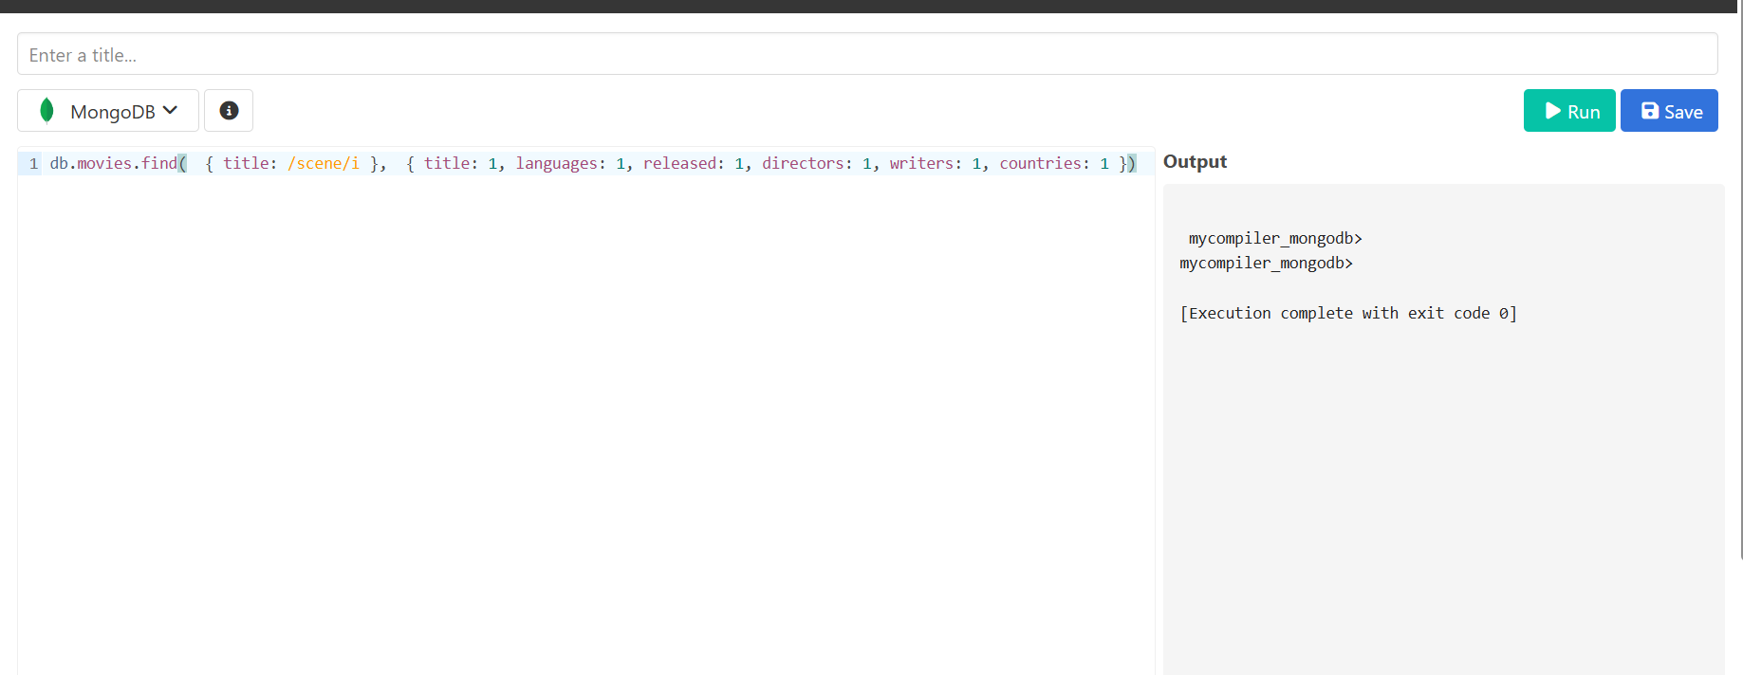

|  |  |
| --- | --- |
| Evaluation Procedure | Marks awarded |
| Query(5) |  |
| Execution (5) |  |
| Viva(5) |  |
| Total (15) |  |
| Faculty Signature |  |

**RESULT:**